|  |
| --- |
| Office for Nuclear Regulation |

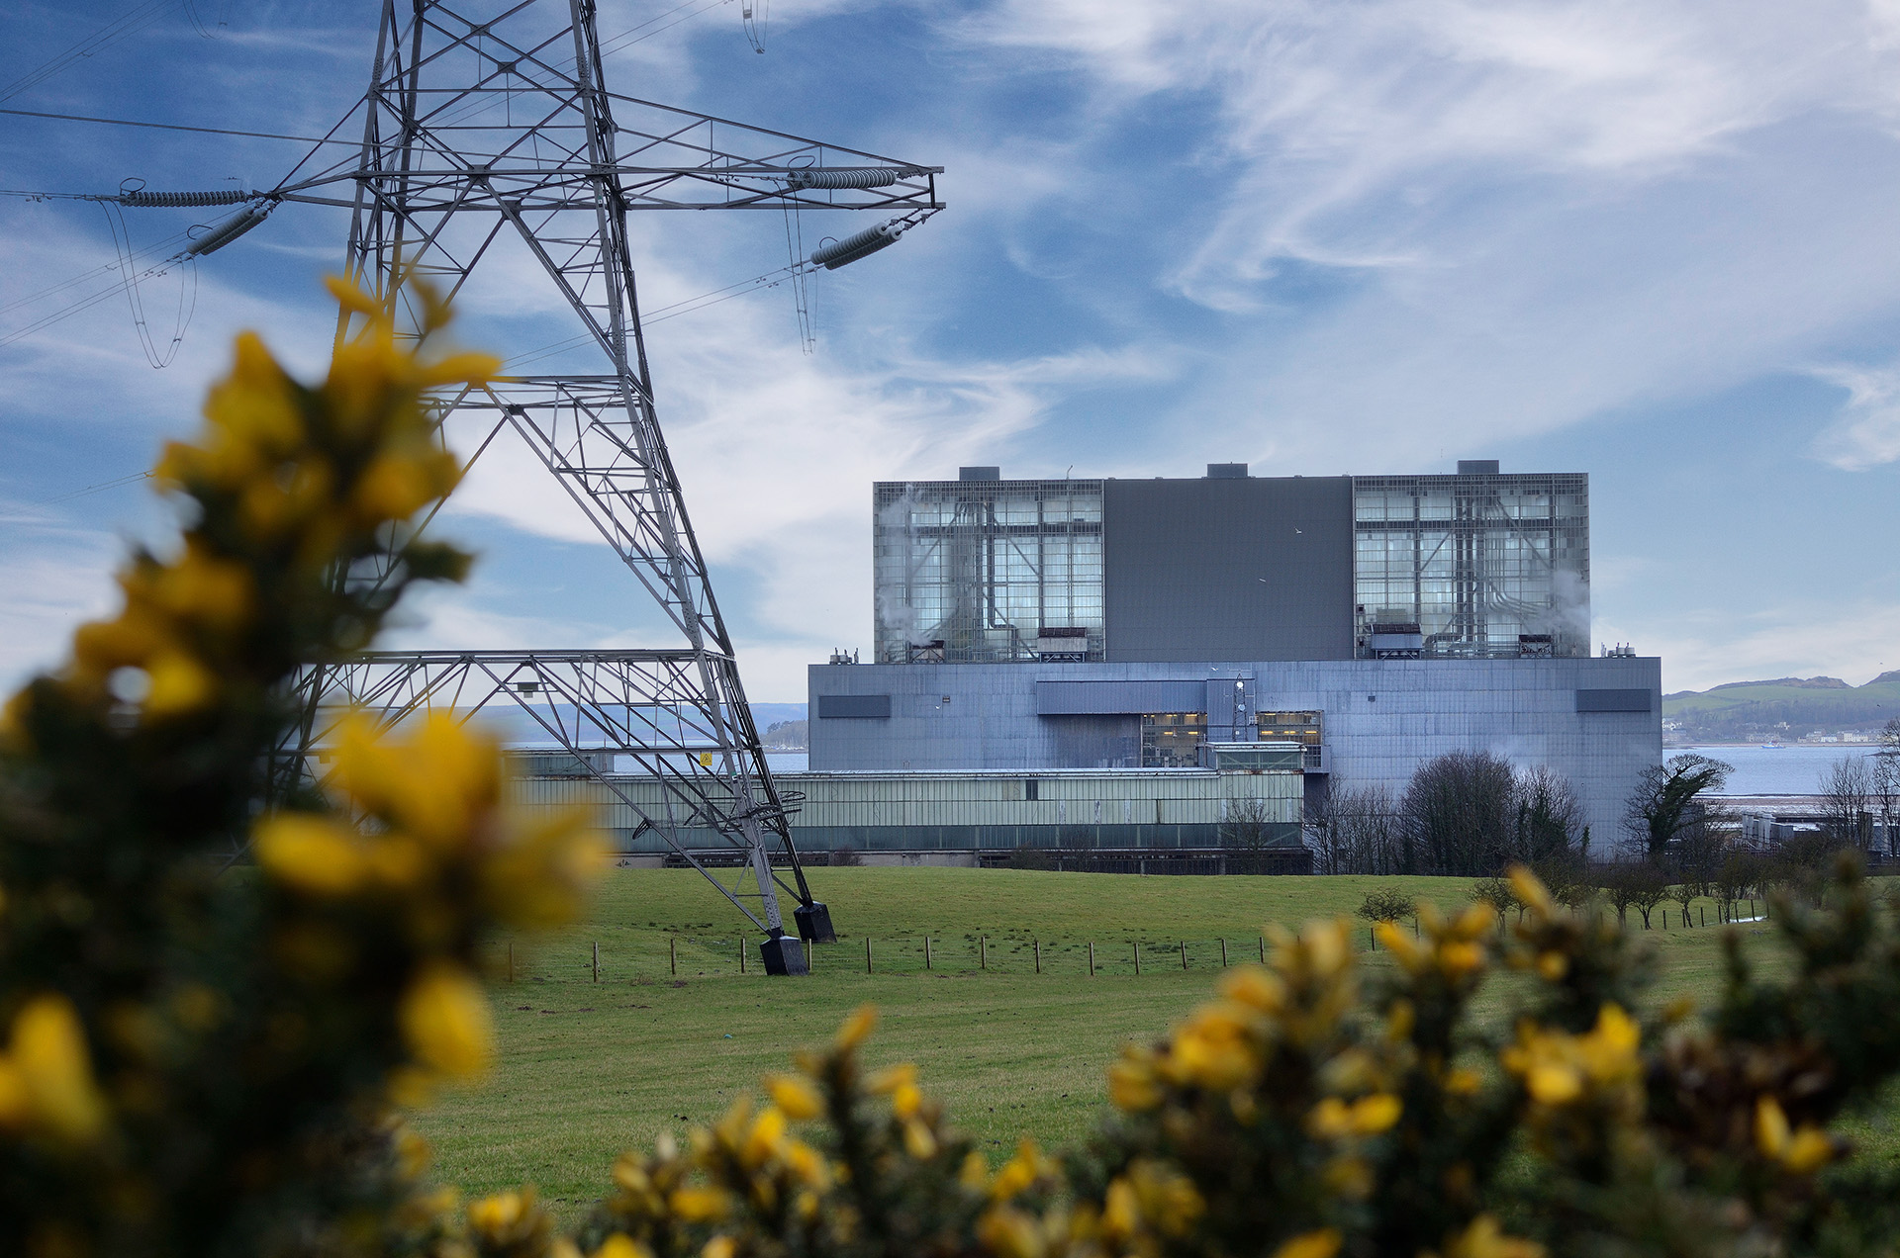

ONR Report

Chief Nuclear Inspector’s Themed Inspection on Climate Change – Summary Report

# Chief Nuclear Inspector’s Themed Inspection on Climate Change – Summary Report- Foreword

Mark Foy, as ONR’s previous Chief Executive and Chief Nuclear Inspector, commissioned this Chief Nuclear Inspector’s (CNI) themed inspection on climate change, in response to scientific evidence that the UK climate may be changing at a faster rate than anticipated, and that the goal “to limit the temperature increase to 1.5 °C above pre-industrial levels” made at the UN Climate Change Conference (COP21) in December 2015 is unlikely to be achieved. We were seeking assurance that the nuclear industry within Great Britain is able to demonstrate that its activities are and will remain safe and secure in the future, subject to the reasonably foreseeable effects of climate change.

The key finding from this CNI themed inspection is that industry is making progress in relation to ensuring climate change effects are understood and mitigated against. We did not identify any fundamental shortfalls that would indicate sites are not currently robust against external hazards. However, there is still work required by dutyholders to implement adequate arrangements to ensure sites remain resilient against future effects of climate change in the medium and long-term.

During the self-assessment and inspection phase, I was pleased that my inspectors identified areas of good practice as well as areas of learning both for the industry and for ourselves.

I have written to industry outlining the findings from this CNI themed inspection and reaffirmed our expectations. I have tasked our inspectors with continuing their risk-informed and targeted activities in relation to external hazards to hold dutyholders to account and ensure that their sites are resilient against the future effects of climate change.

Since highlighting the need for attention in this area, I have drawn confidence from the positive response of the nuclear industry and the steps taken to improve its arrangements.

Throughout this CNI themed inspection, we have worked with other regulators and industry stakeholders. This has maximised the sharing of learning across the industry, which is a key outcome of this themed inspection. The activity has also provided us with an opportunity to identify areas for greater future collaboration and reduce regulatory burden. I’m particularly grateful for the support of the environment agencies who participated in the inspection phase and whose findings are included as part of this summary report.

We engaged with international regulators as part of the CNI themed inspection work, to benchmark our regulatory approach. I am pleased to say that our work on climate change is forward looking and other regulators are keen to learn from our approach. We will continue to engage through appropriate international fora, to share the learning and identify opportunities for continuous improvement in this fast-moving area.

**Mike Finnerty, Chief Executive/Chief Nuclear Inspector**

# List of abbreviations

ALARP As Low As Reasonably Practicable

AMOC Atlantic Meridional Overturning Circulation

ARP Adaptation Reporting Power

AR6 Sixth Assessment Report

AWE Atomic Weapons Establishment

C&I Control and Instrumentation

CCRA Climate Change Risk Assessment

CDOIF Chemical and Downstream Oil Industries Forum

CNI Chief Nuclear Inspector

COMAH Control of Major Accident Hazards (Regulations)

COP Conference of the Parties (often refers to the United Nations Framework Convention on Climate Change (UNFCCC) international meeting focusing on climate)

DCP Dounreay Cementation Plant

Defra Department for Environment, Food and Rural Affairs

DNO Defence Nuclear Organisation

DNSR Defence Nuclear Safety Regulator

EDF NGL EDF Energy Nuclear Generation Limited (EDF NGL)

EVA Extreme Value Analysis

GB Great Britain

GDA Generic Design Assessment

GP Good Practice

HMNB His Majesty’s Naval Base

HPC Hinkley Point C

HVAC Heating, Ventilation and Air-Conditioning

IAF International Accreditation Forum

IPCC Intergovernmental Panel on Climate Change

ISO International Organisation for Standardisation

LC Licence Condition

LLWR Low Level Waste Repository

NAFRA2 National Flood Risk Assessment 2

NCERM National Coastal Erosion Risk Map

NDA Nuclear Decommissioning Authority

NRS Nuclear Restoration Services

NWS Nuclear Waste Services

ONR Office for Nuclear Regulation

PSR Periodic Safety Review

RCP Representative Concentration Pathway

RGP Relevant Good Practice

SAP Safety Assessment Principle

SSC Structures, Systems and Components

SSP Shared Socioeconomic Pathway

TAG Technical Assessment Guide(s)

TP Tipping Points

UKCP18 UK Climate Projections 2018

Contents

Chief Nuclear Inspector’s Themed Inspection on Climate Change – Summary Report - Foreword 2

List of abbreviations 3

1. Overview of the Chief Nuclear Inspector’s themed inspection on climate change 5

2. The climate of the British Isles 7

3. Self-Assessment Questionnaire 9

4. Site-based inspections 13

5. Environment Agency summary 17

6. Findings and forward actions 20

7. Conclusions 28

References 29

Appendix 1 – The future climate of the British Isles 33

Appendix 2 – CNI themed inspection on climate change self-assessment questionnaire 37

Appendix 3 – Findings identified from the self-assessment questionnaire responses 43

Appendix 4 – Learning points identified from the site-based inspection phase. 46

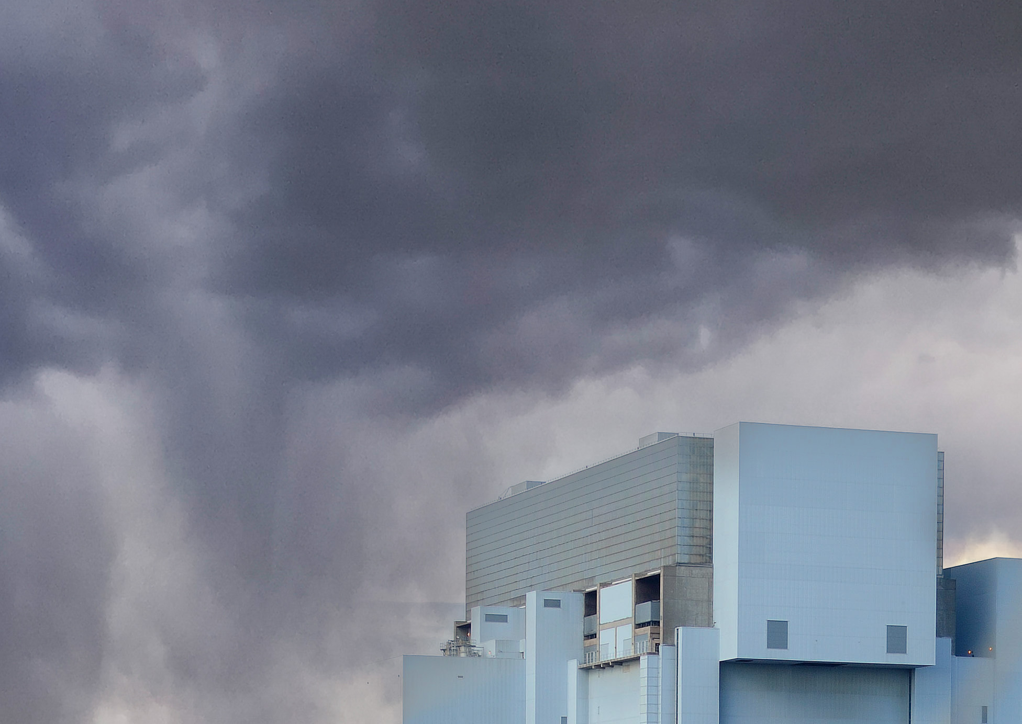

# Overview of the Chief Nuclear Inspector’s themed inspection on climate change

## Aim of the inspection

1. The Chief Nuclear Inspector’s (CNI) themed inspection on climate change commenced in 2023 with the aim of seeking assurance that the nuclear industry within Great Britain:

* Understands and has taken account of recent climate change projections in relevant safety cases and hazard definitions.
* Is able to demonstrate that activities are and will remain safe and secure in the future, subject to the reasonably foreseeable effects of climate change.
* Has effective arrangements to monitor and review climate change information to determine if additional measures are needed to ensure that activities remain protected in the future.

## Phases of the inspection

1. The CNI themed inspection on climate change had three phases:

* **Self-assessment questionnaire** – We requested that dutyholders complete a self-assessment questionnaire, providing information on their arrangements and resilience in relation to climate change effects.
* **Site-based inspections** – We conducted five site-based inspections, a representative sample of industry, informed by responses to the self-assessment questionnaires. The inspections examined the effectiveness by which sites implement the arrangements described in safety cases, and the extent to which these arrangements align with relevant good practice.
* **Summary report** – We authored this summary report to highlight our findings and identify future regulatory activities.

## Stakeholder engagement

1. We have engaged with a range of nuclear industry stakeholders during the CNI themed inspection on climate change, including:

* **Industry** – We held two industry engagement events in addition to the phased inspection activities. The events were attended by representatives from across nuclear licensed sites, as well as prospective licensees and requesting parties to our Generic Design Assessment (GDA) process. The first was held in May 2023, to introduce the CNI themed inspection on climate change. The second was held in February 2025, to outline our findings and next steps.
* **Environment agencies** – The relevant environment agencies were invited to all five of the site-based inspections, focusing on areas of common regulatory interest. The Environment Agency has also contributed to this summary report, including its findings.
* **Defence Nuclear Safety Regulator (DNSR)** – DNSR participated in the inspection at the Atomic Weapons Establishment (AWE) Aldermaston site. We engaged with DNSR when finalising the findings from the CNI themed inspection.
* **Nuclear Decommissioning Authority (NDA)** – The NDA observed two inspections at Sellafield and Dounreay.
* **Defence Nuclear Organisation (DNO)** – We have engaged with DNO on progress and findings from the CNI themed inspection.
* **ONR’s Expert Panel on Natural Hazards** – The draft scope for the CNI themed inspection on climate change was shared with our Expert Panel on Natural Hazards for their input. Our Expert Panel on Natural Hazards has contributed to this summary report with its view on the current and future climate in the British Isles.
* **International regulators** – We have engaged with European regulators from France, the Netherlands, Finland and Belgium on their approach to considering climate change through two multi-lateral meetings. Further international engagements are planned following publication of this summary report.
* **ONR’s response to the fourth round of climate adaptation reporting in accordance with the Adaptation Reporting Power (ARP)** (ref.[1]) – ONR’s report focuses on the aspects of the nuclear industry that we regulate, summarising its state of preparedness, in part informed by the CNI themed inspection work reported here. The Department for Environment, Food and Rural Affairs (Defra) collated information informs the UK’s climate change risk assessment.

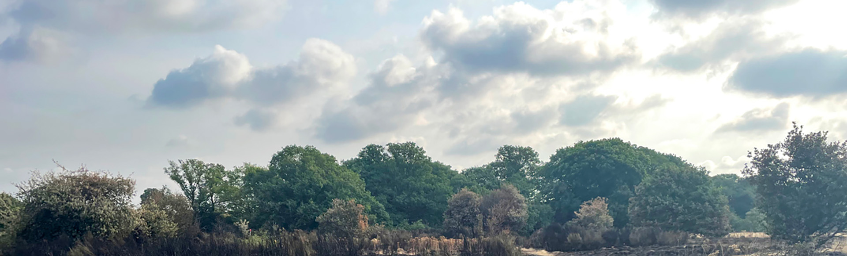

# The climate of the British Isles

This section is authored by our Expert Panel on Natural Hazards – Sub-Panel on Meteorological and Coastal Flood Hazards.

## Current state of the climate

1. The British Isles has a temperate maritime climate, designated as Cfb on the Köppen classification (for example, refs. [2] [3]): temperate climate (C), with no dry season (f) and a warm summer (b). These are typical of west coasts at high middle latitudes and at the edges of continents. Summers tend to be warm and winters mild. All seasons are generally wet, although there is considerable variability at a range of scales from weekly to decadal.

### Extreme heat

1. The impact of climate change can be seen in the British climate, and this is most clearly observed in the record of extreme heat. For instance, the western Europe heatwave of August 2003 produced a record temperature of 38.5 °C, recorded at Faversham, Kent on 10 August 2003 (ref. [4]). This was broken in 2019 at 38.7 °C in Cambridge, England, and in many places in July 2022 (ref. [5]) with a record temperature on 19 July 2022 of 40.3 °C in [Coningsby](https://en.wikipedia.org/wiki/Coningsby), England. These heatwaves caused substantial disruption of transport and numerous wildfires (ref. [5]).

### Extreme rainfall

1. Climate change impacts on the British climate are also observed for extreme rainfall. Most daily extremes of rainfall above 150mm in the British Isles occur in the summer months, probably associated with extreme convective rainfalls. A secondary peak occurs in November and December, probably associated with extreme cyclonic conditions (refs. [6] [7]). For example, in summer 1989, the Halifax convective storm produced 193 mm in less than two hours (ref. [8]). This was associated with a combination of strong urban heat island and sea-breeze convergence (ref. [9]) and could be taken as an indication of possible precipitation events in a warming climate. However, the lack of long-term instrumental records makes it difficult to determine the cause with confidence.

### Extreme sea levels

1. Extreme sea levels around the coast of the UK are typically caused by combinations of high astronomical tides and storms surges and waves, driven by severe weather events (ref. [10]). Extra-tropical cyclones, often called ‘mid-latitude depressions’, are the main weather systems impacting the UK, and can generate storm surges which increase sea levels by several metres, with levels being further elevated by short period wind waves and wave setup.
2. The UK has a long history of severe coastal flooding caused by extreme sea levels (ref. [11]). For example, in 1607 a major coastal flood on the west coast caused the deaths of around 2,000 people and more than 300 people were killed people in eastern England during the coastal flood of 31 January–1 February 1953. More recently, over the winter of 2013/14, the UK experienced an unusual sequence of storms and some of the most significant coastal floods in the last 60 years with £1.2 billion in damages.
3. Around the coast of the UK, extreme sea levels have increased over the last ~150 years, and as a result, extreme sea levels that previously had a long return period (>100 years) near the beginning of the 20th century now have much lower (∼10 year) return periods (ref. [11]). The scientific consensus is that the observed increase in extreme sea levels is primarily driven by climate change induced increases in mean sea level, with little evidence for long-term systematic changes in storminess or storm surge magnitude over the last 100 years above natural variability (ref. [11]), although a recent paper challenges this view (ref. [12]).

## Future climate of the British Isles

1. Appendix 1 of this report provides further information on the future climate of the British Isles including:

* reasonably foreseeable changes to the UK climate;
* climate predictions for 50+ and 100+ years;
* tipping points; and
* UK climate extremes.



# Self-Assessment Questionnaire

## Issue of the self-assessment questionnaire

1. The self-assessment questionnaire was issued to fourteen dutyholders for thirty two sites in June 2023 (Appendix 2):

* AWE plc (for AWE Aldermaston and AWE Burghfield);
* BAE Systems Marine Ltd (for Devonshire Dock Complex at Barrow-in-Furness);
* Devonport Royal Dockyard Limited (for His Majesty’s Naval Base (HMNB) Devonport);
* EDF Energy Nuclear Generation Ltd (for Dungeness B, Hartlepool, Heysham 1, Heysham 2, Hinkley Point B, Hunterston B, Sizewell B and Torness);
* NNB Generation Company (HPC) Limited (for Hinkley Point C);
* Nuclear Restoration Services Limited [Magnox Limited at the time of the questionnaire] (for Berkeley, Bradwell, Chapelcross, Dounreay, Dungeness A, Harwell, Hinkley Point A, Hunterston A, Oldbury, Sizewell A, Trawsfynydd, Winfrith and Wyfla);
* Nuclear Waste Services Limited [Low Level Waste Repository Limited at the time of the questionnaire] (for Low Level Waste Repository (LLWR));
* Rolls-Royce Submarines Ltd (for Neptune Reactor Raynesway and Nuclear Fuel Production Plant Raynesway);
* Rosyth Royal Dockyard Ltd (for Rosyth Royal Dockyard);
* Sellafield Limited (for Sellafield);
* Sizewell C Ltd [Sizewell C was a prospective licensee at the time of the questionnaire];
* Springfields Fuels Limited (for Springfields site); and
* Urenco UK Ltd (for Capenhurst site).

1. The intent was for participants to provide information on their arrangements and resilience in relation to climate change effects. All parties responded to ONR within the requested timeframes by the end of October 2023.
2. Three licensees were not requested to participate in the CNI themed inspection on climate change given the limited nature of activities and the lower radiological risk at their sites. These licensees were Inutec Ltd, Cyclife UK Ltd and GE Healthcare Amersham. At the time, Rolls Royce SMR Ltd was the sole requesting party to the GDA process and opted not to participate, given the early stage in the GDA process.

## Review and findings of the self-assessment questionnaire responses

1. We reviewed the responses to the self-assessment questionnaire in the latter part of 2023. The review was conducted by our external hazards specialist inspectors against standardised criteria.
2. An internal workshop was held during December 2023 to:

* Ensure that a consistent approach had been taken to the review of self-assessment questionnaires.
* Identify cross-cutting themes or findings.
* Agree the sites selected for site-based regulatory inspections in 2024.
* Agree next steps and actions for future stages of the site-based regulatory inspections, including how tasks would be divided between the team.

1. The sites selected for the site-based inspection are identified in Section ‎4.1.
2. Charts consolidating responses to key questions 1.1, 1.2, 1.6 and 1.7 from the self-assessment questionnaire are provided by Figure 1.
3. The cross-cutting themes and findings identified from the licensee self-assessment question responses are outlined in Appendix 3 – Findings identified from the self-assessment questionnaire responses.

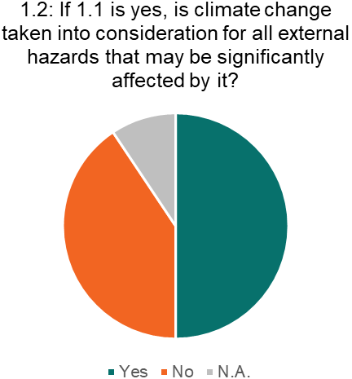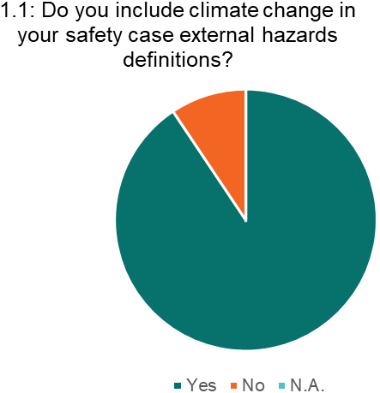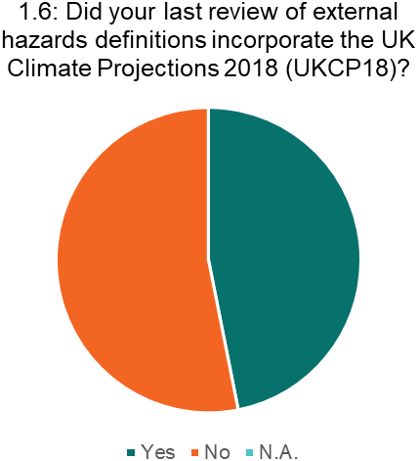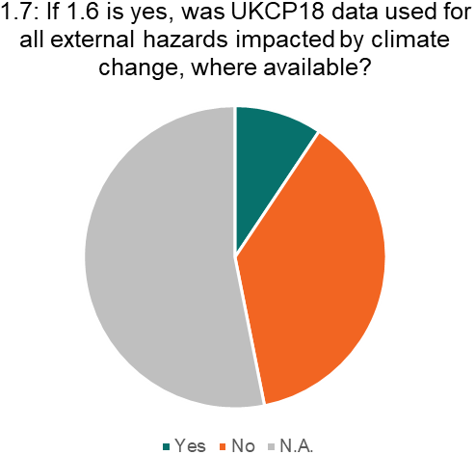

Figure 1 – Charts consolidating responses to the self-assessment questionnaire

## Conclusions from the self-assessment questionnaire

1. The following conclusions are drawn from the self-assessment questionnaire:

* The majority of dutyholders include climate change in safety case external hazards definitions.
* Only half of those who are considering climate change in safety case external hazards definitions are considering it for all external hazards that may be significantly affected by it. The hazards for which climate change is most commonly considered are high air temperature, external flooding and wind.
* Less than half of dutyholders have incorporated the UK Climate Projections 2018 (UKCP18) as part of their most recent review of external hazards definitions.
* A minority of dutyholders (less than 10 %) have used UKCP18 data for all external hazards impacted by climate change.
* Long term modelling software is commonly used across the GB nuclear industry to inform activities and understand the range of potential future scenarios.
* Forecasting software is commonly used across the GB nuclear industry to inform short term operator activities in response to events.
* There were significant ongoing work programmes across the GB nuclear industry to incorporate more recent climate change information at the time of the CNI themed inspection on climate change.
* There is some confusion regarding terminology such as ‘managed adaptive approach’, ‘trigger points’ and ‘credible maximum scenarios’ and how these terms are applied.

1. We found that progress is being made by the nuclear industry in relation to climate change. However, there remains work for dutyholders to include climate change in safety case external hazards definitions for all external hazards that may be significantly affected by it. This should include consideration of current scientific data for climate change, such as UKCP18. Section 7 of this report outlines our overall findings from the CNI themed inspection on climate change.

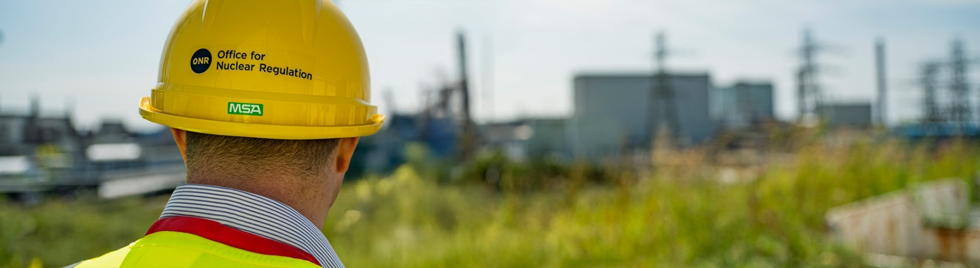

# Site-based inspections

## Sites selected for inspection and inspection scope

1. The sites selected for inspection were informed by the content of the self-assessment questionnaires. The sites were selected based on the nuclear safety risks, operational lifetimes, to provide a representative sample of different facilities across the GB nuclear industry, and the level of existing external hazards engagement with ourselves.
2. Five site-based inspections were undertaken between June-October 2024 at the following sites, which includes operating sites from both civil and defence sectors as well as sites that are being decommissioned and remediated:

* Aldermaston, Atomic Weapons Establishment (AWE Plc)
* Heysham 2, EDF Energy Nuclear Generation Limited (EDF NGL)
* Sizewell B, EDF NGL
* Sellafield, Sellafield Limited
* Dounreay, Nuclear Restoration Services Limited

1. The aim of the site-based inspections was to provide greater insight into how licensees are managing climate change effects and associated risks, as well as identifying learning for both industry and ourselves. The inspections examined the effectiveness by which sites implement the arrangements described in safety cases, and the extent to which these arrangements align with relevant good practice.
2. A consistent agenda was developed for the five site-based inspections. Two external hazards were sampled at each site. These were selected based on our understanding of those external hazards that pose the greatest challenge to the site. Two site-specific focus areas were identified, based on the responses to the self-assessment questionnaires. These included topics where there was potential learning for us and industry.
3. The dutyholders’ internal regulators attended all five inspections.

## Inspection approach

1. The site-based inspection objectives were for ONR to:

* Understand how climate change is being considered in safety case external hazards definitions, including for the:
  + design basis; and
  + beyond the design basis, including cliff edge effects.
* Understand how licensees are incorporating current scientific data for climate change, such as UKCP18, into hazard definitions and safety cases.
* Understand how resilient the site is to the current and future impacts of climate change.
* Understand planned future work on climate change, including:
  + updating external hazard definitions to include relevant good practice;
  + identification and implementation of reasonably practicable improvements or modifications; and
  + identification and implementation of a managed adaptive approach for future site resilience, and associated trigger points for implementation of options.
* Identify areas of good practice and learning across the industry.

1. As a themed inspection, we formed an overarching judgement from each site-based inspection as to whether our regulatory expectations in relation to climate change had:

* been met;
* been partially met and/or there are plans in place to ensure that they are met; or
* not been met and there are no current plans in place to ensure that they are met.

1. This judgement took account of the following regulatory guidance:

* ONR Safety Assessment Principles (SAPs) (ref. [13]).
* ONR External Hazards Technical Assessment Guide (NS-TAST-GD-013) (ref. [14]).
* Use of UKCP18 Position Statement, Revision 2 (ref. [15]).
* Principles for Flood and Coastal Erosion Risk Management, Revision 2 (ref. [16]).
* ONR General Inspection Guide (ONR-INSP-GD-064) (ref. [17]).

1. Our judgement from the five site-based inspections are summarised below and in Figure 2:

* Our expectations were met by AWE Aldermaston.
* Our expectations were partially met with plans in place to ensure that they are met by Dounreay, Heysham 2, Sellafield and Sizewell B.

Figure 2 – Summary of ONR judgements from site-based inspection phase

## Learning points from site-based inspections

1. Learning points from the inspections are captured as ‘Good Practices’ or ‘Constructive’ learning points (see Appendix 4 – Learning points identified from the site-based inspection phase). The learning points include learning for industry as well as us.

## Conclusions from inspection phase

1. The site-based inspection phase demonstrated that across many sites, work is in progress to understand the impacts of information such as UKCP18 as well as developing modelling tools and techniques. However, the implementation of this information into hazard definitions and safety cases is not complete. This has informed the CNI themed inspection on climate change findings and our future regulatory strategy, which is discussed further in Section ‎6 of this report.
2. For those sites that received a judgement of ‘partially met’, we did not identify any fundamental shortfalls that would indicate sites are not currently robust against external hazards. We are satisfied that there are no immediate concerns regarding the impact of climate change and the continued safety of sites.
3. Seven themes that require future focus and improvement were identified, which are presented in this report. We intend to undertake follow-up regulatory activities in the next two years to monitor progress and implementation of updated climate information into hazard definitions and safety cases.



# Environment Agency summary

## Environment Agency involvement

1. The Environment Agency welcomes the opportunity to support the CNI themed inspection on this increasingly important aspect of nuclear sector planning and operation. To contribute, Environment Agency staff joined the inspections at Sizewell B, Heysham 2, Sellafield, and Aldermaston, demonstrating alignment between the two organisations joint expectations for managing climate change impacts and risks. The inspections allowed the Environment Agency to gain insight into how the nuclear industry is managing climate change risks and impacts, and to identify learning for both the industry and regulators. This included consideration of environmental permit and other requirements, as well as the identification of good practice.
2. In addition to the ONR objectives listed in paragraph ‎26, many of which the Environment Agency share, specific objectives for the Environment Agency included:

* Review climate change risk assessments and the operators’ management of the risks that climate change poses to permit compliance.
* Assess the effectiveness of site arrangements for climate change risk management and alignment with good practice.
* Consider potential system effects, for example escalating off-site infrastructure risks.
* Gather information to inform future regulatory development and approaches and determine the next steps for guidance on best practices for climate change adaptation and resilience.

## Summary of key findings

1. The Environment Agency agrees with the learning points presented in Appendices 3 and 4 of this report and identified some additional areas for further development. These included consideration of groundwater flooding and saline incursion, the sharing of information within and across organisations, and consensus on common terminology.
2. The inspections gave the Environment Agency confidence that, in general, the risks of climate change are being appropriately considered, and that there are no immediate threats to environmental permit compliance at the sites inspected. The Environment Agency saw evidence of the latest climate change projections (UKCP18) being used, and the expectations of the joint regulatory guidance being partially met (refs. [15] [16]) (see Section ‎‎4).

## Learning for the Environment Agency and next steps

1. These inspections focused on hazards analysis and resilience to extreme climate events which could have consequences for people and the environment. The Environment Agency is also focused on the potential chronic impacts of climate change, which may have longer-term or cumulative impacts on operation and subsequently the environment, and the ability of operators to comply with the conditions of environmental permits.
2. The inspections highlighted the importance of embedding climate change adaptation into safety and environmental management systems. This is especially relevant given recent changes to ISO management system standards to include climate action requirements (ref. [18]). Long-term planning and anticipation of critical thresholds are key, particularly when significant investments are involved, using adaptation pathway standards (refs. [19] [20]). This ensures assessments consider implications of cascading, concurrent and sequential compounding risks, in addition to individual climate impacts.
3. The challenges of climate change and its impact on safety and environmental protection are shared across wider industry. Nuclear operators can therefore benefit from good practices from other industries and draw upon wider experience and guidance.
4. Environment Agency guidance on climate change risk assessment and adaptation planning is available for environmental permit holders (ref. [21]) and also provides a climate impacts tool (ref. [22]) and non-nuclear industry sector examples of risk assessments (ref. [23]). Some nuclear licensed sites are covered under the Control of Major Accident Hazards (COMAH) Regulations for which guidance on climate change adaptation is also available (ref. [24]). Additionally, operators should make use of updated data available from the Environment Agency in NAFRA2 (Risks of Flooding from Rivers, Seas; and Surface Water) which includes current and future flood risk and the potential impact of climate change on flood risk; and the National Coastal Erosion Risk Map (NCERM) (ref. [25]).
5. The Environment Agency Chief Regulator’s report 2023-24 (ref. [26]) highlights the importance of managing climate change stating that ‘… many businesses are thinking about their resilience to climate change. Yet we continue to see increasing threats from the impacts of climate change to those we regulate. There is an urgent need for them to build resilience to climate driven weather extremes. It is becoming more difficult for sites to prevent and mitigate accidents and comply with the environmental and safety legislation we regulate. We will continue our informing and enabling approach to adaptation aspects of our regulatory activities. I want to support businesses by carrying out adaptation focused inspections and audits.’
6. In line with the Chief Regulator’s intention, the Environment Agency aims to continue a range of activities:

* Continue working with ONR including further development of joint guidance; participation in expert panels, sharing learning and findings; and conducting further joint inspections where appropriate.
* Seek evidence that climate change adaptation is integrated into operator management systems, and relevant aspects such as the Site Wide Environmental Safety Cases and Waste Management Plans.
* Ensure that regulatory guidance is properly considered by operators.
* Ensure that operators identify key risks and impacts of acute and chronic climate change, for example, higher average temperature, higher average rainfall, more frequent extreme events related to temperatures, rainfall and water availability, on site infrastructure, services and systems, as well as on site waste generation.
* Aim to align guidance for nuclear operators with guidance available for other sectors, updating guidance to nuclear operators on climate change adaptation integration into management systems.
* Collaborate with industry and professional organisations to identify skills and capability requirements and look to develop a training framework for climate change adaptation management. The aim of this, is to strengthen adaptive capacity within the nuclear and other high hazard sectors.
* Continue to apply and further develop, an integrated approach to the regulation of climate change adaptation and resilience drawing upon expertise and disciplines from across the Environment Agency and beyond.



# Findings and forward actions

1. The CNI themed inspection on climate change has carefully considered learning from the different inspection phases. We have identified an overarching key finding and seven themes.

## Key finding

***CNI themed inspection on climate change – key finding***

*Industry is making progress in relation to ensuring climate change effects are understood and mitigated against. We did not identify any fundamental shortfalls that would indicate sites are not currently robust against external hazards. However, there remains work for dutyholders to implement adequate arrangements to ensure sites remain resilient against future effects of climate change in the medium and long-term.*

1. The CNI themed inspection on climate change did not identify any fundamental issues in relation to the current safety of nuclear sites against external hazards. The key finding recognises that work is ongoing in relation to climate change, with workstreams identified and created by dutyholders in recent years to address climate change. Some dutyholders were meeting our expectations. However, more broadly, we identified that there is work still required by industry to ensure sites remain resilient against the future effects of climate change effects in the medium and long-term. This is explored in more detail within the identified themes arising from the inspection.

## Themes

1. The seven themes arising from the CNI themed inspection on climate change are:

* Theme 1 – Review and monitoring of data, risks and trends.
* Theme 2 – Update and implementation of dutyholders’ guidance, external hazards analysis and safety cases, including periodicity.
* Theme 3 – Periodic safety review frequency, scope and effectiveness.
* Theme 4 – Ownership, responsibilities and arrangements in relation to climate change.
* Theme 5 – Plant improvements and mitigation measures, including use of the managed adaptive approach.
* Theme 6 – Risk informed approach to understanding the potential effects and consequences of climate change on plant.
* Theme 7 – Future regulatory activities in relation to climate change.

1. These themes support the key finding. For each theme we have summarised current industry practice and reaffirmed our expectations for industry. The summary of current industry practice is based on the findings and learning identified from both the self-assessment questionnaires and site-based inspections. The summary provides a broad insight into industry’s current approach and does not reflect the approach taken by individual licensees.

### Theme 1 – Review and monitoring of data, risks and trends

#### Current industry practice

1. Many dutyholders monitor external hazards for operations (for example, real time high air temperature) and use operational data and climate projections in models, such as site flooding models, to understand the effects of external hazards. However, the longer-term review and monitoring of non-stationary external hazards data and the identification of risks and trends is not being effectively carried out by the whole of the industry, and/or is not being fed into nuclear safety cases (see Theme 2).

#### Expectation for industry

1. Dutyholders should ensure that they have adequate monitoring arrangements for non-stationary external hazards. Data collected via monitoring equipment should be reviewed, along with data from other sources, at appropriate periodicities to identify trends and potential risks. This information should inform relevant nuclear safety cases.

### Theme 2 – Update and implementation of dutyholders’ guidance, external hazards analysis and safety cases, including periodicity

#### Current industry practice

1. We identified that dutyholders are not all updating and implementing their own internal guidance on external hazards affected by climate change effectively and at appropriate periodicities. Similarly, relevant safety cases are not always being updated to take account of recent external hazards data and modelling (Theme 1). This means it is not always clear how climate change effects are being managed.

#### Expectation for industry

1. Dutyholders should ensure that they have adequate guidance relating to climate change and the external hazards affected by it, which is implemented effectively and reviewed at appropriate periodicities. Dutyholders should also ensure that they update analyses for external hazards affected by climate change at appropriate periodicities and ensure that this is adequately incorporated into their nuclear safety cases. Dutyholders should demonstrate that the effects of climate change are understood and risks mitigated against.

### Theme 3 – Periodic safety review frequency, scope and effectiveness

#### Current industry practice

1. We identified that many dutyholders’ approach to periodic safety reviews is limited for external hazards and climate change. Many periodic safety reviews have not used recent climate change models and recent non-stationary external hazards data to inform these reviews. Where licensees have conducted more effective periodic safety reviews, their arrangements require more frequent reviews of external hazards assessments (such as a 3-year periodicity) with these assessments and safety case updates informing the periodic safety review.

#### Expectation for industry

1. Licence Condition (LC) 15 requires licensees to make and implement adequate arrangements for the periodic and systematic review and reassessment of safety cases. Periodic safety reviews are intended to demonstrate that facilities are safe to operate now and in the future. With respect to climate change and external hazards, dutyholders’ arrangements should require a review of sufficient scope for external hazards. Climate change effects for the rest of the facility lifetime, including decommissioning, should be considered within periodic safety reviews. Arrangements should be appropriately implemented to ensure that the effects of climate change and any risks to facilities are adequately understood and mitigated against, through the use of recent non-stationary external hazards data and climate models (for example, Themes 1 and 2). Any modifications to facilities identified through the periodic safety review process should be implemented in a timely manner.

### Theme 4 – Ownership, responsibilities and arrangements in relation to climate change

#### Current industry practice

1. We identified examples of individuals and groups within dutyholder organisations taking ownership and responsibility for ensuring the effects of climate change are understood and mitigated against. However, our inspections highlighted that the arrangements relating to climate change are not always mature, in particular clear ownership, responsibility and interfaces. For example, in some instances environmental and sustainability work could support nuclear safety cases, but appropriate interface arrangements are needed.

#### Expectation for industry

1. Dutyholders’ climate change related arrangements should have appropriate owners and clear responsibilities defined, to ensure that the effects of climate change that may impact nuclear safety are being identified and adequately mitigated against. Where practicable, dutyholders should seek to maximise the use of climate change work across their various legal duties (see Theme 7).

### Theme 5 – Plant improvements and mitigation measures, including use of the managed adaptive approach

#### Current industry practice

1. We identified examples of dutyholders implementing plant improvements based on an updated understanding of external hazards. Dutyholders also routinely identify operator actions when certain external hazards thresholds are reached during operation. These include, pre and post-event inspections or suspending operations when a temperature limit is reached. We have also observed the managed adaptive approach being effectively utilised. For example, the provision of additional space to allow potential installation of further heating, ventilation and air conditioning equipment. However, based on the self-assessment questionnaire responses, not all dutyholders currently utilise a managed adaptive approach and/or there is limited information on potential plant improvements. Some dutyholders are starting to consider trigger points in relation to climate change, but the arrangements for those are not yet mature or being included in safety cases.

#### Expectation for industry

1. Dutyholders should utilise a managed adaptive approach, where appropriate. Plant improvements and mitigative measures should be implemented when trigger points are met, and/or analysis of non-stationary external hazards and climate change modelling identifies plant challenges which will occur in the future. Implementation of these measures should be conducted ahead of climate change effects challenging a facility, ensuring that risks remain as low as reasonably practicable (ALARP).

### Theme 6 – Risk informed approach to understanding the potential effects and consequences of climate change on plant

#### Current industry practice

1. We identified examples where dutyholders are making decisions based on the risks associated with climate change effects and the potential consequences. However, based on the self-assessment questionnaire responses and the inspection findings, dutyholders need to clearly understand their facilities’ resilience to the medium and long term effects of climate change.

#### Expectation for industry

1. Dutyholders should have a clear understanding of the risks posed to their facilities by climate change, plant resilience to those risks, and any potential consequences, to inform decisions.

### Theme 7 – Future regulatory activities in relation to climate change

1. Theme 7 is an internally focused theme for us to consider.

#### CNI themed inspection on climate change practice

1. The CNI themed inspection on climate change has involved joint working between ourselves, the environmental regulators and DNSR. The inspection has identified areas of future work for us and potential future joint regulatory activities and collaboration. These are detailed further in Section ‎6.3 below.

#### Expectation for ONR

1. We should review our regulatory guidance for external hazards and climate change to incorporate learning from this CNI themed inspection. We should ensure that we continue working with fellow regulators.

## Forward work

1. The CNI has written to dutyholders describing the work undertaken, our key finding and themes, and our intended follow-up activities.

***CNI themed inspection on climate change – key forward work***

*Risk-informed and targeted regulatory activities relating to climate change will be undertaken to ensure that dutyholders are proactively taking responsibility and ensuring their sites are resilient against the effects of climate change. We will work with industry to ensure this is done efficiently and effectively, but we will take appropriate enforcement action where dutyholders do not meet our regulatory expectations.*

1. The key forward work identified will allow us to ensure progress in the necessary areas, holding industry to account on its progress against the themes and expectations outlined above.
2. Dutyholders should consider themes 1-6 and address any reasonably practicable gaps in a timely manner.
3. The progress on themes 1-6 will be sampled by us through risk-informed and targeted regulatory activities. Follow-up activities are planned over the next two years at the four ‘partially met’ sites within the CNI themed inspection on climate change, to ensure licensees’ plans are being implemented and arrangements are maturing.
4. We have already begun specific engagements with some dutyholders to follow-up on the responses to the self-assessment questionnaire; see Section 6.4 for further details.
5. The forward work proposed for Theme 7 will include:

* Review of joint regulatory guidance relevant to climate change with the environment agencies and other relevant stakeholders.
* Review of our existing regulatory guidance relevant to external hazards and climate change, including clarification of terminology and review of the Safety Assessment Principles (SAPs) and relevant Technical Assessment Guides (TAGs).
* Identification of appropriate research opportunities to address gaps in understanding and knowledge to support ongoing regulatory decisions and to gain a greater understanding of emerging topics and how they may impact the GB nuclear industry.
* Regular review of climate change studies and data, with input from our Expert Panel on Natural Hazards, the output of which will be published on ONR’s website.
* Working with other regulators to ensure alignment on strategy, where appropriate, and enabling dutyholders to take credit for relevant work undertaken for different purposes/different regulators.
* Engaging with a range of national and international stakeholders from the nuclear industry and other sectors to share learning and good practices.
* Influencing enhancements to codes and standards.

## Further engagement with sites not selected for the site-based inspections

1. Further specific engagements were arranged with Urenco UK Limited, Nuclear Restoration Services (NRS) Corporate and Westinghouse Springfields Limited, following their responses to the self-assessment questionnaire, recognising our relatively limited external hazards engagement with them to date.
2. These engagements focused on our expectations for external hazards and consideration of climate change, and the dutyholders’ consideration of climate change since the self-assessment questionnaire. We found that work is ongoing or has recently been undertaken to update external hazards guidance and understand the impacts of recent climate information on hazard analyses. The implementation of the updated external hazards arrangements will be through periodic safety reviews, which we will sample through future risk-informed and targeted regulatory activities.

### Nuclear Waste Services’ (NWS) Low Level Waste Repository (LLWR)

1. We are working with the Environment Agency regarding NWS’s approach to climate change on the LLWR site. We regulate operations on site until waste is disposed into the vaults. The Environment Agency is responsible for waste once disposed. Climate change is considered in the Environmental Safety Case, which covers performance of the repository in the long-term, including post delicensing. NWS is updating its Environmental Safety Case and this will be assessed by the Environment Agency once produced. We will continue engaging with the Environment Agency to ensure we remain aligned and regulate the site activities in a risk-informed and proportionate manner.

## Summary

1. We have engaged widely with new build sites on the effects of climate change during design assessment, licensing and construction. This is important given that these sites will be operational when the impacts of climate change are more fully realised. The CNI themed inspection on climate change has provided us with the opportunity to look across the GB nuclear industry, to understand how it is accounting for climate change effects.
2. The CNI themed inspection on climate change has not identified any fundamental issues in relation to the current safety of nuclear sites against external hazards. Whilst the effects of climate change are being realised, the challenges to sites are considered manageable but dutyholders should take the necessary steps to address future gaps to expectations in a timely manner. This is due to the longer timescales associated with significant climate change. We will continue undertake risk-informed and targeted regulatory activities in relation to climate change. We will hold industry to account through the identified forward work, ensuring that the GB nuclear industry remains safe and protected against the future effects of climate change.
3. ONR will ensure its regulation of external hazards is kept under regular review, so that it accounts for the latest understanding of the impacts of climate change. We will also ensure we work proactively with the nuclear industry to ensure it is aware, and takes account of up to date climate change projections in its safety cases and physical measures on their nuclear licensed sites.

# Conclusions

1. The aim of this inspection was to seek assurance that the nuclear industry within GB:

* Understands and has taken account of recent climate change projections in relevant safety cases and hazard definitions.
* Is able to demonstrate that activities are and will remain safe and secure in the future subject to the reasonably foreseeable effects of climate change.
* Has effective arrangements to monitor and review climate change information to determine if additional measures are needed to ensure that activities remain protected in the future.

1. The CNI themed inspection on climate change did not identify any fundamental issues in relation to current safety of nuclear sites against external hazards. The key finding recognises that work is ongoing in relation to climate change, with workstreams identified and created by dutyholders in recent years to address climate change. Some dutyholders have been found to meet our expectations. More broadly, however, we identified that there is work still required by industry to ensure sites remain resilient against the future effects of climate change in the medium and long-term.
2. Following this inspection, we will continue to undertake risk-informed and targeted regulatory activities relating to climate change to ensure that dutyholders are proactively taking responsibility for ensuring their sites are resilient against the effects of climate change.
3. The key forward work identified through Themes 1-6 in Section 6 of this report will allow us to hold industry to account on its progress to ensure sites remain resilient against the future effects of climate change in the medium and long-term.

# References

|  |  |
| --- | --- |
| [1] | ONR, “ONR’s response to the fourth round of climate adaptation reporting in accordance with the Adaptation Reporting Power (ARP),” 2024. |
| [2] | Peel, M.C., Finlayson, B.L. and McMahon, T.A., “Updated world map of the Köppen-Geiger climate classification,” *Hydrology and earth system sciences,* vol. 11(5), pp. 1633-1644, 2007. |
| [3] | Cui, D., Liang, S. and Wang, D., “Observed and projected changes in global climate zones based on Köppen climate classification,” *Wiley Interdisciplinary Reviews: Climate Change,* vol. 12(3), p.e. 701, 2021. |
| [4] | UK Met Office, “UKCP18 Derived Projections of future climate over the UK,” 2018. |
| [5] | Kendon, M., “Unprecedented extreme heatwave. Met Office post-event report.,” 2022. |
| [6] | Rodda, J., Little, M., Rodda, H. et al., “A Comparative Study of the Magnitude, Frequency and Distribution of Intense Rainfall in the United Kingdom,” *Nature Precedings,* 2009. |
| [7] | Rodda, H.J., Little, M.A., Wood, R.G., MacDougall, N. and McSharry, P.E., “A digital archive of extreme rainfalls in the British Isles from 1866 to 1968 based on British Rainfall,” *Weather,* vol. 64(3), pp. 71-75, 2009. |
| [8] | Acreman, M., “Extreme rainfall in Calderdale, 19 May 1989,” *Weather,* vol. 44(11), pp. 438-446, 1989. |
| [9] | Thielen, J. and Gadian, A., “Influence of topography and urban heat island effects on the outbreak of convective storms under unstable meteorological conditions: a numerical study,” *Meteorological Applications,* vol. 4(2), pp. 139-149, 1997. |
| [10] | Horsburgh, K., Rennie, A. and Palmer, M., “Impacts of climate change on sea-level rise relevant to coastal and marine environment around the UK,” *MCCIP Science Review,* pp. 116-131, 2020. |
| [11] | Haigh, I.D., Dornbusch, U., Brown, J., Lyddon, C., Nicholls, R.J., Penning-Roswell, E. and Sayers, P., “Climate change impacts on coastal flooding relevant to the UK and Ireland.,” *MCCIP Science Review 2022,* pp. 1-18. |
| [12] | Calafat, F.M., Wahl, T., Tadesse, M.G. and Sparrow, S.N., “Trends in Europe storm surge extremes match the rate of sea-level rise,” *Nature,* vol. 603(7903), pp. 841-845, 2022. |
| [13] | ONR, “Safety Assessment Principles (SAPs) for Nuclear Facilities - 2014 Edition (Revision 1),” 2020. |
| [14] | ONR, “NS-TAST-GD-013 - External Hazards Technical Assessment Guide,” 2023. |
| [15] | ONR, Environment Agency, Natural Resources Wales and Scottish Environment Protection Agency, “ Use of UK Climate Projections 2018 (UKCP18) Position Statement (Revision 2),” 2022. |
| [16] | ONR and Environment Agency, “Principles for Flood and Coastal Erosion Risk Management (Revision 2),” 2022. |
| [17] | ONR, “ONR-INSP-GD-064 - General Inspection Guide,” 2024. |
| [18] | IAF/ISO, “IAF/ISO Joint Communiqué on the addition of Climate Change,” 2024. |
| [19] | British Standards, “BS 8631:2021 Adaptation to climate change. Using adaptation pathways for decision making,” 2021. |
| [20] | ISO, “ISO 14090:2019. Adaptation to climate change — Principles, requirements and guidelines. Edition 1,” 2019. |
| [21] | Environment Agency, “Climate change: risk assessment and adaptation planning in your management system,” 2023. |
| [22] | Environment Agency, “Climate impacts tool,” 2023. |
| [23] | Environment Agency, “Adapting to climate change: industry sector examples for your risk assessment,” 2023. |
| [24] | Chemical and Downstream Oil Industries Forum (CDOIF), “Guideline - Adapting to Climate Change,” 2023. |
| [25] | Environment Agency, “New national flood and coastal erosion risk information,” 2025. |
| [26] | Environment Agency, “Environment Agency Chief Regulator’s report 2023-24,” 2025. |
| [27] | ONR Expert Panel on Natural Hazards, Sub-Panel on Meteorological and Coastal Flood Hazards, “Technical Report for ONR-RRR-115: Tipping Points in the Climate System,” 2024. |
| [28] | Hawkins E. and Sutton R., “The potential to narrow uncertainty in regional climate predictions,” *Bulletin American Meteorological Society,* vol. 90, pp. 1095-4407, 2009. |
| [29] | UK Climate Change Risk Assessment 2, 2017. |
| [30] | UK Climate Change Risk Assessment 3, 2022. |
| [31] | Thompson, V., Dunstone, N.J., Scaife, A.A., Smith, D.M., Slingo, J.M., Brown, S. and Belcher, S.E., “High risk of unprecedented UK rainfall in the current climate,” *Nature Communications,* vol. 8(1), pp. 1-6, 2017. |
| [32] | Palmer, M., Howard, T., Tinker, J., Lowe. J., Bricheno, L., Calvert, D., Edwards, T., Gregory, J., Harris, G., Krijnen, J., Pickering, M., Roberts, C. and Wolf, J., “UKCP18 Marine Report,” 2018. |
| [33] | Fox-Kemper, B., Hewitt, H.T., Xiao, C., Aðalgeirsdóttir, G., Drijfhout, S.S., Edwards, T.L., Golledge, N.R., Hemer, M., Kopp, R.E., Krinner, G., Mix, A., Notz, D., Nowicki, S., Nurhati, I.S., Ruiz, L., Sallée, J-B., Slangen, A.B.A. and Yu., Y., “Chapter 9 - Ocean, Cryosphere and Sea Level Change,” *Contribution of Working Group 1 to the Sixth Assessment Report of the Intergovernmental Panel on Climate Change,* 2021. |
| [34] | Weeks, J.H., Fung, F., Harrison, B.J. and Palmer, M.D., “The evolution of UK sea-level projections,” *Environmental Research Communications,* vol. 5(3), p. 032001, 2023. |
| [35] | Shepherd, T.G., Boyd, E., Calel, R.A., et. al., “Storylines: an alternative approach to representing uncertainty in physical aspects of climate change,” *Climate Change,* no. 151, pp. 555-571, 2018. |
| [36] | Palmer, M.D., Harrison, B.J., Gregory, J.M., Hewitt, H.T., Lowe, J.A. and Weeks, J.H., “A framework for physically consistent storylines of UK future mean sea level rise,” *Climatic Change,* vol. 177(106), pp. 1-24, 2024. |
| [37] | Easterling, D.R., Kunkel, K.E., Crimmins, A.R. and Wehner, M.F. , “Long-term planning requires climate projections beyond 2100,” *Nature Climate Change,* pp. 1-2, 2024. |
| [38] | UK Met Office, “Exploratory sea level projections for the UK to 2300,” 2019. |
| [39] | Hansen, J., Sato, M., Hearty, P., Ruedy, R., Kelley, M., Masson-Delmotte, V., Russell, G., Tselioudis, G., Cao, J., Rignot, E., Velicogna, I., Tormey, B., Donovan, B., Kandiano, E., von Schuckmann, K., Kharecha, P., Legrande, A. N., Bauer, M. and Lo, K-W., “Ice melt, sea level rise and superstorms: evidence from paleoclimate data, climate modeling and modern observations that 2C global warming could be dangerous,” *Atmospheric and Chemical Physics,* vol. 16, pp. 3761-3812, 2016. |
| [40] | Hanlon, H., Palmer, M. and Betts R. A., “Effect of Potential Climate Tipping Points on UK Impacts,” 2021. |
| [41] | Lenton, T.M., Held, H., Kriegler, E., Hall, J.W., Lucht, W., Rahmstorf, S. and Schellnhuber, H.J., “Tipping elements in the Earth's climate system,” *Proceedings of the National Academy of Sciences,* vol. 105(6), pp. 1786-1793, 2008. |
| [42] | Drijfhout, S., Bathiany, S., Beaulieu, C., Brovkin, V., Claussen, M., Huntingford, C., Scheffer, M., Sgubin, G. and Swingedouw, D., “Catalogue of abrupt shifts in Intergovernmental Panel on Climate Change climate models,” *Proceedings of the National Academy of Sciences,* vol. 112(43), pp. E5777-E5786, 2015. |

# Appendix 1 – The future climate of the British Isles

1. Appendix 1 develops on Section 2, focused on the future climate of the British Isles. This section has been authored by our Expert Panel on Natural Hazards – Sub-Panel on Meteorological and Coastal Flood Hazards.

## Reasonably foreseeable changes to the UK climate

1. Assessing future changes in climate is carried out using numerical climate models. These are sophisticated mathematical representations of the complex physical atmospheric processes driving climate, interactions with land and sea, and are forced with emissions scenarios. These scenarios reflect emissions of atmospheric greenhouse gases and are based on plausible economic and political decisions on a range of issues including industrial, land-use and transport policy. Because there is considerable uncertainty in these scenarios, there is similar uncertainty in their climate impact. The latest global emission scenarios are presented in the Intergovernmental Panel on Climate Change (IPCC’s) Sixth Assessment Report and these are known as Shared Socioeconomic Pathways (SSPs). The latest UK climate projections from UKCP18 uses scenarios from IPCC AR5 known as Representative Concentration Pathways (RCPs)[1].
2. Model uncertainty plays a significant role in projection uncertainty at short timescales (over the first few decades of climate projections). At longer timescales (50 – 150 years) the uncertainties associated with greenhouse gas emissions, and feedbacks attached to these dominate. Consequently, until the middle of the century or later, the differences in climate outcomes to different RCPs is quite small, and only becomes significant towards the end of this century even when the scenarios are very different (refs. [27] [28]). All climate models project warming by the end of the century under rising emissions whichever climate scenario is used. Scenarios with the highest atmospheric carbon dioxide concentrations produce the highest global temperature projections.

### Climate predictions 50+ years

1. After about 50 years of model time, we expect model uncertainty to increase. Projections are slightly more dependent on the type of climate model chosen to represent the future climate. However, emission uncertainty becomes the major source of uncertainty. As a result, there are likely to be significant uncertainties in our assessment of the British climate at these timescales. Despite this uncertainty, from the 2050s onwards and under increasingly high emission strategies (in other words, RCP 6.0 or 8.5) clear increases in extreme weather and rising sea levels in the British Isles and globally (ref. [4]) are predicted.

#### Extreme heat

1. Under high emission scenarios (such as RCP 8.5), by 2080, 40 °C temperatures are projected to be exceeded as frequently as 32 °C is exceeded today in the UK and could occur with a return period of 3.5 years by the end of the century. Potentially longer summer dry spells with low wind speeds will occur, presenting more challenging conditions for heating, ventilation and air conditioning (HVAC) equipment. Increasingly frequent and more severe extreme daily high temperatures and Urban Heat Island effects are expected than at present, even though the mean warming could be similar to previous projected increases. The average duration of heatwave periods in which there are more than three days in excess of 25 °C, has increased over time and is projected to continue. Future summers are projected to be even hotter and drier than earlier estimates (for instance in the 2017 Climate Change Risk Assessment 2 report (ref. [29])) for equivalent levels of warming.
2. The recent UK’s 3rd Climate Change Risk Assessment (CCRA3) (ref. [30]) produced risk assessments for the UK based upon a high warming pathway and defined this as the range between the 50th and 95th percentiles in the UKCP18 projections driven by RCP 6.0 emissions. In this, the 50th percentile of the global annual temperature anomaly exceeds 3.5 °C global warming by 2100, and the 95th percentile reaches 4 °C global warming in 2080 and nearly 5 °C in 2100. CCRA3 argues that this might not be the most likely scenario given reductions in current and likely future emissions, but high sensitivities might, conversely, serve to increase this likelihood.

#### Extreme rainfall

1. Rainfall is likely to increase with continued warming in the British Isles. Numerical modelling of current rainfall in England shows that in the next decade or so there is a 34 % probability of an unprecedented winter monthly rainfall total every month in at least one English region (ref. [31]).

#### Extreme sea level

1. Extreme sea levels are very likely to continue to increase in the future, with mean sea level rise being the dominant control (ref. [10]). Projections of changes in mean and extreme sea level for the UK are provided in UKCP18 (ref. [32]). There is high confidence that regional mean sea-level will continue to rise around the UK, and the likely range (90 % confidence) is between 0.27 and 1.12 m by 2100 (excluding vertical land motions). There is low confidence in regional projections of storminess and associated changes in storm surges and waves, and some evidence for smaller changes in tidal range.
2. More recent regional and global sea level projections are available from the latest IPCC Sixth Assessment Report (AR6) (ref. [33]). In general, UKCP18 and AR6 give similar values of projected sea level rise both globally and for UK locations (ref. [34]). Storylines are defined as a physically self-consistent unfolding of plausible future events or pathways (ref. [35]). Recent research presented a range of sea level rise storylines for the UK, including physically plausible high-end storylines (ref. [36]). Under a high-emissions sea level rise scenario, extreme sea level events with a 1 % annual exceedance probability today are likely to occur at least yearly by 2100.
3. In addition to relative sea level rise, coastal flooding will also become even more frequent and challenging to manage because of: (i) ongoing population growth and urban encroachment into flood-prone areas, along with changes in land use and management; (ii) ongoing decline in the extent of natural habitats (for example, coral reefs, mangroves, and saltmarshes) that act as a buffer to flooding; and (iii) ageing assets (ref. [11]).

### Climate predictions 100+ years

1. For timescales beyond 100 years, few model projections have been developed to assess what the climate will be like at these timescales (ref. [37]). A noted exception is sea-level rise projections, which often extend to the year 2150 and for the UK to 2300 (ref. [38]). These use a simplified version of the models used in UKCP18 projections to project a rise of between 1.4 – 4.3 m mean sea level rise for London and Cardiff with the RCP 8.5 scenario, These projections are for mean sea level rise, tides and surge. Projections for Scotland are lower because of isostatic effects.
2. More widely, the IPCC estimates and semi-empirical methods suggest that multi-metre sea level rise is likely by that time given the probable melting of significant parts of the ice sheets by then. However, some research suggests that IPCC might have underestimated the rate of future sea level rise, even by 2100, (ref. [39]). Furthermore, any modelling assumes that continued warming and resulting impacts remain linear; however, changes in feedbacks might be expected and these might push the UK climate into a different state. With these caveats there are a number of rapid climate changes that might be expected to affect the British climate. These have been described as Tipping Points (TP) in a report by the UK Met Office (ref. [40]) as input to the Technical Report of the CCRA3.

## Tipping points

1. TP are thresholds in systems that lead to irreversible changes when the threshold is exceeded. In the context of climate change, TP occur when thresholds in the climate system are exceeded leading to radically different climate states. They are of concern because major shifts in climate would have major impacts on human and ecological systems (ref. [27]). Climate TP are not inevitable but the scientific consensus is that they are increasingly likely as the climate warms (ref. [41]) and several could occur this century even at relatively low amounts of temperature rise (ref. [42]).

## UK climate extremes

1. The likely magnitude and frequency of extreme climate-related events will depend on the amount of warming over the next few decades and century. Climate scenarios are used to assess this warming. The non-linear relationship between extreme events such as wind storms, floods and heatwaves and long-term climate change means that we cannot reasonably forecast such events. However, the physical drivers of climate change will likely increase the magnitude and frequency of extreme events. We should be cautious in assuming that we have sufficient historical and pre-historical data to make assessments of the natural variability of weather events. Without these we cannot distinguish between forced and unforced variability in the climate system, and hence make predictions about future extreme events.

# Appendix 2 – CNI themed inspection on climate change self-assessment questionnaire

This appendix contains the self-assessment questions that dutyholders completed in 2023. The blue text provides guidance on what we expected to be included in the responses and was removed when the questionnaire was completed.

The questionnaire was completed based on the dutyholder’s current position in 2023 and no additional work was expected in order to respond to the questions.

The findings from the self-assessment questionnaire can be found in Appendix 3.

|  |  |  |  |  |
| --- | --- | --- | --- | --- |
| **Self-Assessment Questions** | | | | |
| **1. Climate change consideration and use of RGP** | | | | |
| 1.1 | Do you include climate change in your safety case external hazards definitions? If necessary, use the box below to provide more context. | Yes | No | |
|  |  | |
| Use this box to provide more context, only if required. | | | |
| 1.2 | If your answer to 1.1 is yes, is climate change taken into consideration for all external hazards that may be significantly affected by it? If necessary, use the box below to provide more context. | Yes | No | |
|  |  | |
| Use this box to provide more context, only if required. | | | |
| 1.3 | Please list all external hazards that climate change is considered for. | | | |
| All external hazards for which climate change has been considered should be provided here. | | | |
| 1.4 | Please list all external hazards that climate change is not considered for and why. | | | |
| All external hazards for which climate change has *not* been considered should be provided here. The response should include a *brief* rationale as to why, e.g., hazard not impacted by climate change, no significant effect due to geographical location, etc.  The response should recognise if your approach is likely to change in the future. | | | |
| 1.5 | When was the last review of those external hazards definitions affected by climate change undertaken? | | | |
| The response should make it clear:   * When each external hazard affected by climate change was last reviewed, and whether they were reviewed under the same timescales or different timescales. * Whether the review for each external hazard included consideration of climate change or not. * Why the review was undertaken, e.g. periodic safety review (Licence Condition 15), new scientific information, changes to activities on site, changes to relevant good practice, etc.   Please detail both qualitative and quantitative analyses. | | | |
| 1.6 | Did your last review of external hazards definitions incorporate the UK Climate Projections 2018 (UKCP18)? If necessary, use the box below to provide more context. | Yes | | No |
|  | |  |
| Use this box to provide more context, only if required. | | | |
| 1.7 | If your answer to 1.6 is yes, was UKCP18 data used for all external hazards impacted by climate change, where available? If necessary, use the box below to provide more context. | Yes | | No |
|  | |  |
| Use this box to provide more context, only if required. | | | |
| 1.8 | Which climate change projections were used for each external hazard and what was your rationale for this approach? Please include timescales for which climate change has been considered (e.g. to 2100). | | | |
| The response should clearly identify which climate change projections have been used for each relevant external hazard, this should include the:   * projection(s) * representative concentration pathway [UKCP18], or equivalent for other projections * percentiles used * scale used (e.g. 12km) * timescales for which climate change is considered (e.g. 2050, 2100)   The response should also include a *brief* rationale as to why both the projections and timescales are considered suitable (e.g. latest UK projections, aligned with specific activities, lifetime of facility, etc.).  Please detail both qualitative and quantitative analyses. | | | |
| 1.9 | Please provide any further details on your overarching approach to climate change not captured above. | | | |
| This box provides the opportunity to provide more detail on your approach to climate change.  The following bullet points should be considered:   * Is climate change treated consistently across all relevant external hazards? * Is climate change incorporated into your design basis and/or or provided as a separate allowance? * Is climate change considered over the full lifetime of the facility?   If climate change is not treated consistently across all relevant external hazards, please provide a *brief* rationale for this. | | | |
| 1.10 | When is your next review of external hazards definitions due and will this include the latest UK climate projections? | | | |
| The response should make it clear:   * When each external hazard affected by climate change is next planned to be reviewed. * Whether it is intended that the next review for each of these hazards will include the latest UK climate projections, e.g. UKCP18 or a future equivalent. | | | |
| 1.11 | If not covered by 1.5 or 1.10, how regularly do you review your arrangements with respect to climate change and what is the rationale for this approach? | | | |
| The response should include:   * The current review period for your external hazards definitions including climate change. * Why reviews are undertaken, e.g. periodic safety review, new scientific information, changes to activities on site, relevant good practice. * Whether past reviews resulted in changes to your hazard definitions. * Whether you review your arrangements to ensure they remain fit for purpose. * Whether there are any planned changes to your current approach. | | | |

|  |  |  |  |
| --- | --- | --- | --- |
| **2. Impact of climate change on site/facility** | | | |
| 2.1 | For which external hazards is climate change likely to pose the greatest risk to your site/facility? | | |
| The response should detail those external hazards affected by climate change that are considered to pose the greatest risk to your site/facility and whether this may change through time (e.g. compare present day to future time periods). A brief explanation as to why they pose the greatest risk should be included.  Any significant change in the risk profile due to the effects of climate change should be acknowledged. | | |
| 2.2 | Which Structures, Systems and Components (SSCs) are/will be most affected by climate change? (Please provide an overview of the type rather than an asset list). | | |
| The response should identify SSCs that are/will be most vulnerable to the effects of climate change, given the site/facility under consideration. Please highlight any SSCs where there may be shortfalls at the current time, or they are expected in the future.  The response should also consider how the vulnerabilities may change over time as activities change (e.g. decommissioning).  We do not expect the response to identify specific systems or components. An appropriate level of detail in the response could be, for example, that HVAC systems and C&I systems on the Nuclear Island will be most affected by climate change, due to high air temperatures. | | |
| 2.3 | For external hazards affected by climate change, how have cliff-edge effects been considered to ensure that there is not a disproportionate increase in radiological consequences just beyond the design basis[2]? | | |
| The response should be clear on:   * Whether cliff-edge effects have been considered for external hazards affected by climate change. * Which external hazards cliff-edge effects have been considered for. * Whether the cliff-edge effect consideration includes climate change, which projections etc. * Which parts of your facility/site are considered to be most vulnerable to cliff-edge effects. * Whether existing margin is being challenged by cliff-edge effects when climate change impacts are considered. * Whether any measures have been taken to mitigate cliff-edge effects resulting from climate change. * Any on-going or planned work in this area. | | |
| 2.4 | For external hazards affected by climate change, have beyond design basis margins (i.e. margins to failure) been considered? Please provide details of your approach to considering beyond design basis margins in safety cases. | | |
| The response should focus on:   * Whether beyond design basis margins have been considered for external hazards affected by climate change. * Whether climate change effects have been considered within the beyond design basis margins. * What approach is taken for considering beyond design basis margins in safety cases for external hazards affected by climate change. * Any on-going or planned work in this area. | | |
| 2.5 | Has a ‘managed adaptive approach’[3] been considered for future plant/facility/site resilience against the effects of climate change?  Please provide details. | Yes | No |
|  |  |
| The aim of the managed adaptive approach is to build flexibility into options and decisions today so that they can be adjusted depending on what happens in the future.  The response should identify:   * Whether a managed adaptive approach has been considered and/or adopted to ensure resilience against the effects of climate change on external hazards. * For which external hazards a managed adaptive approach is considered and/or adopted. * What the managed adaptive approach consists of (e.g. increase in sea wall height). * Any on-going or planned work in this area. | | |
| 2.6 | Have you considered credible maximum scenarios33? | | |
| The response should include:   * The hazards for which a credible maximum scenario has been considered. * The scenarios that have been used for the credible maximum. * How the credible maximum scenario is used within your safety case (e.g. as sensitivity studies, to determine design values, as part of the managed adaptive approach). * The timescales for which the credible maximum scenario has been considered (e.g. 2050, 2100). | | |
| 2.7 | Have any ‘trigger points’ been defined that, if reached, would require the implementation of additional measures to protect the site against the effects of climate change (e.g. options considered as part of the managed adaptive approach)?  Please provide details. | Yes | No |
|  |  |
| If trigger points have been identified, the response should include:   * The external hazards for which trigger points have been identified. * The trigger point(s) – the value or set of conditions which, when reached, requires the implementation of additional measures. * The timescales between when the trigger point is reached and when additional measures will need to be in place to protect the site against the effects of climate change. * Your arrangements for monitoring identified trigger points (e.g. methods, review periods, sensitivity studies etc.), and/or planned or future work on monitoring trigger points. * The timescales for when identified trigger points are anticipated to be reached.   If trigger points have not been identified, the response should include:   * Why this is considered reasonable. * Whether there is any ongoing work, or future plans, to identify them. * Whether there is any planned or future work on monitoring in relation to trigger points. | | |

|  |  |  |  |
| --- | --- | --- | --- |
| **3. External hazards safety case conditions and limits** | | | |
| 3.1 | Do you have any conditions and limits specified for external hazards affected by climate change in your Licence Condition 23 (Operating rules) or Licence Condition 24 (Operating instructions) arrangements? If necessary, use the box below to provide more context. | Yes | No |
|  |  |
| Use this box to provide more context, only if required. | | |
| 3.2 | If the answer to 3.1 is yes, what are these conditions and limits, and which hazards do they relate to? If no, why do you consider these to not be necessary? | | |
| The response should clearly identify:   * All conditions and limits specified within the arrangements relating to LC23 and LC24 etc., for those external hazards impacted by climate change effects. * The response does not need to provide specific values or actions. For example, a response may state “we have operating rules and instructions relating to high wind exceeding the 10-2/year event, as specified within our safety case”. * If there are no conditions and limits specified, the response should provide the rationale for why these are not considered necessary. E.g. explain how design basis hazards are addressed in your arrangements. * Identify any on-going or planned work in this area. | | |
| 3.3 | If the answer to 3.1 is yes, have any conditions and limits ever been exceeded? If so, when, by how much and what were the safety implications? | | |
| If relevant, the response should clearly identify:   * Whether any conditions and limits identified in response to question 3.2 have ever been exceeded. * When the conditions and limits were exceeded and what actions were taken at the time to mitigate the consequences. * What were the actual nuclear safety implications as a result of the exceedance(s)? * What were the potential nuclear safety implications as a result of the exceedance(s). * Describe any measures taken after the event to address the exceedances. For example, a review of whether the conditions and limits remain appropriate, follow-up activities to investigate the cause of the exceedances, enhancements to arrangements and implementation of measures to prevent recurrence. * Any on-going or planned work in this area. | | |

# Appendix 3 – Findings identified from the self-assessment questionnaire responses

Table 1 – Areas of potential good practice identified from the self-assessment questionnaire responses.

|  |  |
| --- | --- |
| Areas of potential good practice identified from the  self-assessment questionnaire responses. | Questionnaire Good Practice (Q GP) Reference[4] |
| Some dutyholders have identified limits and conditions of operation and mitigation actions related to external hazards affected by climate change. | Q GP1 |
| The decommissioning sites often utilise a consequence based approach, where the consequences of different impacts from external hazards affected by climate change are determined. For example, the consequences of different flood heights are considered and inform judgements/decisions taken. This approach could be considered within the industry more widely. | Q GP2 |
| Some dutyholders are taking a wider consideration of climate science and research and the potential impacts on nuclear sites. For example, the potential effects of changes to the Atlantic Meridional Overturning Circulation (AMOC). | Q GP3 |
| Many sites have developed site-wide flood models to better understand which areas of plant are most vulnerable to flooding and the water levels that might be expected under different flooding scenarios. | Q GP4 |
| Forecasting software is being used across many operational sites to provide an early indication of weather conditions and any operational actions that may be required in response. | Q GP5 |

Table 2 - Areas for constructive consideration identified from the self-assessment questionnaire responses.

|  |  |
| --- | --- |
| Areas for constructive consideration identified from the self-assessment questionnaire responses. | Questionnaire Constructive consideration (Q C) Reference4 |
| The frequency of climate change and external hazards data reviews is often limited. | Q C1 |
| The effectiveness of periodic safety reviews for consideration of climate change effects is often limited. | Q C2 |
| Where gaps and forward work are identified by dutyholder reviews, forward commitments are often not fulfilled in a timely manner. | Q C3 |
| Climate change is not always being considered for all external hazards that could be potentially affected by it. The external hazards most commonly considered are external flooding and extreme ambient temperature. | Q C4 |
| For the majority of sites who responded to the survey, the external hazards that may be potentially affected by climate change which are causing the greatest challenge are:   * Extreme ambient temperature * External flooding (including pluvial, coastal and fluvial) * Wind | Q C5 |
| The questionnaire responses provided limited information on how and when structures, systems and components will be challenged by climate change effects. | Q C6 |
| Many dutyholders stated that there were ongoing programmes of work to incorporate more recent climate change information, which were due to complete in 2024/25. In some cases, questionnaire responses indicate that the most recent reviews of hazard definitions are not aligned with timescales for review set out in company processes. | Q C7 |
| A number of dutyholders are seeking advice from the Met Office as part of their review of hazard definitions, particularly in relation to Extreme Value Analysis (EVA). | Q C8 |
| There is some confusion over terminology such as ‘managed adaptive approach’, ‘trigger points’ and ‘credible maximum scenarios’. | Q C9 |
| There is uncertainty amongst dutyholders about the potential impacts of climate change (if any) on wind and lightning. | Q C10 |
| Given that climate science continues to evolve and the UK Climate Projections (UKCP) are being updated periodically, ONR should consider reviewing its UKCP18 specific guidance. | Q C11 |
| Some of ONR’s joint climate change guidance is currently new build focused (the Principles for Flood and Coastal Erosion Risk Management (ref. [16]) is focused on nuclear new build in England). ONR should consider broadening the scope of this document during future updates. | Q C12 |
| Work being undertaken for other purposes/regulators, for example, COMAH, environmental permitting is providing relevant information on climate change resilience. Dutyholders should consider how best to take credit for information produced for other purposes. Regulators should consider how best to align expectations in relation to climate change resilience, in future updates to guidance, and consider how to take credit for work produced for other regulators. | Q C13 |

# Appendix 4 – Learning points identified from the site-based inspection phase.

Table 3 – Learning Points from site-based inspections.

| Site | Learning Point (Good Practice) | Learning Point (Constructive) |
| --- | --- | --- |
| **AWE** | **Learning Point (Good Practice)** **[AWE GP1]** A maximum update periodicity of 3 years for the key external hazard assessment document(s), with the possibility to update more frequently to account for key changes, allows for evolving climate change understanding and projections to be part of the licensee’s living safety case. This has been identified as positive learning to be highlighted by the CNI themed inspection on climate change. | **Learning Point (Constructive) [AWE C1]** Whilst there is an expectation that the facility lifetime is taken into account during periodic safety reviews, sampling during the inspection suggested that the next ten years are reviewed, with an additional five years to identify cliff edge effects. Climate change effects of the rest of the facility lifetime, including decommissioning, should be considered within periodic safety reviews. This has been identified as learning to be highlighted by the CNI themed inspection on climate change. |
|  | **Learning Point (Good Practice)** **[AWE GP2]** Use of projected trends in storminess to infer climate change effects on lightning hazard is an example of the application of UKCP projections (or similar), in an informed manner, to correlated hazards. This has been identified as positive learning to be highlighted by the CNI themed inspection on climate change. |  |
|  | **Learning Point (Good Practice) [AWE GP3]** The installation of a flood relief channel, a mitigative action taken to address a revised understanding of risk and consequence from an external hazard, has been identified as positive learning, that is applicable to ensuring resilience against climate change, to be highlighted by the CNI themed inspection on climate change. |  |
| **AWE (continued)** | **Learning Point (Good Practice) [AWE GP4]** The periodic safety review (PSR) process is considering climate change effects on external hazards and identifying challenges to safety functional requirements, with enough time to take mitigative action. This has been identified as positive learning, of effective use of the PSR process, to be highlighted by the CNI themed inspection on climate change. |  |
|  | **Learning Point (Good Practice) [AWE GP5]** Including an expectation to horizon scan for external hazards/climate change Subject Matter Expert role profiles allows a licensee to better understand climate change trends and scientific understanding. This has been identified as positive learning to be highlighted by the CNI themed inspection on climate change. |  |
|  | **Learning Point (Good Practice) [AWE GP6]** Using the latest external hazards data for use in both the new and old methodologies allows for sensitivities to be better understood when updating to a new methodology. This has been identified as positive learning to be highlighted by the CNI themed inspection on climate change. |  |
| **Dounreay** | **Learning Point (Good Practice) [NRS-D GP1]** The licensee’s independent assessment report on climate change resilience is identified as positive learning to be highlighted by the CNI themed inspection on climate change. | **Learning Point (Constructive) [NRS-D C1]** The licensee’s external hazards guidance should be reviewed and updated at an appropriate periodicity to ensure it reflects updates to methodologies, data and relevant good practice. The licensee’s external hazards guidance which concerns climate change should also consider the wider effects this can have on both individual facilities and the site. This has been identified as learning to be highlighted by the CNI themed inspection on climate change. |
|  | **Learning Point (Good Practice) [NRS-D GP2]** The provision of additional space to allow potential installation of further HVAC equipment in response to changing environmental conditions in the Dounreay Cementation Plant (DCP) stores is an example of the managed adaptive approach in design. This has been identified as positive learning to be highlighted by the CNI themed inspection on climate change. | **Learning Point (Constructive) [NRS-D C2]** ONR should understand how CO2 emissions and sustainability are, or will be, considered as part of optioneering studies. |
| **Heysham 2** | **Learning Point (Good Practice) [EDF-HYB GP1]** The creation of a climate change adaptation programme (Climate ADAPT UK) that looks holistically into the future. The programme draws on learning from Climate ADAPT France and implements this to its UK fleet. This has been identified as positive learning to be highlighted by the CNI themed inspection on climate change. | **Learning Point (Constructive) [EDF-HYB C1]** External hazards safety cases and analysis should be reviewed and updated at an appropriate periodicity to ensure it reflects updates to methodologies, data and relevant good practice, and to demonstrate risks remain ALARP. This should include climate change effects. This has been identified as learning to be highlighted by the CNI themed inspection on climate change. |
| **Heysham 2**  **(continued)** | **Learning Point (Good Practice) [EDF-HYB GP2]** The licensee’s asset investment programme ahead of the start of defueling may ensure greater future resilience of assets against the impacts of climate change. This has been identified as positive learning to be highlighted by the CNI themed inspection on climate change. | **Learning Point (Constructive) [EDF-HYB C2]** ONR should review its existing guidance on expectations for beyond design basis and cliff edge analysis for operational and decommissioning sites to ensure it is fit-for-purpose. This has been identified as learning to be highlighted by the CNI themed inspection on climate change. |
|  |  | **Learning Point (Constructive) [EDF-HYB C3]** The licensee should review the adequacy of its arrangements for the periodic and systematic review of safety cases to ensure they are fit-for-purpose and adequately address hazards and climate change effects, and that commitments are appropriately tracked and delivered. This has been identified as learning to be highlighted by the CNI themed inspection on climate change. |
|  |  | **Learning Point (Constructive) [EDF-HYB C4]** ONR should consider future regulatory activities to understand the impact of ongoing workstreams and initiatives such as Climate ADAPT UK to ensure that they deliver the expected outcomes. This has been identified as learning to be highlighted by the CNI themed inspection on climate change. |
| **Sellafield** | **Learning Point (Good Practice) [SL GP1]** The development of a climate dashboard to communicate trends and assist future decision making has been identified as positive learning to be highlighted by the CNI themed inspection on climate change. | **Learning Point (Constructive) [SL C1]** Rainfall intensity information created to support ground level flooding model could also be incorporated into safety cases and design projects for provision of roof drainage and freeboard for open ponds and lagoons. This has been identified as learning to be highlighted by the CNI themed inspection on climate change. |
|  | **Learning Point (Good Practice) [SL GP2]** The use of UKCP18 to project impacts of pluvial and fluvial flooding on site to support future planning has been identified as positive learning to be highlighted by the CNI themed inspection on climate change. | **Learning Point (Constructive) [SL C2]** The licensee’s external hazards guidance, including guidance which sets out principles such as D9.20, should be reviewed and updated at an appropriate periodicity to ensure it reflects updates to methodologies, data and relevant good practice. The licensee’s external hazards guidance which concerns climate change should also consider the wider effects this can have on both individual facilities and the site. This has been identified as learning to be highlighted by the CNI themed inspection on climate change. |
|  | **Learning Point (Good Practice)** **[SL GP3]** The development of the landscape evolution model and consideration of short and long term scenarios, including impacts once the site reaches interim end state, with no further management of coastal defences has been identified as positive learning to be highlighted by the CNI themed inspection on climate change. This is also an example of using data for multiple purposes (safety and environmental protection). | **Learning Point (Constructive) [SL C3]** The licensee should consider the periodicity of monitoring of coastal defences such as Ehen Spit to ensure that any changes are detected at an early stage. The licensee should clarify the responsibilities for monitoring of coastal defences and ensure that information is disseminated to appropriate groups. This has been identified as learning to be highlighted by the CNI themed inspection on climate change. |
| **Sellafield (continued)** | **Learning Point (Good Practice)** **[SL GP4]** The integration of climate change risks into the licensee’s central risk management system has been identified as positive learning to be highlighted by the CNI themed inspection on climate change. This will inform future prioritisation of work on a risk-informed basis. |  |
|  | **Learning Point (Good Practice)** **[SL GP4]** The integration of climate change risks into the licensee’s central risk management system has been identified as positive learning to be highlighted by the CNI themed inspection on climate change. This will inform future prioritisation of work on a risk-informed basis. |  |
| **Sizewell B** | **Learning Point (Good Practice) [EDF-SZB GP1]** Establishing a high-resolution hydraulic model that provides a detailed representation of the topographical features of the station, and use of sensitivities to explore various scenarios, is beneficial in terms of understanding and mitigating flood risk. This has been identified as positive learning to be highlighted by the CNI themed inspection on climate change. | **Learning Point (Constructive) [EDF-SZB C1]** In the licensee’s safety case, the design basis events for non-stationary hazards should account for the reasonably foreseeable effects of climate change or provide an explicit demonstration that they are robust against climate change effects. This has been identified as learning to be highlighted by the CNI themed inspection on climate change. |
|  | **Learning Point (Good Practice) [EDF-SZB GP2]** Access to site-specific data and forecasts are beneficial for operators and enables the undertaking of pre-emptive actions to reduce nuclear safety risk. This has been identified as positive learning to be highlighted by the CNI themed inspection on climate change. | **Learning Point (Constructive) [EDF-SZB C2]** ONR should consider providing additional guidance on expectations for beyond design basis analysis for operational and decommissioning sites. This has been identified as learning to be highlighted by the CNI themed inspection on climate change. |
| **Sizewell B (continued)** | **Learning Point (Good Practice) [EDF-SZB GP3]** Regular exercise of severe weather arrangements can identify gaps and enable enhancements to be implemented, as well as ensuring operators are familiar with required actions. This has been identified as positive learning to be highlighted by the CNI themed inspection on climate change. | **Learning Point (Constructive) [EDF-SZB C3]** The licensee’s review process to date (including PSRs) has not provided a comprehensive and regular assessment of climate change effects on hazards and plant. This has been identified as learning to be highlighted by the CNI themed inspection on climate change. |
|  | **Learning Point (Good Practice) [EDF-SZB GP4]** The licensee’s arrangements including use of the British Energy, Estuarine and Marine Surveys bathymetric surveys, provide a valuable evidential basis for assessing long term morphological change and the evolution of the coastline which can inform future coastal flooding safety cases, and climate adaptation measures. This has been identified as positive learning to be highlighted by the CNI themed inspection on climate change. | **Learning Point (Constructive) [EDF-SZB C4]** EDF NGL has significant ongoing work related to climate change, and updating relevant hazard safety cases. ONR should consider the appropriate regulatory tools to track progress and ensure the licensee delivers its commitments in a timely manner. This has been identified as learning to be highlighted by the CNI themed inspection on climate change. |
|  |  | **Learning Point (Constructive) [EDF-SZB C5]** ONR is well positioned to undertake research on behalf of the whole nuclear industry where topics are relevant to all licensees, such as identifying relevant good practice for maximum credible scenarios. This has been identified as learning to be highlighted by the CNI themed inspection on climate change. |

1. RCPs show the concentrations of greenhouse gases that would result in specific amounts of radiative forcing at the top of the atmosphere by 2100, relative to pre-industrial levels. SSPs model how socioeconomic factors might change over the next century in response to changes in population, economic growth, education, urbanisation and the rate of technological development. They assess five different paths that the world might follow without any climate policy and how different levels of climate change mitigation could be achieved when RCPs combine with SSPs.
2. ONR’s definition of design basis events and beyond design basis events is set out in the [Safety Assessment Principles](https://www.onr.org.uk/saps/), see SAP EHA.3, EHA.4, EHA.18 and EHA.7.
3. See the ONR and Environment Agency Principles for Flood and Coastal Erosion Risk Management for information on the managed adaptive approach and credible maximum scenarios, <https://www.onr.org.uk/documents/2022/principles-for-flood-and-coastal-erosion-risk-management.pdf>
4. The questionnaire references are not discussed in this report, but were used during the development of the themes set out in Section ‎6.2.