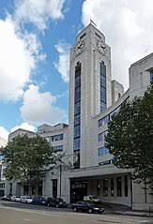ONR London Office

Office for Nuclear Regulation

157-197 Buckingham Palace Road

4th Floor

London

SW1W 9SP

Image courtesy of Google

Directions

Via rail

The nearest mainline station to our London office is Victoria Station. It is served by the following:

* Overground**:** Gatwick Express, Southern, Southeastern, Thameslink
* Underground: Circle, District, Victoria lines

Via London underground

The nearest underground stations to our London office are:

* Victoria (0.4m - 8 min walk)
* Sloane Square (0.6m - 13 min walk)

Via bus

Buses 11, 211, C10 and C239 stop outside the main entrance of our London office.

You can also find our London office via [Google maps](https://www.google.co.uk/maps/place/Buckingham+Palace+Rd,+London+SW1W+9SP/@51.491726,-0.14826,14z/data=!4m6!3m5!1s0x48760518e7719fd9:0xa9cab4c2365e3dad!8m2!3d51.4917273!4d-0.1482356!16s%2Fg%2F1thxq3bs?hl=en&entry=ttu)