ONR – NGO workshops on climate change
2022-2023

Executive summary
The suggestion to hold these workshops arose from an idea put forward by Mark Foy in January 2020. By September 2023 we had completed three workshops focussed on climate change which has been quite a journey. It started with the plunge straight into COVID and lockdowns which was a major challenge.

We realised during the first Zoom workshop in October 2022 that it was proving difficult to move away from old patterns of behaviour between the NGOs and ONR. We were stuck in a format of question and answer with little open discussion or meeting of minds.

At Mark’s suggestion we chose outside facilitators to support us to make the shift. The next two workshops in July and September 2023 showed incremental improvements. More understanding and cooperation was created between the ONR and NGO participants.

We now need to decide how to take this shift forward in a number of significant areas that have emerged from the work done in the three workshops.

These areas include:
- the impact on the nuclear industry of societal change and institutional continuity as a result of our rapidly changing world climate, and the inability of governments to engage in measures to limit this breakdown
- what criteria should be included in the Generic Design Assessments, the site licensing process and radioactive waste storage processes
- ONR's ability to contribute to government nuclear policy in solving the above issues
- a failure to implement the independent Climate Change Committee recommendations and a demonstrable lack of urgency

The aim was to share learning, better understand concerns about how climate change could impact nuclear sites in the UK and for ONR to explain how it factored climate change into its regulation.

The detail in the body of this report will be used to design a strategy for the ongoing engagement within the ONR and NGO forum on the subject of climate change.

Contents
- Glossary of terms 2
- Background, goals and outcomes 3
3. Workshop 1 4
4. Workshop 2 4
5. Background 5
6. Meeting aims and outline 5
7. NGO headline challenges/concerns for climate change in nuclear 6
8. Presentations by Andria Gilmour (AG) followed by Q&A 8
9. Group work considering the effects of climate change on construction 9
10. Assumptions and managing uncertainties 9
11. Key takeaways from Workshop 2 10
12. Workshop 3 - Background and outline 11
13. Presentations and discussions 11
14. Group work 12
15. Climate issues 14
16. Key takeaways from Workshop 3 15
17. Actions from climate change workshops 15
Appendices 16
Appendix 1 – ONR presentation from workshop 1 16
Appendix 2 – Paper by Katy Attwater 16
Appendix 3 – NGO position paper, ‘Time for a sea change’, Andy Blowers 18
Appendix 4 – article by Andy Blowers 28
Appendix 5 – Paper by Pete Wilkinson 38
Appendix 6 – ONR feedback to NGO presentations at Climate Change workshop, October 2022 41
Appendix 7 – Workshop 1 presentation 44
Appendix 8 – workshop 2 presentation 44
Appendix 9 – workshop 3 presentation 44
Appendix 10 - Workshop 2 agenda 45
Appendix 11 - Workshop 2 attendees 45
Appendix 12 - Workshop 3 agenda 46
Appendix 13 - Workshop 3 attendees 47

Glossary of terms
AFD - Acoustic Fish Deterrent
ALARA – As Low As Reasonably Achievable (used in safety)
ALARP – As Low As Reasonably Practical (used in safety)
CC - Climate Change
EA – Environment Agency
EDF – Electricité De France, French energy company
EPR – European Pressurised Reactor
GDF – Geological Disposal Facility
H++ - credible maximum climate change scenario, used by ONR
HPC – Hinkley Point C nuclear facility
NGO – Non-Governmental Organisation – in this case a mix of registered charities and single-issue groups
ONR – Office for Nuclear Regulation
SLR – Sea Level Rise
SMR – Small Modular Reactor
SZC – Sizewell C

Background, goals and outcomes

The purpose of the workshops was twofold.
As relationships between NGOs and ONR have matured NGOs identified a desire to find a mechanism to allow us to engage on topics of mutual interest outside of the usual question and answer format provided by our twice-yearly main forum meetings. As part of ONR’s work to improve openness and transparency the aim was to have more detailed, two-way dialogue and mutual learning on specific topics.
Given the implications of climate change it was agreed that this was a good topic to choose. The aim was to share learning, better understand concerns about how climate change could impact nuclear sites in the UK and for ONR to explain how it factored climate change into its regulation. The workshops were co-chaired by Rachel Grant, Director of Policy and Communications at ONR, and NGO representative Katy Attwater from Stop Hinkley – Holding EDF to Account, and supported by a small planning team. The group was made up of:
Rachel Grant - ONR
Katy Attwater - Stop Hinkley, Holding EDF to Account
Pete Wilkinson – Together Against Sizewell C
Andy Blowers – Blackwater Against New Nuclear
Jill Sutcliffe – Low Level Radiation and Health Conference
Peter Burt - Nuclear Awareness Group / Nuclear Education Trust
This report is a summary of what was discussed and gives the key takeaways from each workshop, along with the agreed actions.

Workshop 1

The first workshop was intended as a scene-setting opportunity on the issues raised by climate change for nuclear regulation.

Workshop 1 was held virtually in October 2022. Presentations were given by the Meteorological Office and ONR and some NGOs outlined papers previously submitted.
Documents discussed:
ONR presentation on the current position (appendix 1)
Papers by:
Katy Attwater (appendix 2), Andy Blowers (appendix 3 and appendix 4), Pete Wilkinson (appendix 5)
ONR’s response to the papers presented (issued after the meeting) (appendix 6)

The workshop was worthwhile and constructive but highlighted areas for improvement as we progressed with future workshops. We learnt that face to face works better than online, all papers must be submitted well in advance of the meeting to allow people to read them and sufficient time to be allocated on the agenda for fulsome discussion.
The organising team also felt that we might benefit from independent facilitation for the next two workshops and so ONR arranged for this to happen.
Workshops 2 and 3 were in-person and independently facilitated.
See appendix 7 for the presentation covered in the workshop.

Workshop 2
6 July 2023, Birmingham
ONR inspectors and representatives with specialist knowledge on the subject matter gave technical detail and supported understanding:
Andria Gilmour (AG) | Civil Engineering & External Hazards Lead – Nuclear Safety
Shane Turner (ST) | Superintending Inspector – Nuclear Safety and Head of Nuclear Safety Regulation – Hinkley Point C and Sizewell C
Dr Denise Varley (ST) | Principal Inspector, Nuclear Liabilities Regulation
Donald Urquhart | Deputy Chief Nuclear Inspector/Executive Director ONR

Background
To enable a full range of discussion, the workshops considered the end to end nuclear process. This ensured participants gained an understanding of both how and when ONR includes climate change in considerations when regulating new, existing and decommissioned nuclear facilities.
The discussions used the Hinkley Point C development to illustrate activities throughout the two workshops.
Climate change was considered at each point of the nuclear journey and discussion followed this outline:
- Generic Design Assessment (GDA)
- Licensing (site-specific)
- Construction
- Commissioning
- Operating
- Post-operations

Meeting aims and outline
Alongside the agenda, meeting aims were collaboratively agreed by the working group:
- Review and refresh the headline challenges of climate change as outlined by participants both today and in workshop 1
- Explore how the headline challenges of climate change for nuclear regulation discussed in workshop 1 are reflected in ONR thinking by using Hinkley Point C as a case study
- Share and develop mutual understanding around these challenges and aspects of regulatory approaches and rationale with a view to shifting ways of thinking and perspectives
- Explore points on which ONR and NGOs disagree and undertake joint fact-finding or other approaches to managing uncertainties to help resolve any differences of opinion
- Agree and allocate actions ‘what, by who, by when and why’ – including points to inform development of September 2023 ONR NGO climate change workshop 3
During the workshop, post-it notes were used to group and discuss the points raised.

NGO headline challenges/concerns for climate change in nuclear
This section formed a basis for the day’s discussions as NGOs outlined what they considered were the main threats facing nuclear new build such as HPC and SZC, and decommissioned sites, as a result of climate change. The points raised were consistently referred to throughout the rest of the workshop.
Storm surge and sea level rise
Concerns that HPC is inadequately prepared for sea level rise, e.g. the sea wall at HPC (14m) is not high enough, particularly when storm surges or high rainfall can add 1-2 metres to an astronomical tide (max. 14.7m in the Severn Estuary). NGOs felt there was not enough joined-up concern about what happens on either side of the sea walls.
There was concern around the uncertain lifespan of SZC and currently no design of the coastal defences.
Concern around the delays at HPC taking it into the dangers of SLR and storm surges and that the coastal geomorphology assessments aren’t sufficiently conservative
Temperature
Concern about the effects of high temperatures, especially as we have already reached temperatures of 40 degrees Celsius.
Monitoring
Questions around whether an early warning monitoring system exists for storm surges and tsunami, and whether there would be a seismic monitoring station for a GDF.
Questions of why an organisation would support the building of another EPR when none the four that are built are fully operational.
New build
Questions of the potential number of sites for SMRs, and also questioned how site suitability is considered with regards SLR, air temperature and other external threats.
More challenges
Less wind is predicted as a result of climate change so tidal power is a better alternative.
Questions around the current situation at Bradwell B and separately considered the conflict of water for residents near a nuclear plant and the plant itself.
Waste
Concerns about the potential wasted construction of HPC were it not to go ahead because of climate or operational safety concerns. Waste concern was a theme, with NGOs arguing that we stop generating more waste and should dismantle existing power stations in recognition of the effects of climate change, rather than build new ones.
Future uncertainties including radioactive waste
There was reference to ONR’s climate change document.
Discussion focused on the risk of new nuclear given the uncertainties and potential instability that may arise as a result of climate change.
There was concern that ONR would authorise new nuclear plants and radioactive waste stores despite the unknown risks from climate change, and NGOs felt ONR must be prepared to refuse new nuclear on this basis. NGOs thought climate change should be reviewed more frequently than every 10 years and questioned the effectiveness of the managed adaptive approach.
Given the specific resources needed to manage a nuclear power station throughout its lifespan (over 250 years as high level spent fuel needs to be secured well beyond the generation life), NGOs questioned how these could be guaranteed in the context of climate change and the political and societal unknowns.
Concerns focused on civil unrest as a result of climate change pressures and the ethics of leaving a legacy of failing nuclear facilities for future generations.

Wider conversations
While the concerns below are not strictly related to climate change, they played a role in directing discussion and provided background for other climate change related NGO concerns.
Government policy and the role of ONR
NGOs felt ONR should focus on making existing nuclear facilities safe rather than enabling more to be built. NGOS believe this is the understanding of the mission ‘to protect society by securing safe nuclear operations’.
Concern continued around the building of another EPR at SZC with taxpayers money, when other constructed EPRs (Taishan, Olkiluoto, Flamanville) weren’t fully functional.
NGOs expressed concern about the divisions and inefficiencies between ONR, EA and NDA, saying the roles of each were confusing.
Developer credibility
NGOs had the impression ONR is not sceptical of EDF and wanted confidence that ONR is critical of EDF’s assertions. They asked whether ONR has influence to hold EDF to account, given they want to change the plans made by the DCO at HPC. NGOs asked the criteria for a developer to be considered a responsible company.

Presentations by Andria Gilmour (AG) followed by Q&A

- Climate change and GDA, both generic and site-specific
Following the presentation (appendix 8), NGOs wanted to focus on how ONR interprets government policy around climate change.
Discussion covered concerns about how sites are protected from the effects of climate change, including access to sites. AG explained that to enable safe operations, sites need to operate for a minimum of 72 hours independently with no access offsite and that while expensive, there are steps to take to defend nuclear facilities from the effects of climate change. In Japan for example, there have been lessons learnt from Fukushima.
Questions were asked about the number of sites for SMRs, , and questioned ONR’s position as a ‘critical friend’ to the industry when assessing new reactor designs. AG explained that the purpose of GDA was to work with requesting parties to assess plans and stop unsuitable designs at an early stage.
When questions were for the EA rather than ONR, covering erosion and environmental disruption when building new nuclear, it was advised that whist ONR are not involved in decision making processes so could not comment, we continue to work closely with EA.
- Licensing
NGOs were interested in ONR’s work with developers and conversation followed AG’s presentation on licensing. NGOs asked how ONR judges a responsible developer, to which AG replied that a framework is followed to take into account future risks and hazards. ONR also looks at liquidity of the relevant company.
Questions moved on to consider waste and storage at HPC in relation to climate change. AG explained the meaning of H++; NGOs asked how long waste was planned to be stored at HPC, to which Shane Turner (ST) explained that 120 years is the assumed design life of the dry fuel store but the length of time fuel will be stored depends on a number of factors, and the length will vary as a result.
NGOs were concerned about future flooding of the M4 and railway and the impact of this on moving waste from HPC, to which ONR replied that a permanent state of flood is predictable and having waste that is safe to move is a legal requirement.
The group discussed protecting aging facilities especially with temperatures increasing, protecting against flood risk and storm surges over the longer term, and ONR’s accountability overseeing the project from beginning to end. Particular questions focused on whether a whole nuclear site would be protected from the effects of climate change, or key areas such as fuel stores.

Group work considering the effects of climate change on construction

In small groups, NGOs and ONR discussed what may be missing from the climate risks already mentioned, and discussed their views on ONR processes informing their views on risks, managing uncertainties and timetables.
Group 1 felt there was an assumption in the nuclear industry that there was a fix for everything. However, we can’t reliably know the risks of climate change as we are forecasting too far into the future.
Discussion centred around commercial decisions versus safety issues and the associated costs, which could end up sitting with the government.
Questions included defining ‘reasonably practical’, how cost is assessed, do other agencies such as EA have sufficient powers, and whether decisions made by ONR can be overturned.
Group 1 asked about HPC in the context of climate change and whether ONR had identified tipping points which would cause closure of HPC or cease construction, along with ways to reduce the carbon footprint of construction.
Group 2’s discussion of climate risks focused on the threat nuclear facilities would face following climate change, such as water shortages, getting clean water and electricity to the site in case of flooding, the acidity of seawater in affecting welds, and civil unrest causing issues like water rationing and a shortage of trained personnel. Group 2 thought that future unknowns were very broad and there isn’t currently a remit broad enough to cover the uncertainty.
As solutions to these problems, group 2 thought that sites should have all-round protection rather than just the seaward side, knowledge of the availability of potable water, especially in drought areas, and advances in concrete technology after pouring. They also suggested making data available to the public for scrutiny and making changes in regulation to adequately capture the risks.
The groups expressed concern about the perceived lack of ‘joined-up-ness’ between regulators, and the limits to regulator power, using the example of the fish deterrents at HPC.

Assumptions and managing uncertainties

This section was considered through the lens of Andy Blowers’ list of different kinds of uncertainty: certainty, inaccuracy, ignorance, indeterminacy.
NGOs listed the assumptions they thought played a role in ONR decision making and how these factors influence regulation within the context of climate change. Common assumptions were:
- Sea walls are built to specified standards
- Specified standards are a sufficient response to predicted sea level rise
- ONR thinks periodic reviews every 10 years is adequate
- Storm surges indicate a greater likelihood of impending sea level rise
- A GDF will be available and storage is possible before this is built
- Waste can be moved
Common views in the context of climate change:
- We are beyond 1.5 degrees
- Tipping points are significant
- The need for nuclear power is questionable
- Radioactive waste is increasing
- Spent fuel is hazardous
- All radioactive waste must be secure and safe for all of its future
- Radioactive waste seems a low priority for government

Key takeaways from Workshop 2

Much of the day’s discussion focused on the specific threats climate change poses to the entire nuclear life cycle of a nuclear power plant, viewed through a lens of the uncertainties that NGOs felt ONR was not fully considering when regulating.
NGOs had concern about the future of nuclear plants in a world with societal breakdown as a result of climate change, and felt regulation did not go far enough to future-proof against this.
The resilience of the nuclear sector against the threats posed by climate change will be a theme to progress in the final workshop.

Workshop 3
20 September 2023, Birmingham

Background and outline
The meeting followed a similar pattern to the previous workshop, building on past conversations about climate change through the lens of the whole nuclear cycle, focusing on commissioning, operating and post-operations.
NGOs listened to presentations from ONR experts (see appendix 9) which led into a discussion and group work.

Presentations and discussions

Commissioning, operating and post-operations
Following on from the stages of the nuclear life cycle considered in workshop 2, ONR inspectors Andria Gilmour (AG) and Dr Denise Varley (DV) discussed commissioning and operating, and post operations followed by a Q&A.
Commissioning and operating explanation – Andria Gilmour
AG explained that some tipping points have already been reached and while this is bad news, it reduces uncertainty in planning assumptions. ONR is working with the Met Office on specific scenarios.
AG explained that the periodic reviews of safety starts when the reactor becomes operational and there are different safety cases for each stage. At this point, if ONR doesn’t feel that all points have been considered (e.g. sea level wall) the reactor cannot operate.
Discussion moved onto managing hazards as a result of climate change. AG explained that drought is easier to manage than intense rainfall - if there is not enough water, ONR has the power to shut the facility down.
Financial pressures are not a consideration in ONR’s decision to shut down a facility. If ONR instructs a facility to shut down, there is a legal responsibility for that to happen immediately.
It was noted that due to not being related to climate change, seismic activity wasn’t part of the scope of this workshop. However, if a tsunami were to significantly raise the sea level, this may affect the sea bed and influence decisions.

Questions about commissioning and operating
NGOs asked whether dry storage was always underground. AG replied that waste will be stored above ground at sites. There is an assumption that at some point there will be a GDF, although this is not the only possibility.
NGOs said attitudes towards time, hazard and risk will alter over time, and asked whether ONR is learning lessons from other sites.
AG replied that ONR is working to the ‘worst case scenario’, e.g. the maximum sea level rise and maximum wind speed. The current position is that nuclear facilities can operate safely in the UK but we recognise that all systems are only as safe as the humans who run them.

Post-operations explanation – Dr Denise Varley
DV explained the processes involved when facilities move to post-operations.
DV explained how waste would be handled at HPC. The fuel for HPC will be removed, cooled, then moved off-site. Intermediate level waste (ILW) will be cleaned and stay on-site.
The core will be cut up under water, put in packages and stored onsite, leaving multiple packages in stores.
Under the terms of the site licence ONR has powers to direct the start and halt of decommissioning. There is also a licence condition on the prevention and detection of leakage and escape of radionuclides to air, water and land.
The site needs a supply of clean, pure water for the cooling of spent fuel, typically for a period of around 10 years.

Group work
For each topic, the groups discussed:
- Their views on the climate risks mentioned
- What might be missing
- Their views on the processes ONR uses to manage risks and uncertainties (e.g. H++ scenario or monitoring)
Commissioning and operating
A range of sites and climate challenges were shared and discussed. ONR experts gave answers, an outline of which is below.
NGOs asked how commissioning works when there is little room for movement in climate models.
NGOs were concerned that spent fuel from Bradwell B may be better left onsite and that it will take 60 years to be safe. DV explained that spent fuel can be moved as soon as it is removed from the ponds. For the current fleet, this is 4 years but newer fuel is hotter and therefore takes longer to cool.
NGOs were concerned that politicians want to redevelop the Dungeness site with little scientific evidence to support this decision. DV advised that this is not something that ONR would have responsibility for.
When talking about using water for cooling, NGOs used France as an example where rivers are used to cool which has resulted in nuclear facilities having to be turned off.
There was concern from NGOs about water temperatures and the effect of hot water sucking fish into pipes.
NGOs were also concerned about the safety mechanisms in place at sites and EPRs being able to maintain water and pressure in the event of a shutdown. Using the example of Fukishima, DV explained that the UK has different safety mechanisms and ONR’s role is to ensure continuity of supply and to ensure there are safe margins for operations.
DV continued to explain that ONR’s safety margins are internationally recognised as being very high. ONR considers the worst case scenarios of rain and sea level and although storm surges can affect transformers going into the power station, there are backup generators that are tested and monitored.

Post-operations
NGOs defined post-operations as everything that happens once the reactor stops operating, including de-fuelling. There is no end point.
NGOs asked how far ahead ONR looks when assessing a safety case; Denise replied that ONR considers long term aspects of safety. For spent fuel this takes account of removal, cooling and storage, a period which can exceed 70 years.

Climate risks to post-operations
NGOs shared three events that they felt demonstrated the scope of the effects of storm surges and why climate risks must be taken into account at every stage of the nuclear life cycle, and the particular importance of considering post-operations.
These were the 7.5 metre storm surge at Hinkley Point in 1607, the storm surge in 1923 that buried the Port of Lilstock with shingle, and the 19th century storm surge that created Loe Bar (approx. 3/4 mile wide and 30m high) and cut off the port of Helston.
NGOs noted that sites need storage for high level and intermediate level waste but events such as these triggered by climate change present a major challenge to coastal site waste storage.
NGOs again expressed concern that climate challenges may lead to societal breakdown and having nuclear sites to contend with would make the scenario even more dangerous. NGOs pointed to evidence from Libya that showed societal breakdown can reduce the safety of critical infrastructure. NGOs thought ONR should consider the timeframe of 200-300 years when looking at assumptions about society in relation to climate risks. Resilience was a key theme that appeared that NGOs wanted to explore more.
NGOs shared concerns about the waste generated by nuclear power with no long term storage facility. They considered whether a GDF could be relied upon as a solution to the problem of waste and whether a GDF was acting as a distraction to finding another solution.
They also questioned where waste would be stored if a GDF isn’t built to the implied timescales. They used the example of Hunterston B which closed more than three years ago but has spent fuel stored at Sellafield. NGOs argued that moving waste offsite assumes a GDF will be built.

Climate issues

NGOs considered: what are the key assumptions held around the following climate issues, who are they held by and what are their sources?
How are risks and uncertainties monitored and measured, or how could they be?
Looking to the future for predications and plans, what would happen if there are major deviations from any projections or assumptions?

- Sea level rise and meteorological phenomena
AG gave input to this session – see appendix 9.
NGOs were concerned about sea level rise and how flooding could affect nuclear sites, and in particular what measures were taken to protect sites and build resilience. Conversation focused on HPC and SZC.
NGOs asked about the height of the sea defences at HPC; Andria replied that she wasn’t sure, but that the Hinkley C site is approximately 3.5 to 4m higher than the Hinkley B site. Maximum tide level predictions are fairly accurate at this location due to the well understood physical processes associated with storm events in the Bristol Channel.
NGOs expressed concern about the wave defence wall at Hinkley Point A and B but AG explained that given the low risk level, it is likely they won’t need defending with a sea wall.
Conversation moved on to Sizewell C and NGOs voiced concern that SZC is not protected by a sea wall at the back, which doesn’t make sense from a coastal management perspective. Some NGOs wanted further conversation with ONR about flooding at SZC.
NGOs mentioned the plan to use de-salination for SZC and said they were not in favour of this due to issues with noise, harming nature and releasing CO2.
NGOs were concerned that building on weak material at SZC, if not known about, could cause a wall to fall, and therefore different materials must be guaranteed for the future. AG explained that SZC will not be built on rock and if construction goes ahead, there will be 10 metres of large rock and concrete called ‘improved ground’.

- High level waste
NGOs outlined the assumptions about high level waste that they felt there led considerations within the nuclear sector:
- Emergency resilience is adequate to cope with a site-based contingency
- EPR fuel can be disposed of
- We can continue to build waste stores for as long as they are needed
- Climate change is a factor that must be taken into account in building on-site waste stores
- There are off-site options for waste stores
- A GDF, or multiple GDFs will be built
- It’s possible to build on-site stores resilient to sea level rise and moving waste is also possible
- Transport methods and routes would be available to move waste
NGOs did not agree with many of these assumptions and felt they did not accurately capture the climate issues discussed at the workshops. They felt that the periodic review of safety could take place more regularly to ensure all risks were captured and evaluated, especially as some risks are still unknown.

Key takeaways from Workshop 3

The discussion largely focused on the operating life of a reactor and post-operations, as much of the NGOs concern was about managing the challenges of a nuclear site in the context of climate change in the future.
The open dialogue between ONR experts and NGOs made for a productive conversation and questions were answered, with more key themes emerging to explore in future meetings.

Actions from climate change workshops
- ONR to share the workshop report with NGO attendees
- ONR to organise a meeting with the climate change working group to establish next steps and agree whether to run more workshops
- If more workshops are agreed, ONR and the working group to agree on a topic to explore

Appendices

Appendix 1 – ONR presentation from workshop 1

Appendix 2 – Paper by Katy Attwater
UPDATED OCTOBER 3RD 2022
Good afternoon. My background is 20 years as a Management Consultant in the Finance, Automotive and Airline industries.

I retired and joined the Stop Hinkley Campaign in 2008, before EDF got its site licence and DCO for Hinkley C. I joined the NGO Forum as a Stop Hinkley representative in 2018.

Hinkley C, close to where I and my family live, is now the largest construction site in Europe.

However, given the problems of its EPR predecessors, under construction and trial, Okiluoto, Flamanville and Taishan, there is every possibility that Hinkley C may never be operational.

Hinkley Point is a very low eroding sand and gravel shoreline. Similar to that of Sizewell and Bradwell. The Severn Estuary has very fast and extreme high tides and has had many devastating floods and storm surges in the past due to its funnel shape and shallow mud flats.

We became aware of the implications of Climate Change for these sites from the findings of the IPCC Report on Climate Change in 2018.

Since then, Stop Hinkley, alongside the other NGOs, have been challenging the ONR on what will happen to Hinkley C and other coastal sites as sea levels rise on low eroding coastlines, and more frequent storm surges impact on Hinkley's three nuclear power stations, and radioactive waste storage.

In January 2020 Mark Foy and his ONR team offered to meet with Stop Hinkley and the Sizewell and Bradwell Groups, in Somerset, to address our concerns on Climate Change. At this meeting, as a result of our concerns being so many and complex, Mark Foy and Adriènne Kelbie suggested that a Climate Change Workshop would be a good way forward.

So here we are, two and a half years later, post pandemic, in a world where Climate Change has been declared a Global Emergency.

In the light of the climate uncertainties for the future, the NGO Forums major concerns are:-
Firstly, our government is still asking the ONR to approve and enable the building of new nuclear power stations.
Secondly, due to its remit, the ONR is not allowed to challenge government policy, however, to our knowledge, it is not educating or informing our government of the danger and complexity of using nuclear power as the core of it’s strategy.

One overwhelming drawback is that nuclear power stations, necessarily on low level coastlines, will be overwhelmed by rising sea levels with catastrophic results.

Another overwhelming drawback to the government's strategy is the length of time it takes to develop, approve and build a nuclear power station.

Hinkley C - 16 years and rising.
Okiluoto - 18 years and still being tested
Flamanville - 16 years with no start-up date in sight.

Taishan’s fate is unknown as the Chinese are not saying what's going on since a near catastrophe within 6 months of going operational.

So surely, given such a track record there are very good reasons not to support the building of any nuclear power stations and, as a matter of urgency, decommissioning those in danger from sea level rises.
Our purpose in working with the ONR to design and attend this series of Climate Change Workshops, is to go through the evidence that can bring all of us to some understanding of why we find ourselves in this position and how to go forward.

We need to find a way to work together to create understanding, and to support the ONR in their Mission Statement ‘to protect society by securing safe nuclear operations’.

There are many good reasons not to use nuclear as our saviour from Climate Change.

We are looking to the ONR, as worldwide experts in the use of Nuclear Power, to provide the intelligence and guidance that this government needs in this time of crisis.

We feel very strongly that we all owe this to our families and future generations to come.

END

Appendix 3 – NGO position paper, ‘Time for a sea change’ by Andy Blowers
Introduction
The intention of this first workshop between NGOs and ONR is to present an overview to frame the key issues and concerns on Climate Change that will be the substance of subsequent more specific investigations. We aspire to an engagement which, if it does not reconcile differing viewpoints and perspectives, at least exposes them to scrutiny and reasoned justification. The workshop must be seen as a mutual exploration of ideas, principles, processes and policies. This is not a customary exercise in question and answer, statement and response, in which NGOs propose and ONR responds. The intention is to achieve understanding, consensus where possible and clarity on points of divergence.
To that end this contribution attempts to set the scene on the impacts of Climate Change on nuclear development and the issues it poses for regulation of nuclear facilities throughout the phases of development, operation, decommissioning and waste management. More specifically, the question I am dealing with is, ‘The uncertainties in climate science. How can ONR expect a ‘managed adaptive approach’ to work as a solution to every Climate Change issue?
I shall argue that the uncertainties around the consequences of Climate Change are so profound that they require a different approach to regulation. It is no longer tolerable to rely on probabilistic risk assessments and provide reassuring support for projects and proposals. Periodic monitoring and review and measures of adaptive management cannot guarantee safety and security in the long-run and certainly not into the far future. The idea of ‘transformational adaptation’ which may be applied to renewable energy systems as a way of managing the transition to low carbon, surely cannot be applicable to nuclear energy which carries high risks, high costs and a legacy burden that cannot be readily transformed.
Therefore, if adaptation is not capable of ultimate transformation in the nuclear sector, recourse must be had to mitigation. In the long run the profound risks of nuclear power can only be mitigated by abandonment of the technology altogether. And, ONR with its independent regulatory authority has the power to accept, request modification or reject proposals altogether both through its GDA function and its licensing role. While, in the face of Government and industry pressures, ONR’s reluctance to apply regulatory sanctions to nuclear power may be understandable, that does not mean it is acceptable. The NGOs’ position is that the impacts of Climate Change, especially in the form of storm surges, flooding and Sea Level Rise (SLR), may be so destructive that nothing less than declining to approve GDA or refusal of permits may be appropriate, in some, if not all circumstances.
In other words, the consequences of Climate Change mean that it is Time for a Sea Change in ONRs approach to the regulation of nuclear power.
Climate Change – Into the Unknown
It has become axiomatic to state that we are already into the era of accelerating Climate Change driven by anthropogenic activity warming the climate and producing manifold and deleterious consequences in the form of SLR, warming oceans, ocean acidification, changes in ocean currents, global greening, changes in the hydrogeological cycle, warming land and air, more extreme weather and so on It is the result of increased CO² in the atmosphere generated by human activities, including deforestation, changing land use, burning of fossil fuels. Nuclear facilities (power stations, radioactive waste facilities) are especially vulnerable to impacts, including: risk to water supplies, localised flooding, flooding of coastal regions, damage to marine ecosystems and damage to infrastructure. We have already reached a point where extreme temperatures, severe flooding, wildfires, loss of biodiversity, declining agricultural production, drought and desertification are becoming commonplace in many parts of the globe. What once seemed a fantasy of the future has become normalised for a growing part of the world’s population, flora and fauna.
It is difficult to be pragmatic or prosaic about the imminence of the threats to environments and human wellbeing. The statistics are stark. Already global temperatures are at 1.1ºC above pre-industrial levels and a rise of 1.5⁰C, the aspirational level deemed just about safe for the world’s most vulnerable communities, will certainly be exceeded by mid-century. The relatively sluggish response to the Paris accord and the slow implementation of implementation plans set out at COP 26 make it highly likely that the target cap of 2⁰C, beyond which level consequences would be widespread and disastrous and potentially unmanageable, will be exceeded before the end of the century. With little or no realistic action to reduce the growth in GHGs temperatures could pass 3⁰C or even 4⁰C especially if the terrifying runaway scenarios materialise. The 3rd UK Risk Assessment indicates a 30% probability of exceeding 4⁰C by 2100 against a 50% for below 2⁰C. The probabilities are concerning, the consequences could be lethal and we are becoming used to the idea that what seems improbable now materialises within a few years. Therefore, a cautious, risk averse position must be adopted towards relatively remote but potentially imminent scenarios.
Rises in temperature affect SLR both directly and indirectly. The IPCC indicate that at 2⁰C SLR will be of the order of a metre and possibly 2m. (under a high GHG scenario) but it does not stop there but continues increasing beyond 2100. Further, by the middle of the next century there is the prospect (low confidence) under a very high GHG that a rise of 5m. ‘cannot be ruled out due to deep uncertainty in ice sheet processes’. The ‘deep uncertainty’ applies to several cataclysmic processes that may bring about ‘tipping points’, that is feedbacks which literally run out of control. They are unpredictable as to occurrence and unknowable as to timing and impact. Among these are:
- Atlantic Meridional Oscillating Circulation (AMOC), familiarly known to us as the Gulf Stream. Under conditions of thermal warming of the oceans AMOC can slow down or switch off altogether possibly within the next century (weakening by 34 – 48% by 2100,This would increase storminess, SLR, loss of agricultural output.
- North Atlantic Jet Stream. This meanders and stalls blocking pressure systems (for example creating persistent high pressure zones with very high temperatures). But, there is considerable uncertainty about the Jet Stream, a subject requiring urgent research.
- Greenland and Antarctic Ice Sheets. Melting of these ice sheets would be responsible for 2/3rds of global SLR. It is estimated that the complete loss of the Greenland Ice Sheet would create a 7m. rise in SLR over 1000years. The West Antarctica Ice Sheet faces possible collapse which might give a 2m. rise in SLR by 2100.
- Permafrost. Carbon emissions through a ‘permafrost carbon feedback’ could result in rapid rather than gradual thaw thereby releasing methane a highly potent GHG from the tundra areas.
- Reduced carbon uptake by biosphere. Deforestation, fires and agricultural land use change can reduce the capacity to absorb carbon. It is estimated that there is already a 17% loss of Amazon forest and the tipping point here could be 20-25%.
No Need for Nuclear so What is the Point?
It must be stressed that the science is indicative, not conclusive and much further research is needed before definitive results related to specific processes and places can be generated. But, it is also the case that the uncertainties increase over time and the possibility, however remote, of tipping points being reached and accelerating Climate Change and its impacts on the whole complex of global interacting systems becomes more threatening in the latter part of this century and beyond.
There is a human tendency to acknowledge the uncertainties and even their implications but to stay calm and carry on. ONR cannot be immune to this tendency. The prospects of such major changes may be imagined but drastic action is avoided. For the immediate future, even the medium term, it is possible to follow the path of adaptation. But, as we enter the farther future, into the unknown, an adaptive approach becomes less tenable and measure of mitigation must be considered. The IPCC Report on Mitigation and Climate Change places the stress on mitigation within and between sectors. Carbon removal, whether by capture or low carbon production, is the key element in this.
At this point it is possible to draw some broad but fundamental conclusions about the future of nuclear power. Nuclear energy as a low carbon system is not specifically mentioned in terms of mitigation in these reports. Its role in transformational adaptation is likely to be marginal. Moreover, nuclear power presents a risk throughout its long lifetime, including the risk from radioactive waste extending into the far future. Any putative benefits to society from nuclear power in mitigating carbon output must be set against the very substantial risks to nuclear power infrastructures resulting from the impacts of climate change in the long run. These risks will need to be mitigated to avoid placing a radioactive burden on future generations. It is difficult to foresee any form of mitigation other than the abandonment of nuclear power as a source of electricity in the future.
Although not specifically relevant to ONR’s s regulatory remit as an independent regulator, it should be recognised that there is no paramount need for nuclear power. This is certainly the case in the UK where the Government’s proclamation of a nuclear future is patently unjustified and absurd. The reasons why new nuclear is not needed are familiar:
- Deployment is slow and new nuclear will make a limited contribution to net zero by 2050. It is liable to displace cheaper, faster and safer alternatives.
- New nuclear is expensive in comparison with low carbon alternatives. It requires considerable subsidy from taxpayers and consumers.
- New nuclear is technically complex and subject to delays in development and in operation.
- It tends to run over time and over budget
- Nuclear power is potentially high risk and creates a long-lasting legacy in the form of highly active wastes.
Government policy still relies heavily on deployment at eight ‘potentially suitable’ sites by 2025 enabling nuclear to contribute ‘as much as possible towards meeting the need for 25GW of new capacity. The policy was set in 2011 and has subsequently been reinforced in various statements and proposals. Despite the support only one project, Hinkley Point C, has got off the ground and even its completion is not guaranteed. Apart from Sizewell C now mired in planning and financial issues, there is a myriad of projects but no firm proposals for rejuvenating the ambitious programme. Even so, nuclear energy will continue to supply 4.5GW (SZB, HPC) until mid-century and beyond, sufficient to enable it to make a modest contribution to net zero by 2050. The key point here is that Climate Change may be a constraint but, if nuclear not needed, what’s the point?
This digression on the need for new nuclear is relevant to ONR for two reasons. One is that resources have to be committed to a number of projects that have very little prospect of development. It may be observed ONR has devoted resources to granting a much prized GDA to the Hualong I reactor which the Chinese operator will now use to promote its business elsewhere. The question is whether through its close relationship to the nuclear industry ONR may perform a facilitative role which may compromise its position of independence on nuclear power. ONR has sometimes portrayed itself as the developer’s ‘critical friend. This raises a broader question as to whether ONR may be captured within the heavily pro-nuclear discourse that currently pervades business, politics and government. There may be a set of assumptions, values and beliefs that are implicitly imbibed creating a presumed consensus that favours the further development of nuclear power and is adverse to counter arguments. It is true that opponents of nuclear power, like the group of NGOs at this workshop, also embrace a particular discourse and create an unquestioning and counteracting dissensus. The purpose of this workshop is to recognise, respect, challenge and criticise different viewpoints.
Uncertainty
Regulation is not simply a technical process. It is embedded in a social context comprising technocratic and bureaucratic practices. ONR’s approach to regulation and licensing is, fundamentally and understandably, based on science and engineering. Its independence is founded upon the application of scientific method and empirical methodology. This rational evidence-based approach conveys a belief in neutrality, objectivity and reasonableness and claims of rightfulness. This is alright but only up to a point. Uncertainties increase with complexity and over time. We may identify four levels of uncertainties:
- Certainty. There are many routine and even some novel proposals that can, with a fair degree of certainty, be declared safe and secure on the basis of example, repetitive production and testing. In the nuclear world scientific consensus may provide assurance but rarely can outcomes be completely assured.
- Inaccuracy. Assured predictability quickly falls away when technical processes are complex, tightly coupled and unpredictable. Measurement is subject to inaccuracies. At this level, science and engineering move from certainty to the realm of prediction and probability. For instance, the experience of reactor design suggests that complexity, and scale and materials, over time may lead to unforeseen problems and outcomes. This suggests only a probabilistic assessment is possible. Go-ahead may be provisional based on future monitoring and review (adaptive management).
- Ignorance. This is the area of the unknown where data is lacking, modelling incomplete and understanding partial. Further information, experimentation and knowledge are needed to provide greater confidence. Until this happens only provisional assessment or qualified approval is justifiable. Full approval would be premature. The fate of the Taishan reactor may be an instance of premature approval.
- Indeterminacy. This is the area of the unknowable, more colloquially put as ‘we don’t know what we don’t know’. This is particularly important when dealing with issues of such complexity or novelty that it is impossible to know for certain what the outcomes will be. The long time scales of nuclear facilities mean that we are dealing with the unpredictable, unforeseen, unintended consequences that may ensue in the far future. At this level, uncertainties from Climate Change and societal organisation and survival make regulation a matter of scenario building, guesswork or even fantasy.
Our concern is with the implications of these different levels of uncertainty for regulatory practice. In particular to question the meaning and practice of adaptive management. In other words how does regulation deal with uncertainty?
ONR claims to base its approach on science. It receives insight into recent scientific advances in relation to climate change issues from an Expert Panel. The Panel highlights trends or significant changes in scientific understanding which, ONR claims, ‘will ultimately inform our regulatory guidance’. The Panel has provided insights into a range of climatic uncertainties such as tipping points, oceanic current circulation, atmospheric absorption and so on. The Panel has indicated the degree to which there is a scientific consensus on these matters. But, as with most scientific research, translating possibilities into best practice is a formidably difficult task. That said, it is not clear whether and to what extent ONR has attempted to take into account the findings of its Panel in its regulatory advice.
Observations and Implications
Climate Change clearly has profound implications for ONR’s regulation especially in relation to GDA and to Licensing. A number of issues have been raised in this discussion mainly at a general and generic level. They pose a number of more detailed and specific questions for further development in this series of workshops.
- Dependent or independent? The purpose of GDA from the ONR’s viewpoint is to decide whether a design is suitable for development. Its assessment looks at a design from the safety and security viewpoint. While it is an independent assessment the process is essentially reactive, based on information and proposals from a developer. The issue is how far assessment is constrained by this dependence. And, whether the regulator routinely uses information from other sources or from its own researches. A case in point would be how far ONR relies on a developer’s assessment of Climate Change impacts, especially in the far future. For instance, is use of UKCP18 dependent on the developer’s interpretation or independently derived? To what extent does or can ONR utilise advice and information from independent experts? Is regulation truly or effectively independent in terms of knowledge?

- Generic or specific? The GDA provides an assessment of suitability for development; it does not provide an assessment of suitability for deployment. In respect to a specific GDA the ONR is a joint regulator with the EA and regulation is based on parameters for a generic site. This may pave the way for site specific assessment but that will be a matter for planning (under PINS), permitting (EA) and licensing (ONR). In practice a generic site is relatively unconstrained and cannot take into account some design features that may be applied at site specific level. For example, a GDA may be based on a direct cooling system proposed by the developer whereas at site specific level an indirect hybrid system may be necessary. Or, sites which are highly vulnerable to the impacts of Climate Change may not be ruled out at the outset. Having given a green light at GDA level the ONR may be hesitant to reject a proposal when it comes to the siting level. This is especially the case where there is only one design and one presumed site on the table. This problem suggests that GDA should have greater regard to the siting problems. How far should potential siting conditions constrain regulation at the level of GDA?
- Regulation or facilitation? Interested parties, like NGOs but also the general public, are somewhat baffled and bemused by the concept of ‘generic’ as applied to assessment. There is a view that a generic assessment provides scope for development while leaving some basic issues unresolved to be left for later stages in the permitting process. This has two potential consequences. One is that GDA confers a presumption of permission when it comes to specific sites. If some of the more site specific but fairly common siting characteristics were incorporated at the outset the GDA process could become far more rigorous and realistic. The second consequence is that a successful GDA application offers a developer the prestigious imprimatur of ONR for promoting its design elsewhere. This ‘grab and go’ approach may, ultimately or retrospectively, have been the purpose of CGN’s application for GDA for its Hualong 1 reactor especially as prospects at its favoured site, Bradwell, appeared to be diminishing. The question this raises is: What is the function and purpose of the GDA?
- Adaptation or Mitigation? Regulators have tended to rely on developers’ proposals for managed adaptation to facilitate permission to proceed in conditions of uncertainty. At both Hinkley Point C and Sizewell C proposals for reinforcing and defending the nuclear island have been proposed with the prospect of increasing the heights of barriers if necessary in the face of Climate Change impacts, notable storm surges and SLR. At SZC it is argued that the design of sea defences meets the necessary criteria for the worst case but plausible scenario. While this may be justifiable possibly up to the turn of the century, beyond that no specific projections of coastal change have been made and depend on modelling which is unlikely give a detailed appreciation so far into the future. Here we encounter a case of passing the buck between regulators holding joint responsibility. It is left to ONR ‘to be satisfied that the site is protected from external hazards taking full consideration of climate change and extreme events’ .

Similarly, in the case of Bradwell B plans envisage protecting the main development site of 100 ha. including reactors, turbines, cooling towers and long-term radioactive waste stores, by creating a buttressed ‘nuclear island’ elevated above the surrounding sea. The power station would sit on a raised platform at an indicative 7.4m. AOD, pending more detailed studies to determine the actual level. But, ‘In the event of an extreme flood event, it would also be necessary to protect the power station from wave run-up and overtopping which would require new flood defences’. These would be rock armoured defences with a crest level of 9.8m AOD. It is not clear how this height was arrived at or if there would be any flexibility built in whereby height could be increased if sea level trends suggested adaptation was necessary. It is questionable whether such a policy of managed adaptation, if introduced at Bradwell, would be implementable in conditions of increasing uncertainty up to 2100, let alone in the unpredictable and unknowable conditions thereafter, stretching well into the next century. It would be imprudent and irresponsible to contemplate development of a new nuclear power station and long-lived highly radioactive waste stores in conditions which quite conceivably would overwhelm the site making the power station inoperable. This introduces two crucial questions, What levels of uncertainty are acceptable for managed adaptation? Put another way, At what point in time does managed adaptation become unfeasible and measures of mitigation (including abandonment of the project) need to be considered? Answers require thinking about the implications of ignorance and indeterminacy in regulation for the far future. It should be pointed out that answers are necessary before development is permitted; otherwise it may be too late. Decisions taken now may have irreversible consequences later.
- Society and Science. Independent regulation does not take place in a scientific vacuum. ONR is a social and scientific institution, reflecting and sometimes representing the dominant scientific consensus. It is noted that its research briefings on meteorological and coastal flooding hazards routinely report the ONR Expert Panel’s view that the work supports current scientific consensus, thereby reinforcing the scientific credibility of its advice. Much of this research is based on the latest evidence or theory and may be at an early stage where further research is needed to reduce the degree of ignorance. Nevertheless, such research supporting a scientific consensus points to credible future scenarios which should be heeded. Should the implications of research that is at the ignorance level of uncertainty be translated into regulatory advice?
There appears to be a paucity, even absence, of social science research informing ONR’s advice. Yet, as uncertainty moves from inaccuracy through ignorance and ultimately to indeterminacy societal and subjective factors come into play. Beyond a certain point in time these factors may come to dominate more scientific ones in risk assessment. Adaptive management need to take into account issues of intergenerational equity, institutional continuity and societal stability. Over the long term (in which nuclear facilities continue to operate or enter a long period of decommissioning and waste management) social factors will become more and more prominent in regulatory assessment and advice. At the level of indeterminacy where future conditions are unknowable, regulation becomes a matter of speculation on potential physical and social scenarios. It is noticeable how the regulatory advice on new nuclear build, as evidenced at the Sizewell C Examination, diminished in specificity and confidence over time while beyond the turn of the century it was couched in vague, imprecise and provisional terms. I made the following observation at the ExA:
Thus, whereas plans for the defence of Sizewell C during its period of operation are sufficiently developed to be subject to scrutiny and challenge, plans for the period of decommissioning and radioactive waste management are effectively non-existent. We are told that work is ongoing to assess viability and adaptive defences but nothing has been vouchsafed beyond a rather vague promise that modelling of sea level rise and shoreline change appropriate to the decommissioning phase will be undertaken and reported on’.
A question arises: Should there be a greater emphasis on social science research on the potential societal and institutional consequences of climate change for regulation in the far future?
- Policy and Practice. ONR is an independent body ‘with the legal authority to regulate nuclear safety, civil nuclear security and safeguards, and conventional health and safety’. It is important to be reasonably clear what this much vaunted notion of ‘independence’ means. Independent of what? Presumably this might include political interference, pressure from business or from elsewhere, including NGOs. In practice, independence is qualified. ONR works within a political and policy framework. At present that framework is supportive of nuclear expansion and, implicitly or explicitly, ONR is expected to facilitate that policy. Therefore, ONR must continually strive to maintain its independent regulatory function against informal or even formal government pressure. At a time when deregulation is favoured and speeding up of regulation is encouraged, ONR must resolutely defend it independence in principle and in practice.

Similarly, it is vital that ONR maintains an independent arm’s length relationship with those it regulates. Regulatory practice requires close working relationships with developers and sharing of information, some of it classified. In the public interest and as public servants ONR has to guard against penetration by those anxious to gain consent or licence. It needs to be seen to promote safety and security at the expense of all other pressures. It must ensure independent regulation and avoid partisan facilitation. ONR operates in the interests of the public, not government nor business. NGOs wish to see a greater explicit avowal of independence along with a belief in openness, transparency and inclusivity. This aim should be at the forefront of both ONR’s and the NGO’s commitment to this engagement.
This leads to a final question: Should the ONR review and refresh its commitment to independence uncompromised by political, government and business influences?
Final Thoughts
The era of Climate Change is upon us now and its impacts and consequences will increase and pose existential threats to infrastructures. There is increasing concern that there may be tipping points that will accelerate the impacts such as sea level rise, flooding and storm surges especially impacting coastal infrastructures. Uncertainties will increase the further into the future we look, transforming inaccuracies to ignorance and, ultimately, to indeterminacies. As this happens regulation based on adaptive management will become more problematic. It becomes necessary as time goes on to move from a probabilistic science-based approach towards one of building scenarios communicated by what one risk analysis describes as ‘event-base storylines’ (85-86). This approach fosters communication between stakeholders and regulators to achieve understanding of scenarios in the unknowable future. What is absolutely clear is that climate change requires some fundamental thinking about the relevance and role of adaptive management and mitigation in the decades ahead. It indicates that now is the time for a sea change.
Emeritus Professor of Social Sciences, The Open University
September 2022
Andrew Blowers
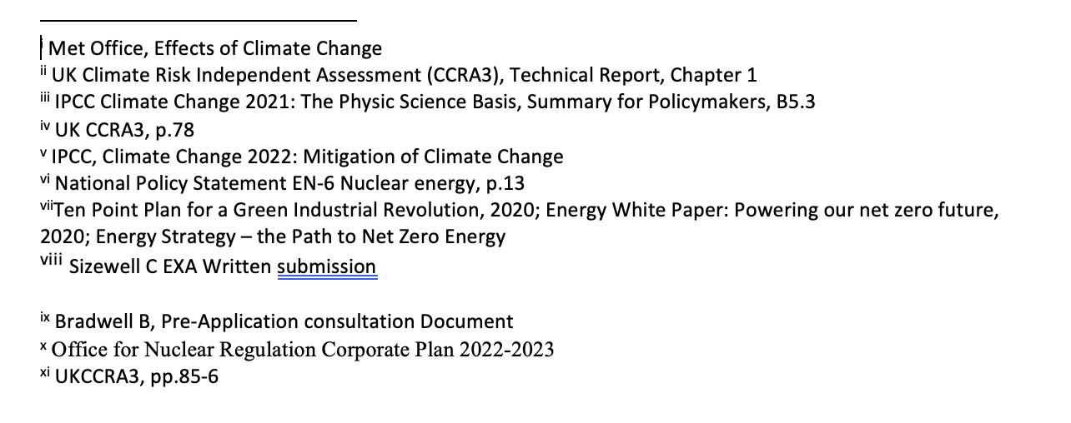

Appendix 4 – article by Andy Blowers

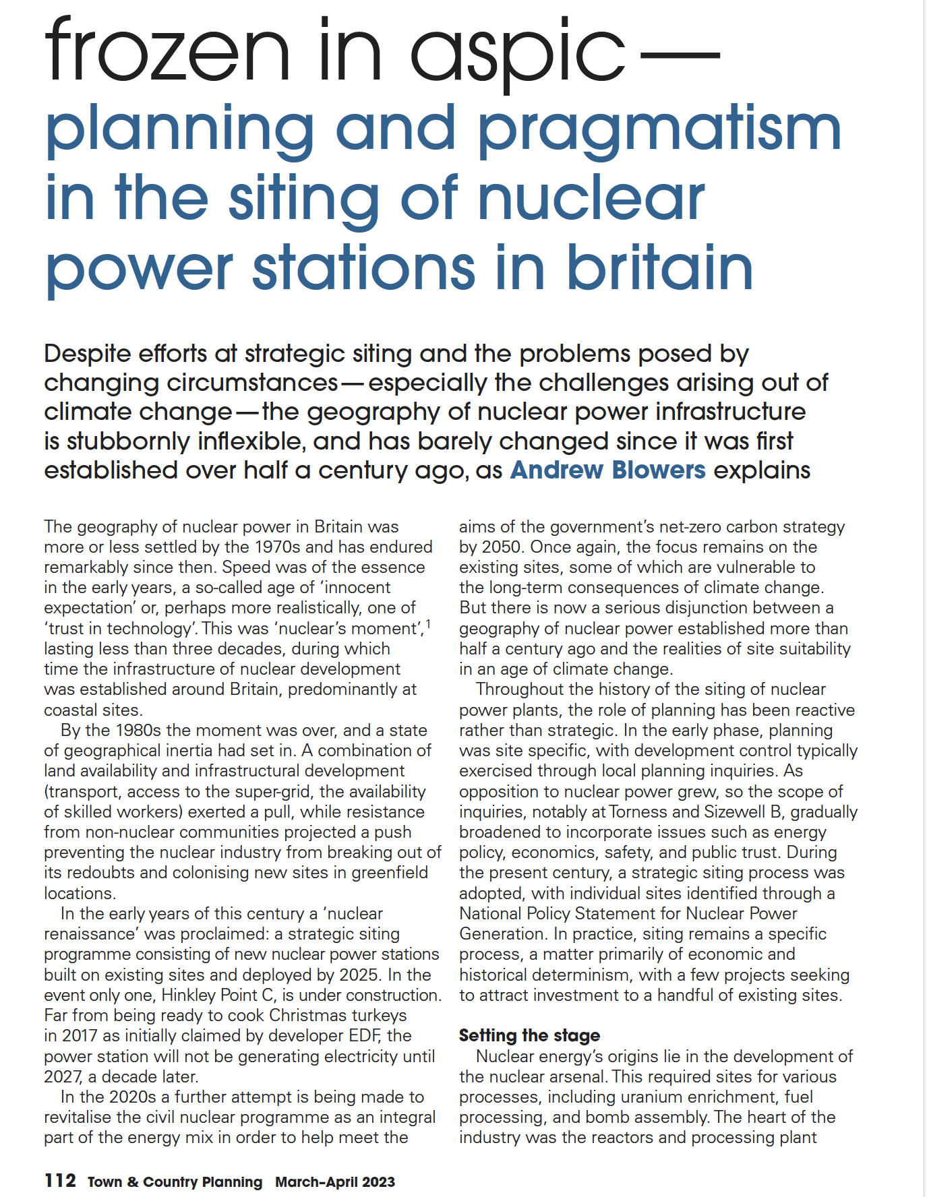

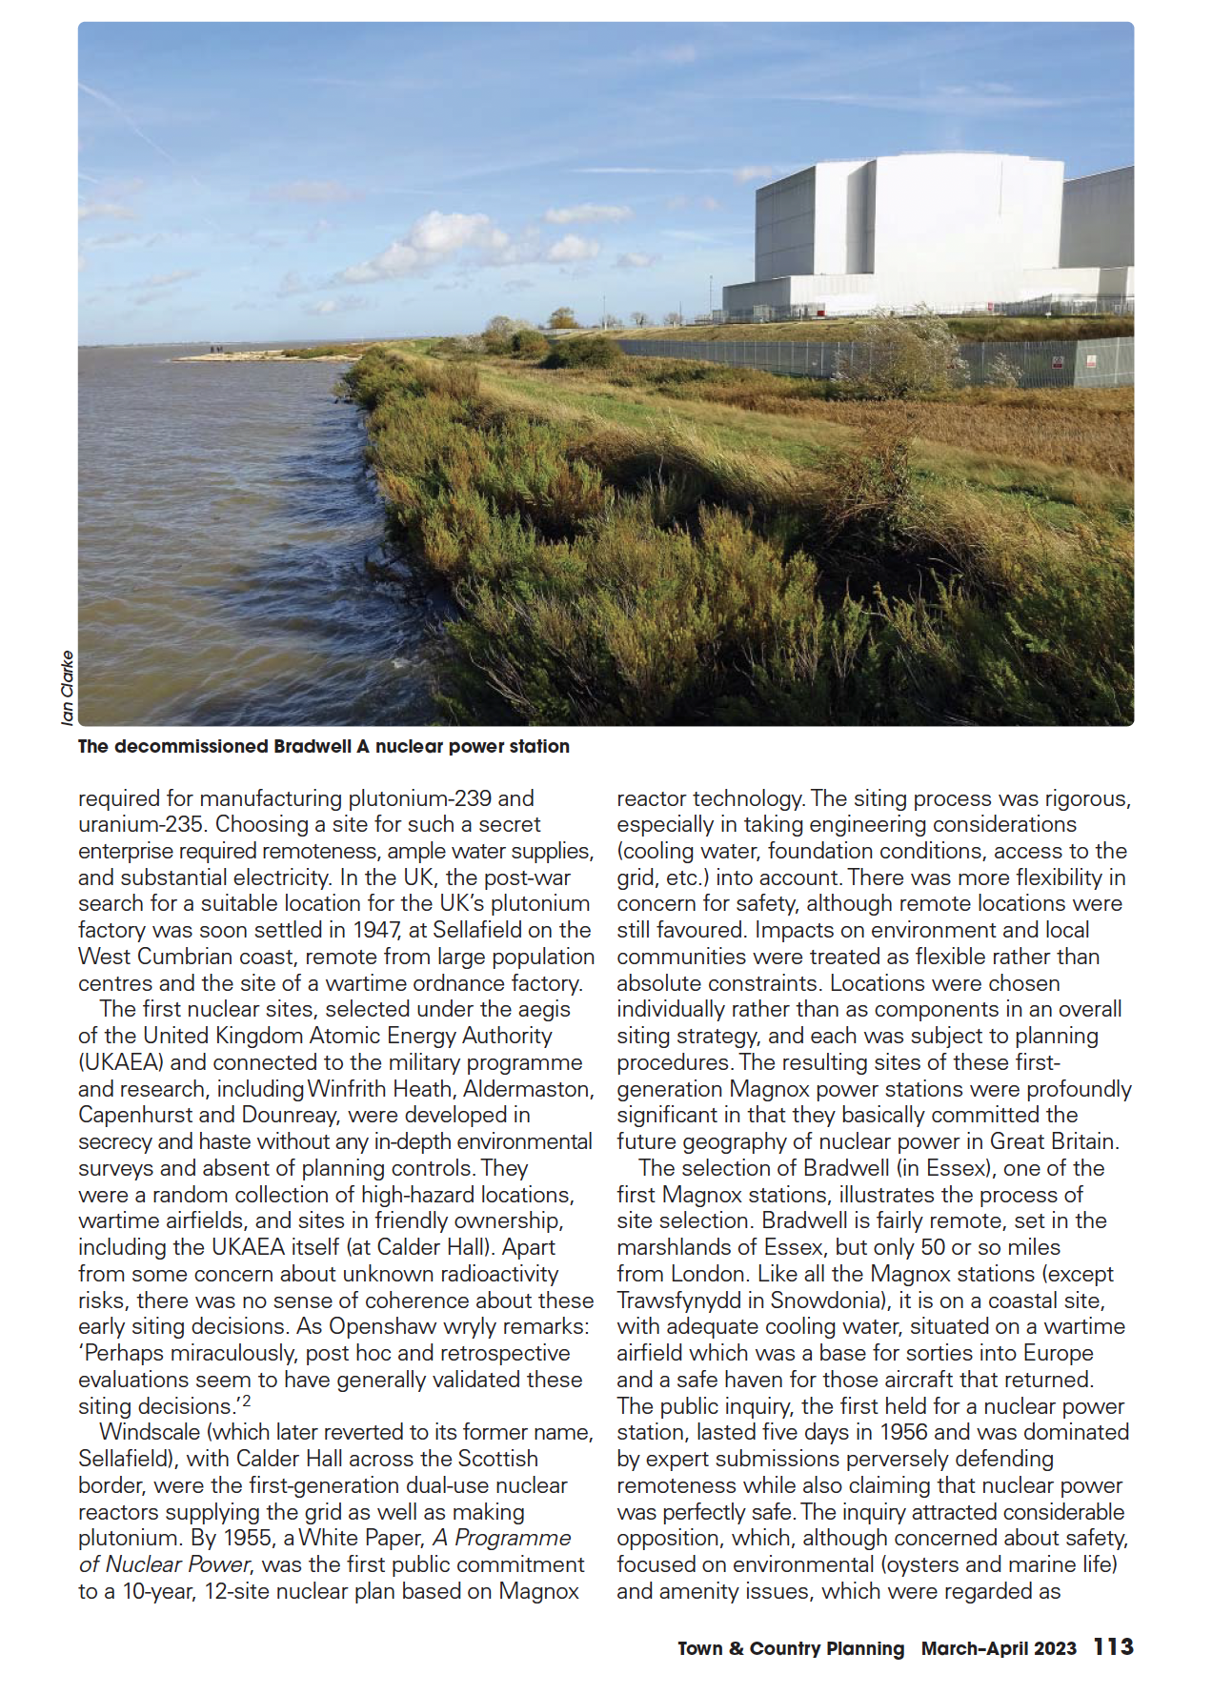

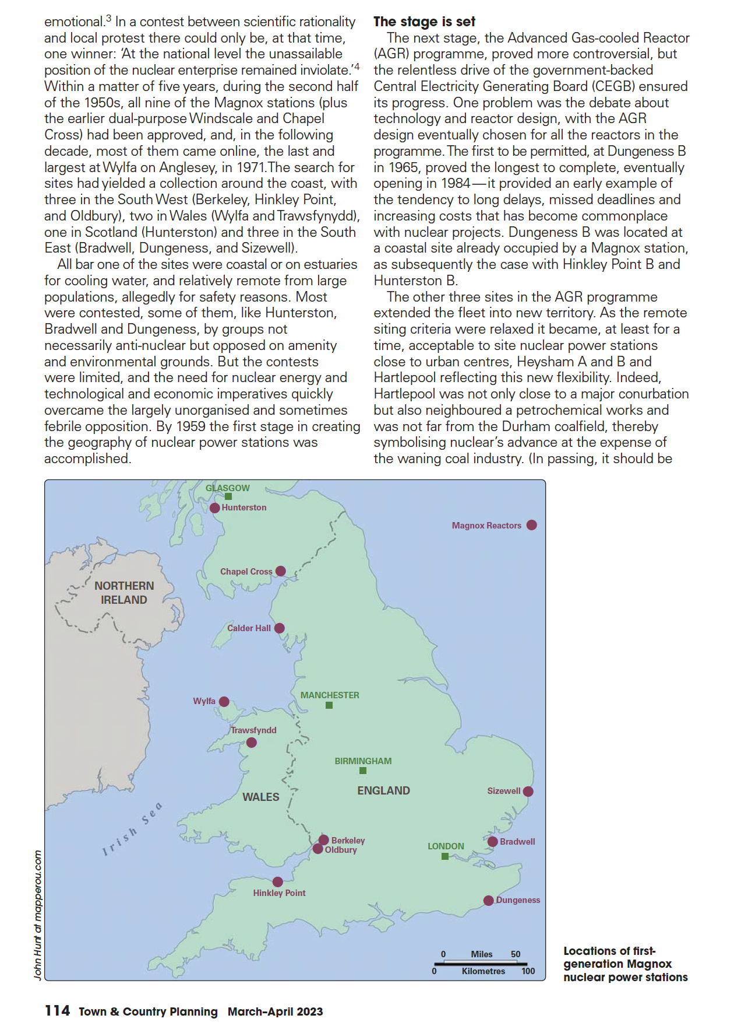

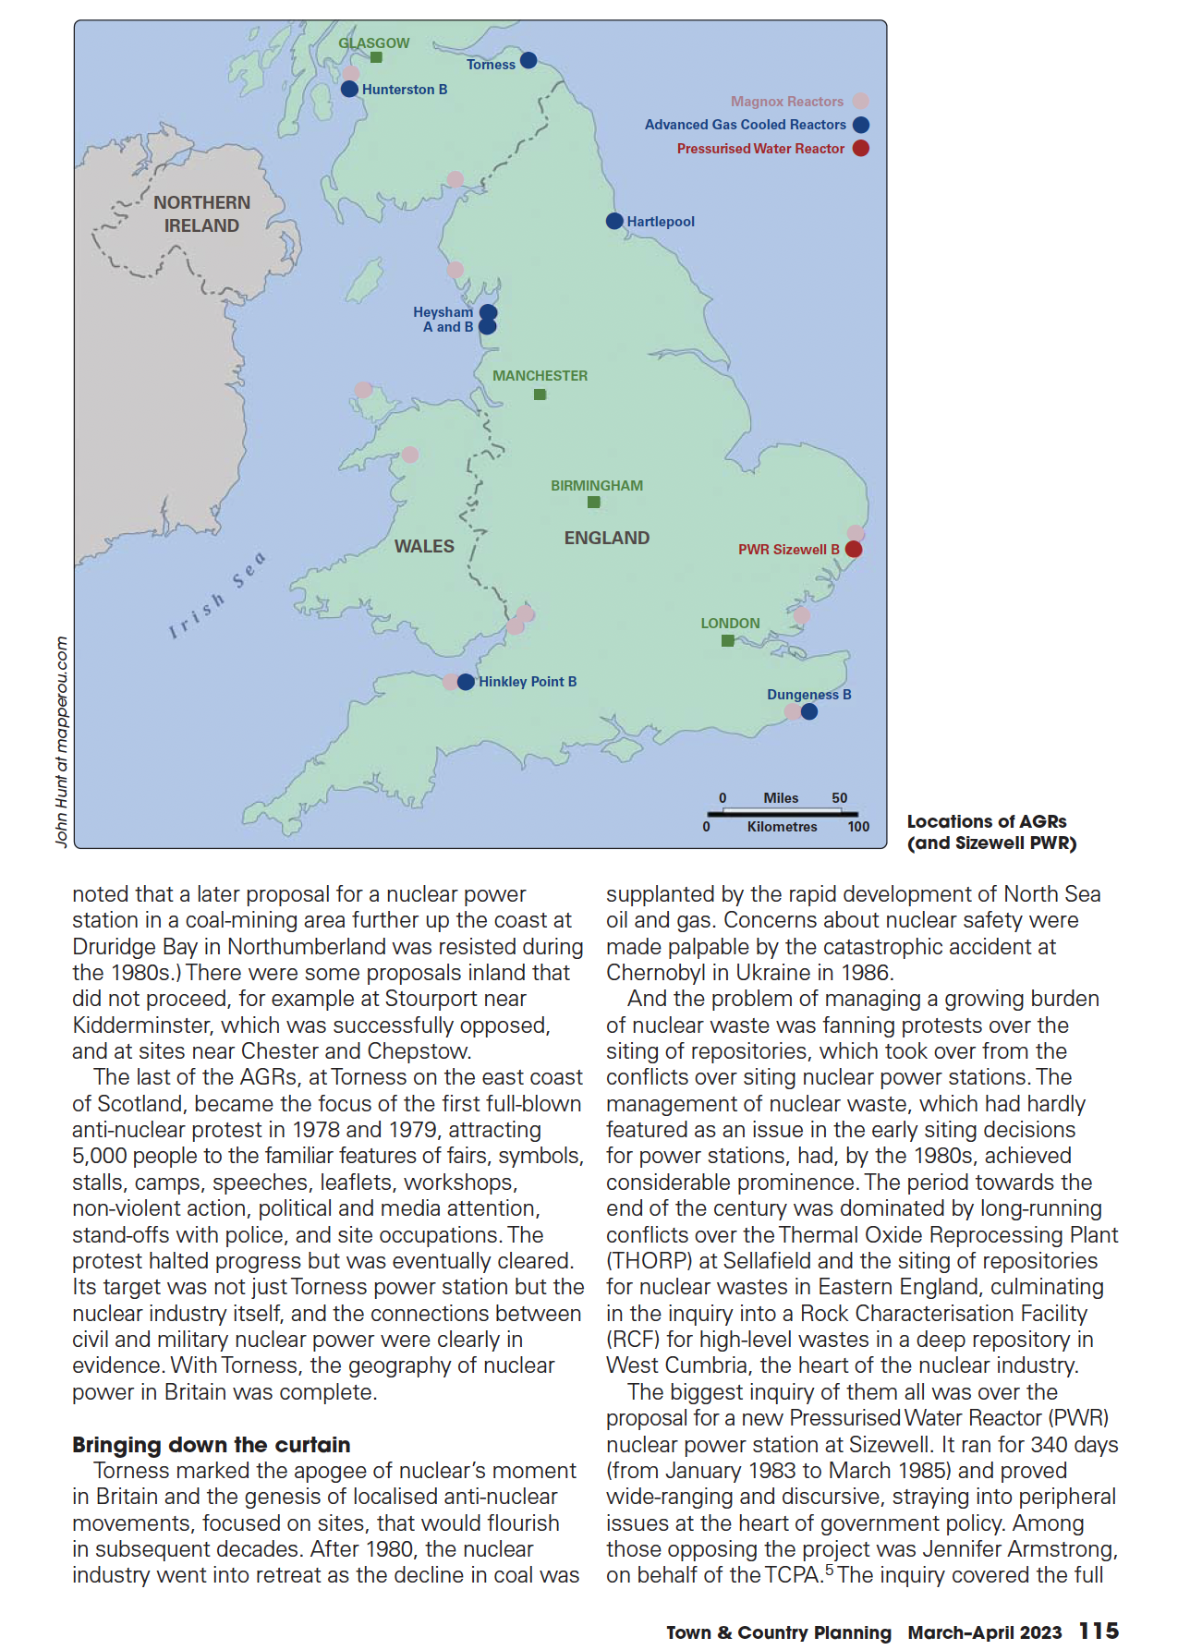

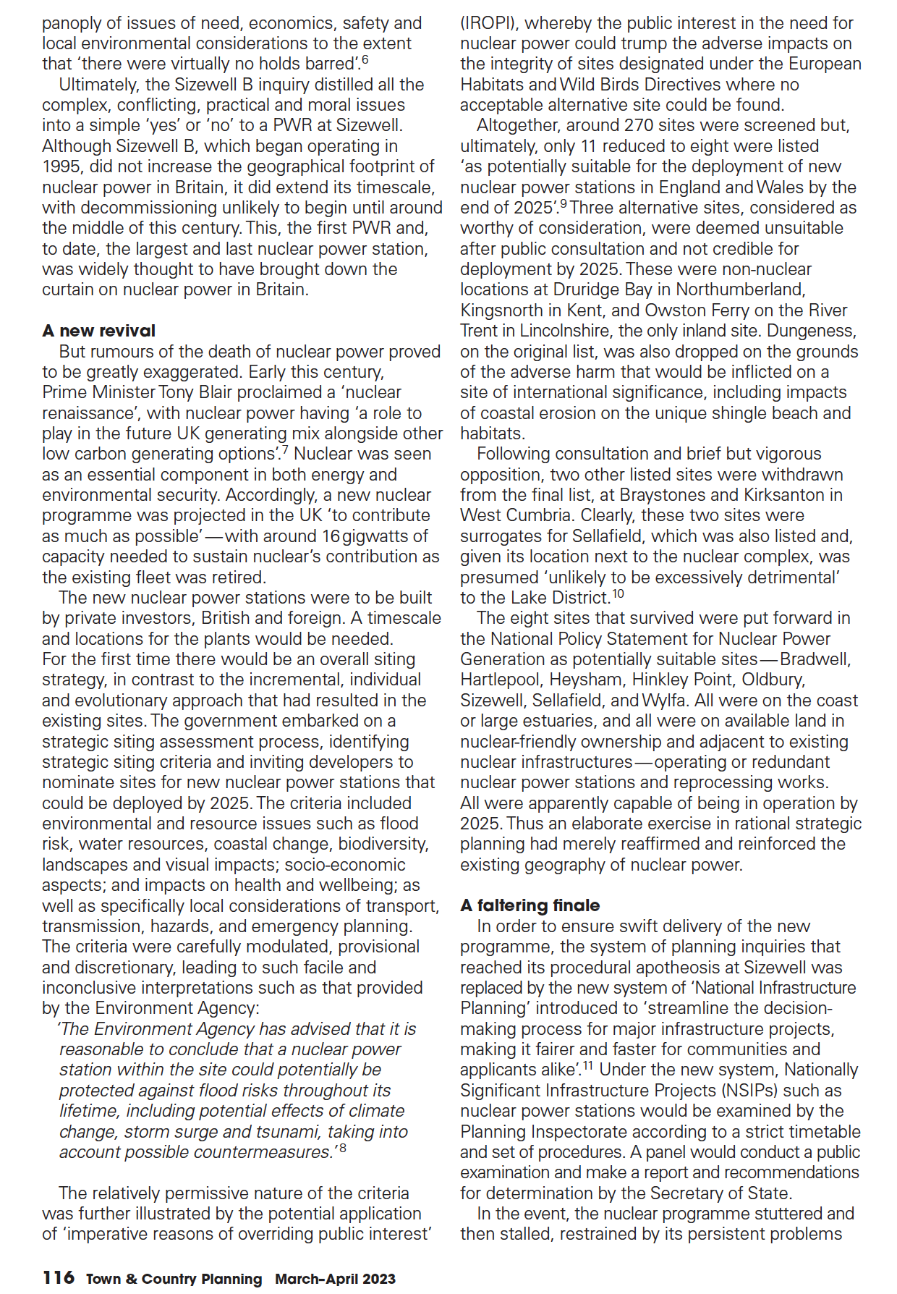

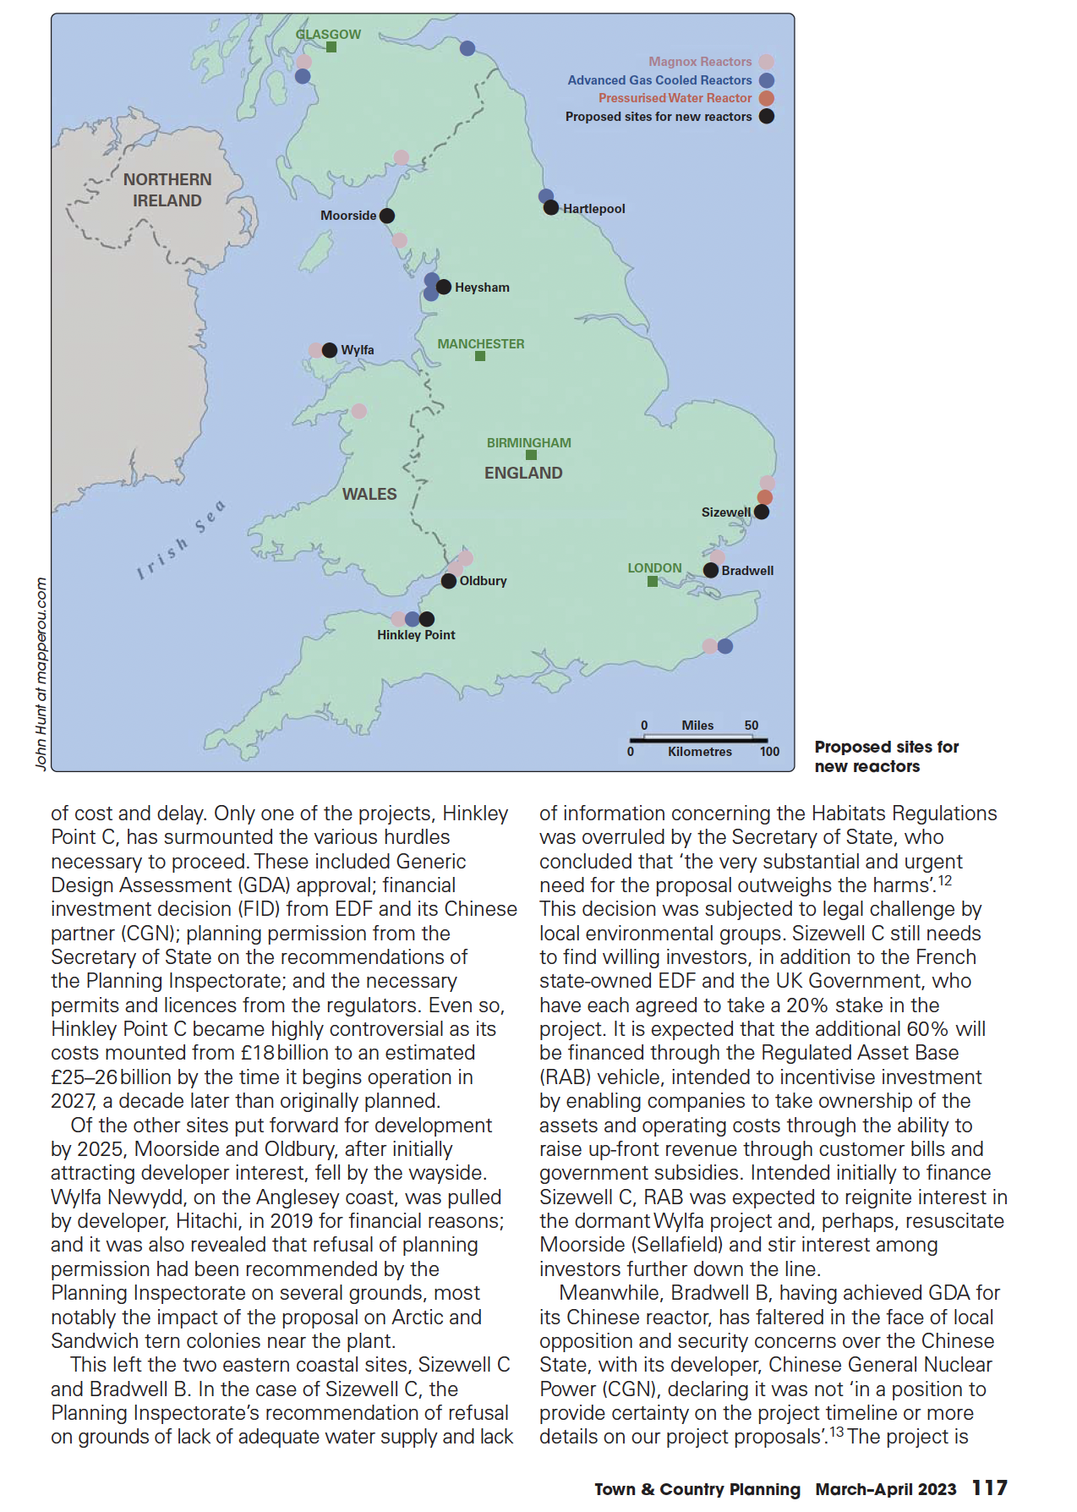

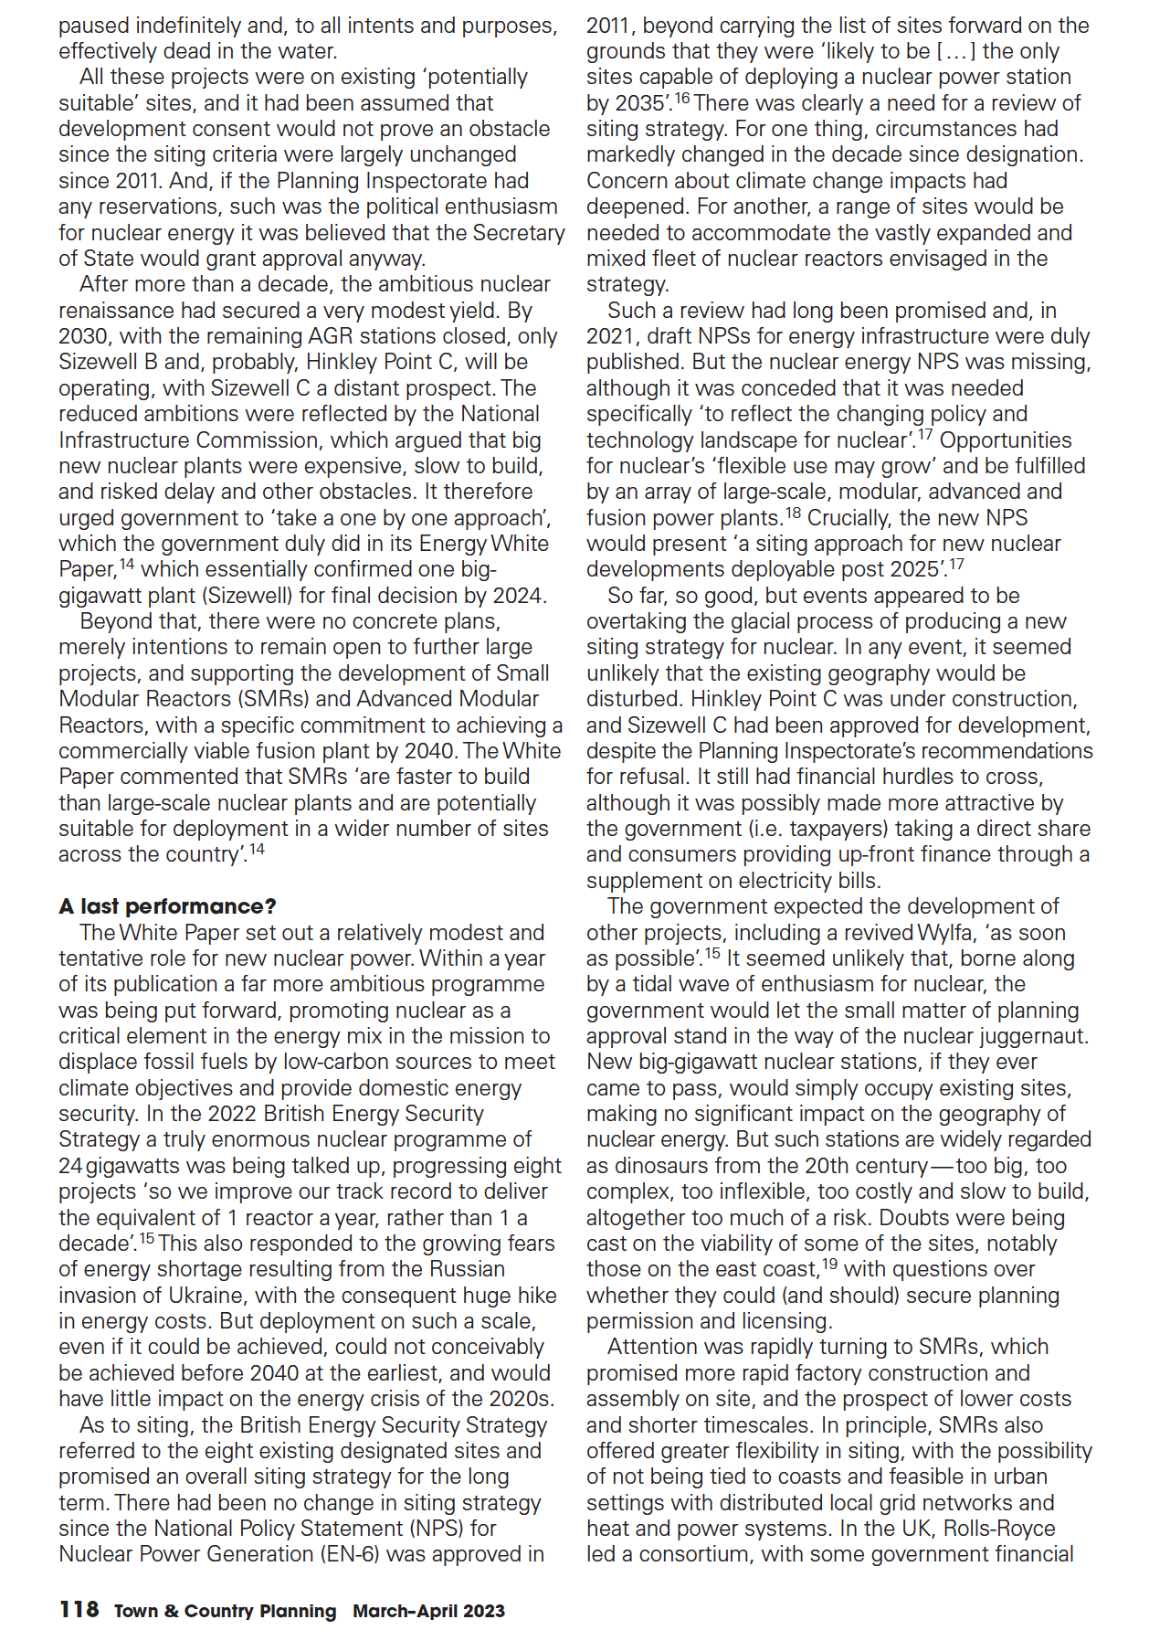

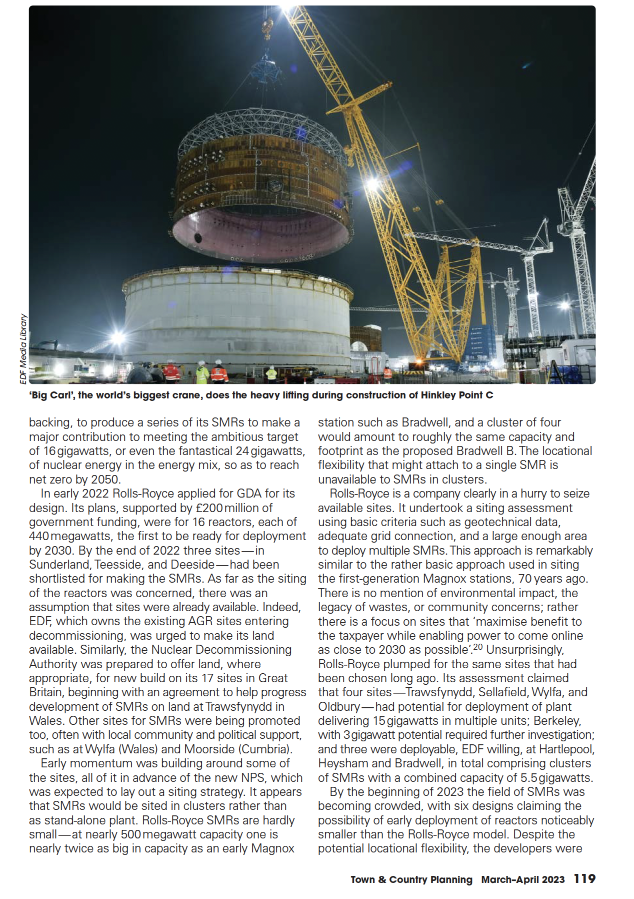

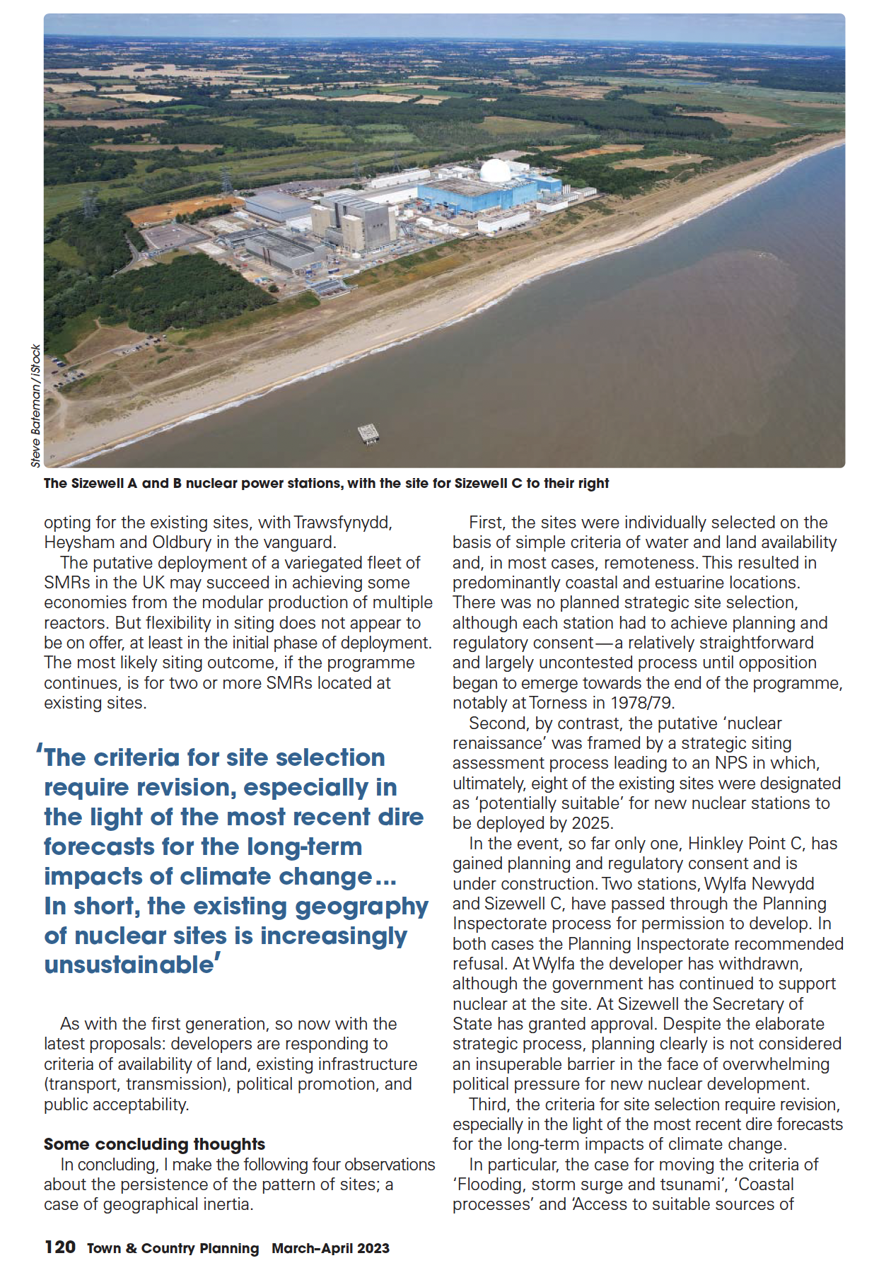

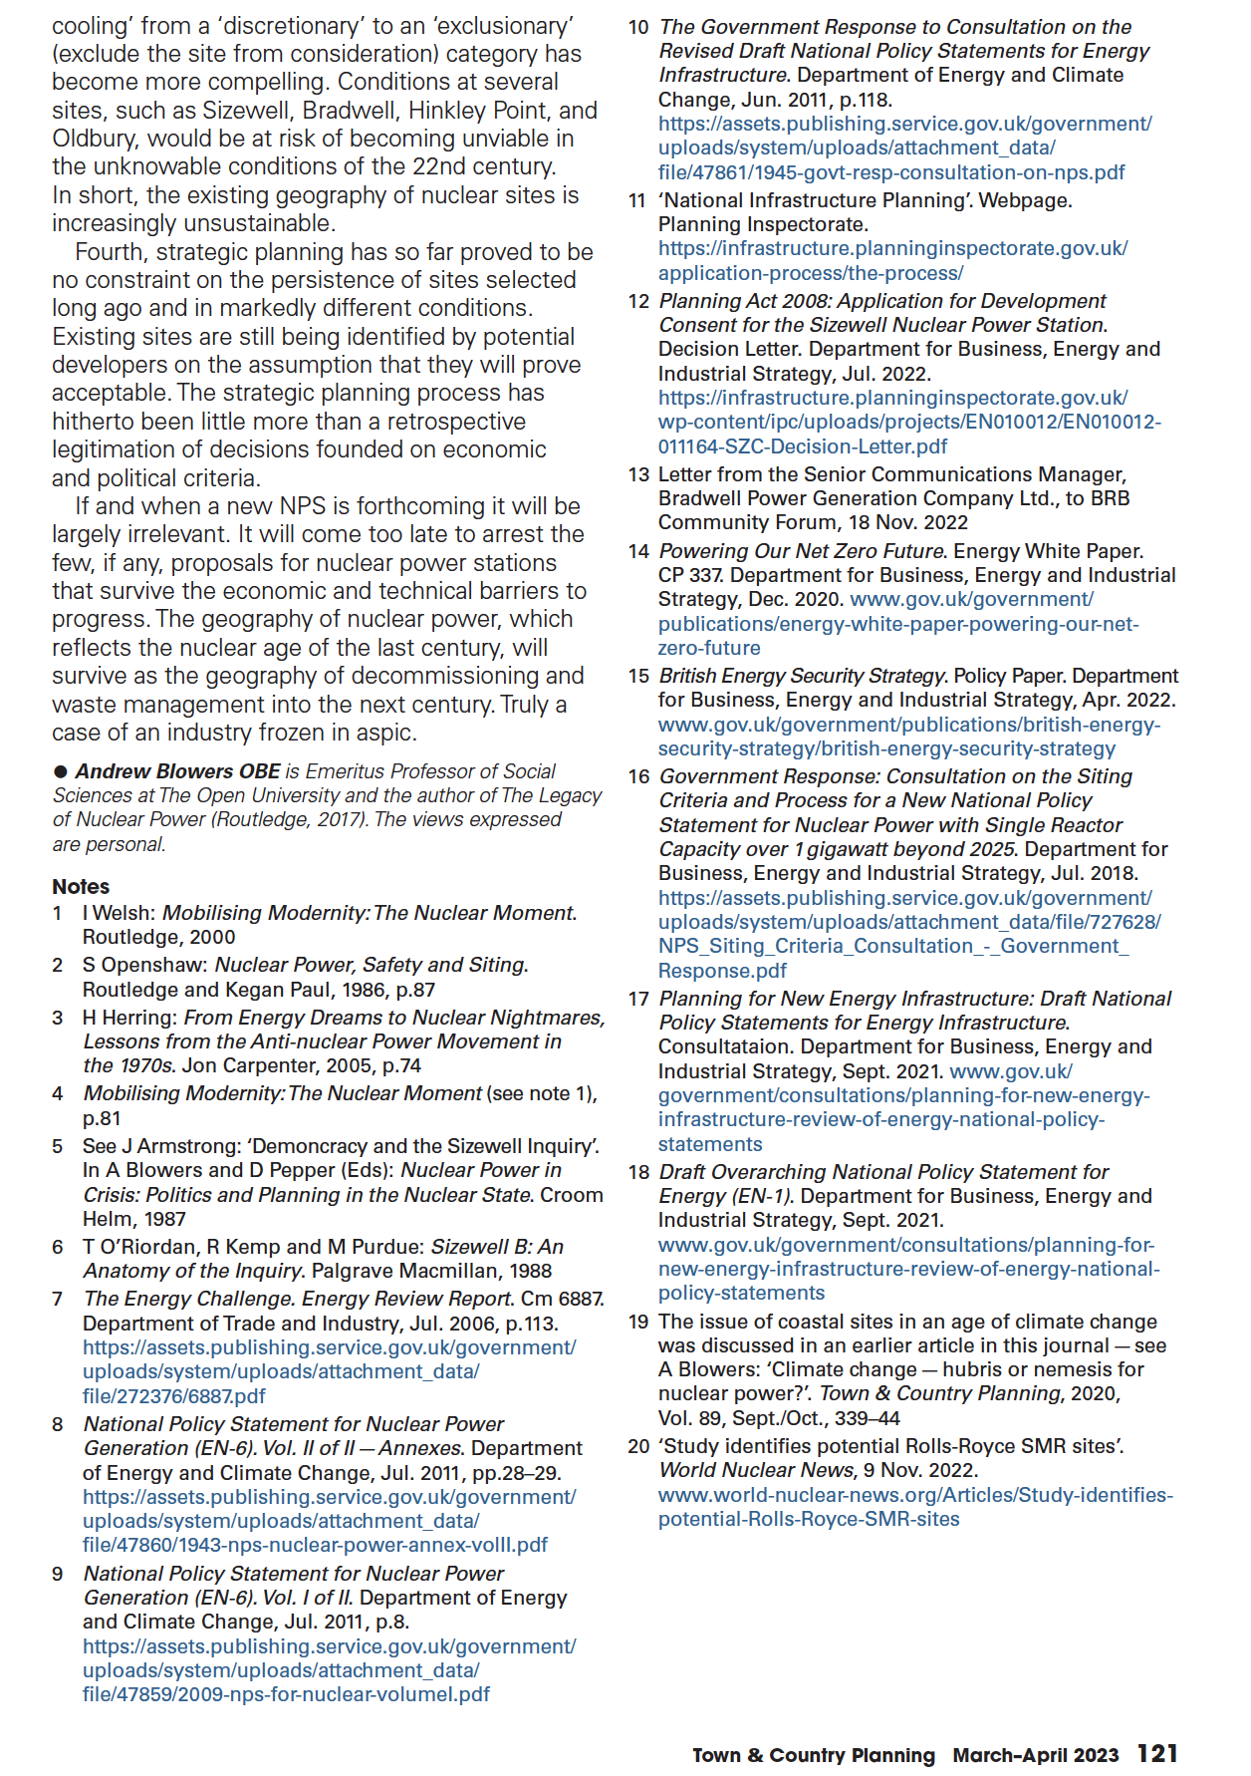

Appendix 5 – Paper by Pete Wilkinson

Speaking on behalf of the NGO Forum on why the present ONR/NGO engagement process is unsatisfactory and how we want the ONR to engage with us, particularly on the issue of climate change.
I believe I speak for all NGOs and most anti-nuclear organisations when I say that we welcome and accept the presence, the need and the purpose of a nuclear regulator.
In such a body, NGOs and nuclear communities around the country should have uncritical faith and trust. They should be secure in the knowledge that such a regulator acts to protect the workforce and the public from the hazards of the nuclear industry and that it operates in a way in which there is a presumption of disclosure supporting an open and transparent approach.
NGOs are fully aware that the ONR’s future depends on undertaking Generic Design Assessments, the issuing of licences, site licencing and decommissioning activities and justifying the maintenance, regulation and expansion of an industry which NGOs want to consign to the rubbish bin of history. In that respect, there is a fundamental fault in the relationship between the two. However, until the NGOs win, and clearly for the foreseeable future, there is a need to foster a relationship between the two based on mutual respect and a commitment to uphold the ONR’s much trumpeted policy of openness and transparency and its putative independence.
But it is an unavoidable and harsh truth that the Office of Nuclear Regulation today represents to many NGOs more of a nuclear policy enabling organisation than a regulatory body. It is seen as a body which exists to ‘box tick’ more than to provide a service which rationalises government policy through regulatory norms and rationales. It has, for instance, far more experience and expertise than, say, the Committee on Radioactive Waste Management to advise on the safest way to manage the nationally embarrassing separated plutonium stockpile, for example. Or to correct the view that SMRs are neither small nor cheap. Or to refuse more readily to licence reactors when they are manifestly past their sell-by date. NGOs, perhaps unsurprisingly, find it inconceivable that, for example, the Hunterston nuclear power station could be licenced for operation while requiring the moderation by super-articulated control rods, or that the ONR could consider without the merest hint of protest the licencing of manifestly unreliable and untested nuclear plants in such ridiculously inaccessible and vulnerable sites as Sizewell, or that it could remain silent when the government produces nuclear policies which are not only delusional but which are conjured up for what are clearly misdirected, blatant political effects rather than as an effective response to the existential threat presented by climate change.
According to the publication, ‘Licensing nuclear installations (November 2021)’, ONR's processes for considering applications for licences for new nuclear sites are (interalia) informed by the desire to:
• build on the proven UK nuclear regulatory process, to protect people and society from the hazards of the nuclear industry;
The regulatory process may have been proven, but its effectiveness in achieving the desired level of protection is impossible to judge for the simple reason that the hazards of the nuclear industry are poorly understood and the ICRP recommendations for exposure limits which are embodied in PHE/Comare regulations are hotly contested. Under the Energy Act 2014, from analysis of the ONR’s website, references to its obligations and referring to the Acts of Parliament which bind them, it is possible to argue that it is a primary requirement on the ONR to feel confident that the regulations it enforces in respect of the safety of the workforce and the public are sufficiently robust to achieve the required level of safety. As far as we are aware, ONR does not independently check the accuracy of the exposure levels it enforces despite its awareness that the issue is subject to growing international criticism.
The HSE, of which the ONR is a non-statutory agency, is concerned with the control of exposure to radiation arising from the use of radioactive materials and radiation generators in work activities ‘…. to ensure that workers and members of the public are not harmed by these activities.’ No such assurance is possible.
The process also requires that the ONR
• minimise(s) uncertainties and ensure(s) (that) our process is clear and transparent to the public and industry;
The climate change issue cannot be minimised, only explored in all aspects to allow a transparent and rational conclusion to be drawn. We support the ONR in its desire to ‘ensure that its process is clear and transparent’. For that reason, later in this statement, we will set out what we mean by those words.
The ONR also tells us that it will:
• ensure a rigorous, robust and transparent examination of the safety case and the safety management arrangements for new nuclear facilities;
This objective, we hope, will form the focus of this and future workshops on climate change and the ONR’s approach to this existential threat to humanity and more directly, in the medium and long term, to the communities which host nuclear facilities. We seek a robust and transparent examination of how the ONR arrives at a position where it can, in all consciousness, indicate that despite the precarious locations of both HPC and SZC, despite the dire warnings and predictions on increasingly rapid sea level rise, issue site licences against its objectives of its mission ‘to protect society by securing safe nuclear operations’.
However, in respect of SZC which uniquely in the UK is a site on which an operating nuclear plant, SZB, sits adjacent to the proposed site of a twin EPR development, it is difficult to see how a site already compromised by its location on an eroding coast, in a flood zone, already acting as a spent fuel store for some 6,000 tonnes of PWR fuel, can possibly be seen as suitable. All the sites identified in the now-redundant NPS EN6 document are referred to as ‘potential’ sites. Despite this caveat and despite overwhelming reasons which were identified in the inquiry process which clearly ruled out Sizewell as suitable site, ONR tells us that it can tick all the boxes for a site licence for SZC barring two issues which relate to the ownership of the land.
At a recent SSG meeting, in my capacity as Deputy Chair of the SSG, I asked the Sizewell B site inspector if he could assure the Sizewell community and the NDA that spent nuclear fuel from SZB and from a notional SZC, was disposable, what the demographic density criteria were for Emergency planning (scenario - by 2030, housing expansion in Leiston adds at least 1000 people, SZC construction adds 3000 and an outage at SZB adds a further 2000 = more than doubling of the people potentially needing to be evacuated in the event of an untimely emergency at SZB) and finally, if the ONR is responsible for the health of the workforce, why don't they support the NGO call for a review of the ICRP recommendations and authorisations given the fact that once upon a time that's exactly what they did but now seem coy about it?
Answers have not been forthcoming and remain unresolved, although it must be said that the inspector in question has recently produced documentation on the subjects of disposability and demography which we are in the process of reviewing. Important as they are to the local community which has acted as a de facto spent nuclear fuel store for decades, which has lived with inadequate and inoperable emergency planning contingencies and with the knowledge that there is controversy around the health consequences of exposure to low doses of radioactivity, these matters have not been dealt with in a timely, robust and transparent manner despite the assurances given on the ONR website that, ‘Transparency about our work is essential to build and maintain public confidence in our regulation.’ The ONR, despite its mantras of ‘open and transparent’ and ‘independence’ has not lived up to these principles and, as a consequence, has failed in its goal to build and maintain public confidence.
According to its website, HSE is concerned with the control of exposure to radiation arising from the use of radioactive materials and radiation generators in work activities. This is to ensure that workers and members of the public are not harmed by these activities.
If that is so, then the HSE as well as the ONR have a moral and legal obligation to ensure that the regulations which govern the environmental contamination from nuclear facilities which directly or indirectly impact the workforce and the public are fit for purpose.
So, what do we want?
We want a frank and open relationship with the ONR on the most pressing of all the environmental issues facing the nuclear industry, climate change. As we are all aware, the nuclear industry requires that we consider the impossibility of looking ahead to unimaginable timescales when considering the management of some of the waste it creates. It requires us to take precautions when the conditions against which we must legislate in terms of protection, technology and safeguards for future generations are inconceivable. It asks of us the impossible and requires us to pass on the consequences of a legacy which we can only minimise rather than remove. NGOs believe we have an intergenerational duty to reduce the risks we pass on to a minimum which means that, in the face of climate change and our inability to predict the future climatic conditions our great grandchildren will face, we have to make decisions today to achieve that goal. We can start by recognising that building new nuclear stations on vulnerable coasts, in flood zones and on eroding coasts is not a good idea.
NGOs need to know the thought processes that lead the ONR to take a different view. What leads the ONR to believe that climate change will not lead to situations in the future which we would do best to avoid by making pre-emptive decisions today?
We want a truly open and transparent engagement with the ONR based on a ‘presumption of disclosure’. We need the ONR to recognise that most NGOs with which it engages spend their own time and energy arriving at their positions of opposition and that their concerns are well-founded, non-trivial and articulated carefully and responsibly. NGOs do not expect to have the efforts of their labours dismissed with disrespectful mantras. They expect grown-up engagement and dialogue. In practice, we believe this will mean that the steps that the ONR takes in its regulatory process which involve the consideration of climate change implications for the nuclear industry are subject to forensic examination through the workshop process, scrutiny, explanation, criticism and justification and that when and if we reach the ‘agree to disagree’ point in these discussions, both sides agree to arbitration through the services of a jointly appointed group of experts to examine and pronounce on the nature and resolution of the impasse. In short, we expect openness and transparency of a nature which can be recognised as such.
Thank you.
Pete Wilkinson
September 2022

Appendix 6 – ONR feedback to NGO presentations at Climate Change workshop, October 2022

Thank you to Katy, Andy and Pete for taking the time to prepare and present your papers at the first ONR/NGO Climate Change Workshop on 04 October 2022. We have considered each in turn and offered our response/thoughts to help begin to set out where we can see alignment and where there may be differences of opinion.
As previously discussed, we will make sure that any future papers are distributed in advance to allow for more of this discussion at future workshops.
Katy Attwater’s paper
In summary the paper sets out
- the background to the workshop
- concerns regarding the suitability of HPC as a site; particularly given its location and the impact of climate change/sea level rise
- a desire for ONR to challenge government on their nuclear policy.
ONR Response
- We reiterate our thanks to Katy for her time in helping to plan and deliver the first workshop and look forward to considering how we make progress with future discussions.
- This is an area where we want to improve our openness in our processes and decision making, explaining how we have reached our judgements and allowing NGOs to scrutinise and understand through the workshops. The climate change discussions will act as a pilot to establish an alternative means of stakeholder dialogue, envisaged in our transparency policy. Andria Gilmour’s presentation to the workshop attendees sought to begin our efforts in this regard by setting the scene and explaining the work of the ONR External Hazards team. The ONR team was clear that the decision on whether nuclear power is the answer to climate change is not a matter for ONR – as the regulator, our purpose is to make sure that it is built and operated safely.
- We recognise that we can do more to be more open about how we inform government policy and have set out how we will do this in our Openness and Transparency Policy. This will include things like publishing our responses to government consultations and explaining some of the advice we provide on topics of interest (as we did recently at the NGO Forum in Manchester).
Andy Blowers’ paper
In summary the paper set out:
- a desire for engagement which exposed ONR’s decisions to scrutiny and reasoned justification.
- questioned the need for nuclear power and challenged the suggestion that it was part of the solution for climate change concerns and a drive to Net Zero
- suggested that the consequences of climate change are so profound that ONR’s managed adaptive approach is inadequate and a different approach to regulation is required,
- aligned with KA and PW comments, challenges ONR to review and refresh their commitment to independence uncompromised by political, government and business influences.
ONR Response
- We share the same aspiration and look forward to taking climate change as a pilot topic to enable us to try and achieve understanding, consensus where possible and clarity on points of divergence. We welcome the NGOs engagement and support in this.
- This is not a matter for ONR and not something we can comment on.
- We recognise the profound challenges climate change will bring and are not complacent about the potential impacts on nuclear safety. We agree with Andy that a cautious approach must be taken and we hope to be able to use the forthcoming workshops to explain in detail how we take climate change science into account at key points in our decision making. We would be happy for these to address Andy’s more detailed questions about the role of the managed adaptive approach in GDA etc.
- As explained above we recognise there is more we can do to be open about how we inform government policy. We regularly inform government policy on a range of matters including for example GDA, siting and the Regulated Asset Based Model. On each occasion our intention is to ensure that the impacts of new policies on nuclear safety and security remain paramount on policy makers minds. We are committed to taking steps to being more open in our policy advice whether that be through publishing our consultation responses or providing more detailed updates at future NGO forums.
Pete Wilkinson’s paper
In summary the paper:
- Challenges ONR’s independence from government, citing the various activities ONR undertakes including undertaking Generic Design Assessments and issuing licences which may expand an industry NGOs do not believe should exist,
- Makes the point that this can be an opportunity to foster a relationship based on mutual respect and a commitment to uphold ONR’s policy of openness and transparency. That the workshops can allow for a robust and transparent examination of ONR decision-making
- Sets out an objective for the workshops to enable NGOs to ‘feel confident that the regulations ONR enforces in respect of the safety of the workforce and the public are sufficiently robust to achieve the required level of safety. Reference to ONR’s role in independently checking the accuracy of the exposure levels it enforces.
ONR response:
- ONR as a statutory public corporation is not free from parliamentary accountability, nor is it entirely divorced from government policy, decisions on nuclear policy made by government do have an influence on the size and shape of ONR.
ONR is neither pro nor anti-nuclear but we advise and inform government policy to inform design and implementation of policies in a way that protects workers and the public, and maintains the high standards of safety, security and safeguards expected in the UK. The independence of our decision making is paramount and remains constant regardless of political or economic considerations and we are happy to discuss this further.
- We agree and this is exactly why we want to do these workshops. The purpose is precisely that, a commitment to openness and transparency and to genuinely welcoming challenge and diversity of thought.
- The issue of exposure levels is a topic out of scope for the climate change workshops, but a line of enquiry we will follow up separately.

Appendix 7 – Workshop 1 presentation

Appendix 8 – workshop 2 presentation

Appendix 9 – workshop 3 presentation

Appendix 10 - Workshop 2 agenda
Time | Item | Notes
9.30 | Arrival | Sign in & participant views on climate challenges from Workshop #1
10.00 | Safety briefing | Stephen J Robinson, facilitator
 | Welcome and introductions | Donald Urquhart, Executive Director of Regulation, Rachel Grant, Director of Policy and Communications, Katy Attwater from Stop Hinkley
 | Reflections on workshop #1 & headline climate change challenges for nuclear regulation | Andy Blowers, Pete Wilkinson, Andria Gilmour, with input from participants
 | Climate change assessment at GDA stage | Andria Gilmour, with participants observations and feedback
11.10 | Coffee
11.30 | Climate considerations at licensing stage | Andria Glimour/Shane Turner, ONR Inspector, Hinkley/Sizewell & future thinking, with  participants review
Lunch
13.15 | Climate considerations at licensing stage (cont.) | Participants discussion and plenary feedback
 | Climate considerations at construction stage | Led by Andria Gilmour and Shane Turner with participants review and plenary feedback
14.40 | Tea
15.00 | Exploring common and divergent views and managing uncertainties | Based on insights from today’s conversations
 | Way forward, next steps and action | Items for workshop 3, points for joint planning workshop 3
 | Closing remarks | Katy Attwater and Rachel Grant
16.00 | End

Appendix 11 - Workshop 2 attendees
NGOs
Alison Downes | Stop Sizewell C
Pete Wilkinson | Together Against Sizewell C (TASC)
Richard Outram | Secretary, UK/Ireland Nuclear Free Local Authorities and Mayors for Peace Chapter Secretary,  City Policy, Manchester City Council
Rita Holmes | Ayrshire Radiation Monitoring Group (ARM)
Jean Allen | Bradwell B Action Network
Stephen Dewick | Bradwell B Action Network
Allan Jeffery | Assistant Co-ordinator Stop Hinkley
Katy Attwater | Stop Hinkley, Holding EDF to Account
Sue Aubrey | Stop Hinkley, Holding EDF to Account
Chris Wilson | TASC
Jill Sutcliffe | NGO co-chair
Andy Blowers | Blackwater Against New Nuclear
Jo Smolden | Stop Hinkley
Ian Ralls | Friends of the Earth Nuclear Network

ONR
Rachel Grant | Director of Policy and Communications
Lorraine Medcalf | Senior Policy Advisor
Nirvana Kidwell | Policy Advisor
Shane Turner | Head of EPR Safety Regulation
Andria Gilmour | Civil Engineering and External Hazards Professional Lead – Nuclear Safety
Donald Urquhart | Executive Director of Regulation and Deputy Chief Nuclear Inspector
Madeleine Bird | Senior Communications Manager

Facilitators
Stephen Robinson
Alison Crowther

Appendix 12 - Workshop 3 agenda
Time | Item | Notes
9.20 | Welcome
10.00 | Introductions, agenda run-through, discussion of any nuclear/climate change related news
 | Explanation of commissioning and operating, post-operations, with quick Q&A sessions following for clarification | Donald Urquhart, supported by Andria Gilmour and Dr Denise Varley
11.05 | Coffee
11.25 | Facilitated group discussions on 1. Commissioning and operating, and 2. Post-operations | Report back from groups
12.30 | Lunch
13.20 | Discussion of previously considered items | Two stations comprising a facilitator and an expert; both groups work concurrently. Participants then swap over and build on the work of the first group and are asked structured questions around uncertainties, monitoring and measuring, future predictions and future plans.  Stations:  Rate of sea level rise and meteorological phenomena (e.g. floods and warming seas)  Future Management of Waste (e.g. site storage of High Level Waste)
15.00 | tea
15.30 | Way forward – next steps and actions
16.00 | Thanks and close

Appendix 13 - Workshop 3 attendees
NGOs
Pete Wilkinson | Together Against Sizewell C (TASC)
Richard Outram | Secretary, UK/Ireland Nuclear Free Local Authorities and Mayors for Peace Chapter Secretary,  City Policy, Manchester City Council
Rita Holmes | Ayrshire Radiation Monitoring Group (ARM)
Jean Allen | Bradwell B Action Network
Stephen Dewick | Bradwell B Action Network
Allan Jeffery | Assistant Co-ordinator Stop Hinkley
Katy Attwater | Stop Hinkley, Holding EDF to Account
Sue Aubrey | Stop Hinkley, Holding EDF to Account
Chris Wilson | TASC
Jill Sutcliffe | NGO co-chair
Andy Blowers | Blackwater Against New Nuclear
Varrie Blowers | Blackwater Against New Nuclear
Jo Smolden | Stop Hinkley, Holding EDF to Account
Ian Ralls | Friends of the Earth Nuclear Network
Bill Parker

ONR
Andria Gilmour | Civil Engineering and External Hazards Professional Lead – Nuclear Safety
Dr Denise Varley | Principal Inspector, Nuclear Liabilities Regulation
Donald Urquhart | Executive Director of Regulation and Deputy Chief Nuclear Inspector
Madeleine Bird | Senior Communications Manager
Lydia Bower | Communications Manager

Facilitators
Stephen Robinson
Alison Crowther

Presentations made by Met Office staff
Met Office, Effects of Climate Change
UK Climate Risk Independent Assessment (CCRA3), Technical Report, Chapter 1
IPCC Climate Change 2021: The Physic Science Basis, Summary for Policymakers, B5.3
UK CCRA3, p.78
IPCC, Climate Change 2022: Mitigation of Climate Change
National Policy Statement EN-6 Nuclear energy, p.13
Ten Point Plan for a Green Industrial Revolution, 2020; Energy White Paper: Powering our net zero future, 2020; Energy Strategy – the Path to Net Zero Energy
Sizewell C EXA Written submission
Bradwell B, Pre-Application consultation Document
Office for Nuclear Regulation Corporate Plan 2022-2023
UKCCRA3, pp.85-6

