|  |
| --- |
|  |
| ONR Strategy  ONR’s approach to regulatory research 2025-2030 |  |



ONR Strategy

ONR’s approach to regulatory research 2025-2030

**Authored by:** Cenbee Bullock, Principal Nuclear Safety Inspector

**Approved b**y: Colin Tait, Technical Directorate Deputy Director

**Issue**: 2

**Published**: August 2025

**Next scheduled review**: August 2029

**ONR Document reference**: ONR-RF-STRAT-001

**ONR Record reference**: [ONRHH-822789359-19664](https://prodonrgov.sharepoint.com/sites/HOW2Hub/_layouts/15/DocIdRedir.aspx?ID=ONRHH-822789359-19664)

Revision commentary

|  |  |
| --- | --- |
| Issue | Description of update(s) |
| 1 | New strategy document setting out ONR’s approach to regulatory research for the period 2025-30. |
| 1.1 | Addition of links to associated documents in Appendix 1. |
| 2 | Minor update to reflect the research topics priority and latest research process. |

Contents

1. Background 4

2. Strategic research objectives 4

3. Approach 4

4. Governance, openness and transparency 5

5. Collaboration and partnering with stakeholders 6

5.1. National stakeholder engagement 6

5.2. International stakeholder engagement 7

6. Value for money 7

7. Near-, medium- and long-term outlook 9

Appendix 1 – Regulatory research process map 10

Appendix 2 – Further details of specialism research areas 12

# Background

This strategy outlines the Office for Nuclear Regulation’s (ONR) research objectives, approach, governance and effectiveness in supporting regulatory decision-making.

Section 88 of the Energy Act 2013 enables ONR to carry out or commission research in connection with our purposes (i.e., nuclear safety, security, transport, safeguards and nuclear site health and safety) and requires publication of results where appropriate.

We regulate Great Britain’s (GB) nuclear sites covering the full spectrum of the nuclear fuel cycle. Research helps us to ensure our regulatory decision-making remains robust, objective, well informed and evidence based. This is vital given the increasingly high-profile and fast-developing environment in the GB nuclear industry.

# Strategic research objectives

To enhance our regulatory capability and effectiveness, and to fulfil our duty as an independent regulator, we commission research activities with the following objectives:

* Address knowledge gaps and obtain independent advice more effectively and sustainably to support ongoing regulatory decision-making, particularly in high-priority or contentious areas; and
* Gain a greater understanding and oversight of emerging topics and how they may have impact on nuclear industry.

# Approach

ONR research projects address highly complex and specialised areas. Where a research need is identified, the Research Function (RF) will discuss its significance and priority with the relevant Head of Profession (HoP)[1].

We ensure selected research projects adequately support our strategic objectives and comply with the National Audit Office’s (NAO) value for money criteria[2] (refer to section ‎1 for details). This forms part of the RF’s annual planning process.

To support ONR’s vision as a modern and transparent regulator, we have a strong link with innovation, ensuring the latest technologies, methodologies and approaches are appropriately used (refer to ONR’s innovation strategy for details[3]).

The Technical Directorate (TD) is responsible for approving research projects in line with the allocated budget. We co-ordinate research activities with relevant specialisms providing advice and support as required to ensure research projects are in line with our regulatory framework and support our strategic themes.

The use of our research process map supports effective decision-making when commissioning a research project and technical support contracts. It ensures consistency and accountability in managing financial arrangements and monitoring progress (refer to Appendix 1).

# Governance, openness and transparency

The RF has governance arrangements which are overseen by ONR’s senior leadership to ensure all research activities are adequately managed. They include:

* A standing agenda item at the TD Operations Board, where ongoing and proposed research contracts are reported and discussed; and
* Presenting matters of interest to the ONR Board and the Chief Nuclear Inspector’s Advisory Panel (CNIAP) [4], which evaluates the effectiveness of research projects.

Where projects are high cost or judged to be contentious, we commission independent assurance reviews. These ensure research meets strategic objectives and supports ongoing and future regulatory activities.

We carry out an annual review of regulatory research effectiveness. This is to determine whether ONR-commissioned research has effectively achieved its desired outcomes and satisfied the purposes as outlined in our research strategy.   
The outcomes of the annual effectiveness review forms part of the annual Chief Nuclear Inspector’s report on the state of safety, security and safeguards in the GB nuclear industry.

The RF manages the regulatory research register (RRR) which lists our commissioned research projects. In line with ONR’s transparency agenda, we publish our approach to research and commissioned research reports, where we consider it appropriate to do so, via our website[5].

ONR recognises the long-term value of research activities for knowledge management. Research reports are retained in line with ONR’s document retention strategy to ensure organisational learning and support to future decision-making.

# Collaboration and partnering with stakeholders

The RF actively engages with national and international stakeholders. Supported by our specialisms, we collaborate with industry, research councils and institutes, professional bodies and academia. This supports our aim to deliver research activities that are fit for purpose and represent good value for money.

Where similar research needs are identified by different specialisms, the RF encourages collaborative approaches (refer to section ‎7 for details).

## National stakeholder engagement

The RF works closely with a range of other UK regulators including the Health and Safety Executive, the Environment Agency, Natural Resources Wales, the Scottish Environmental Protection Agency and Public Health England. We have several Memoranda of Understanding (also referred to as General Agreements)[6] in place with different parties to govern relationships and clarify the responsibilities of each involved party.

ONR participates in several nuclear industry research projects as an observer.   
We encourage nuclear research and innovation whilst maintaining regulatory independence. For example:

* The Nuclear Decommissioning Authority Research Board;
* The Nuclear Innovation and Research Advisory Board, which promotes strategic coordination between relevant research bodies across the UK;
* The Control and Instrumentation Nuclear Industry Forum (CINIF); and
* The Expert Panel on Natural Hazards.

At the working level, our specialist inspectors use routine regulatory engagements with stakeholders to:

* Share research governance arrangements;
* Discuss topics identified as requiring research;
* Provide stakeholders with opportunities to undertake this research; and
* Ensure research is not duplicated across the nuclear sector.

## International stakeholder engagement

We have entered Information Exchange Arrangements (IEA)[7], also known as bilateral agreements, with other national nuclear regulators. These include the US Nuclear Regulatory Commission, the Canadian Nuclear Safety Commission and the French Autorité de Sûreté Nucléaire et de Radioprotection. These arrangements enable the involved parties to share information, experience and good practice, where it is believed to be mutually beneficial and in the UK’s national interests.

Our IEAs cover the exchange of regulatory information covering our five purposes. This includes the regulation of siting, construction, commissioning, operation, transport of radioactive material, radioactive waste management and decommissioning of civil nuclear installations. They also cover the preparedness and management of nuclear and radiological emergencies.

# Value for money

The RF uses a rigorous governance process (refer to Appendix 1). This ensures our research complies with the NAO’s value for money criteria, i.e., economy, efficiency, and effectiveness.

We work closely with specialisms and the finance team to optimise the use of our resources and maximise the value of our activities, including:

* ONR’s contract management risk profile tool: we measure the contract value, strategic importance, complexity, availability and level of risk, which defines the contract category before the approval of the research;
* Ensuring the proposed research is not a duplication of existing work: we engage internally with specialisms and carry out peer reviews;
* Seeking to maximise value from research activities: we partner with national and international stakeholders (as above), particularly where knowledge gaps have been identified;
* Technical support contracts: we ensure contracts are awarded and progressed according to our technical support framework, drawing on the support of our commercial and procurement team and the project officer[8] (refer to Appendix 1);
* Ensuring stakeholders fully understand our charging regime for research; and
* Applying internal qualitative evaluations of effectiveness for each research project.

# Near-, medium- and long-term outlook

The RF works closely with ONR’s directorates and specialisms to identify significant upcoming challenges in line with our five regulatory purposes under the Energy Act 2013. This informs our research strategy in the near- and medium-term.

Table 1 provides the top priority research areas that support our regulatory activities for the near-, medium- and long-term. Further details of research topics for each specialism are shown in Appendix 2.

Table 1 – Top priority research areas that support ONR regulatory activities.

|  |  |  |  |
| --- | --- | --- | --- |
| No. | Research areas | Driver for research | Key topics |
| 1 | Climate change | Improve understanding of climate change and its impact | Climate change feedback mechanism and advances in climate science |
| 2 | Advanced technology | Simplification, efficiency, effectiveness and safety demonstration | Artificial intelligence, digital systems, use of advanced analysis tools, advanced nuclear fuel and technology |
| 3 | Cyber security | Greater understanding of how to manage emerging areas of risk | Managing cyber security intrusion |
| 4 | Asset management | Support lifetime extension of advanced gas-cooled reactors | Graphite brick cracking |
| 5 | Nuclear waste | Improve understanding of how radioactive waste is managed | Geological disposal facility |

# 

# Appendix 1 – Regulatory research process map

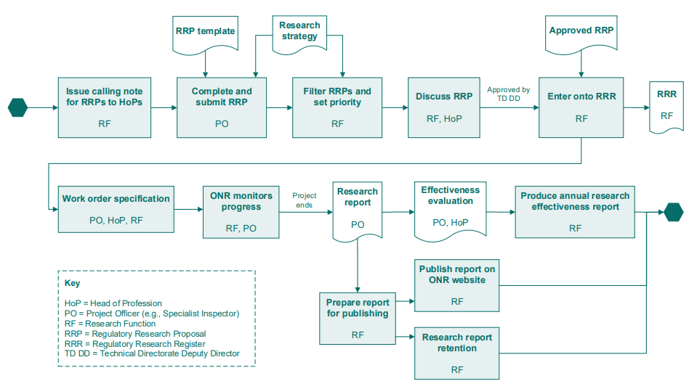

Figure 1 - Regulatory research process

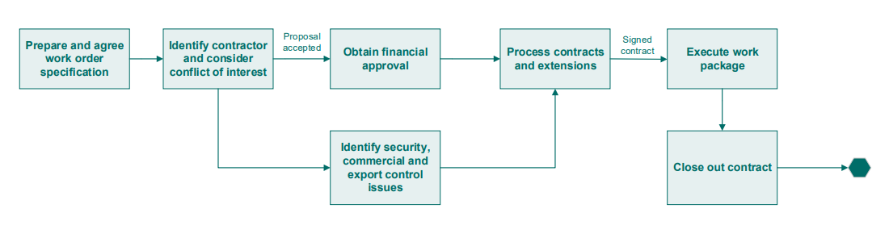

Figure 2 - Commission research and technical support

# Appendix 2 – Further details of specialism research areas

| Cross-cutting specialism areas | | 2025–2030 | 2030–2035 | | 2035–2040 |
| --- | --- | --- | --- | --- | --- |
| Chemistry and Chemical Engineering | | Chemistry of ANT/AMR/SMR/large scale reactors |  | |  |
| Long term corrosion performance of stainless steel and cast iron exposed to potentially aggressive wastes |
| Zinc dosing in light water reactors |
| Graphite disposal |
| Chemistry implications of national plutonium strategy |
| Civil Engineering and External Hazards | | Pre-stressed concrete reactor pressure vessel (PCPV) post operation | Demolition methods for PCPVs | |  |
| Climate change and advances in climate science | Climate change and advances in climate science | |
| Regulatory approach for novel material | Regulatory approach for novel material | |
| UK ground motion model | UK ground motion and seismicity modelling | |
| Civil Nuclear Security | Cyber Security | Emerging areas of risk given ongoing advances in technologies |  | |  |
| Refining cyber security regulatory expectations including cyber protection system |
| Protective Security | Use of artificial intelligence (AI) to help predict or identify insider risk |  | |  |
| Electrical, Control and Instrumentation (EC&I) | | Regulatory approach of deploying AI technologies on UK civil nuclear facilities |  | |  |
| Practical techniques and guidance for building safety demonstrations for computer-based system important to safety |
| Techniques for assessing a system’s adequacy for its safety application and producing evidence to contribute to the safety demonstration |
| Investigation and guidance on use of new technologies |
| Consideration of cyber security aspects from a C&I safety perspective |
| Fault Analysis | Fault Studies | GenIV thermal hydraulic and physics modelling (inc. validation) | Additive manufacturing technologies for the construction of nuclear fuels. | |  |
| Fuel and Core | GenIV Fuels |  | |  |
|  | Probability Safety Analysis | PSA for SMR/AMRs - modelling passive components and/or non-traditional consequences and accident sequences (collaborate with HF) |  | |  |
| Human and Organisational Capability (HoC) | | HF aspect of robotic and autonomous system (collaborate with C&I) | Long-term communication of hazards associated with GDF. | | |
| Efficacy of peer checking |
| HoC aspect of deploying AI |
| Human behaviour and reliability during emergency tasks |
| Enhanced decision making |
| Further validation of nuclear safety culture index and potential expansion into Security and Supply Chain culture |
| Electric vehicle fire |
| Mechanical Engineering | | ASME NOG1 | Security of fuel supplies for emergency generators |  | |
| Geological Disposal Facility |  |  | |
| Nuclear Liabilities Regulation | | Drying and dry storage of spent nuclear fuel | Geological Disposal Facility | | |
| Materials to waste |
| SMR/AMR/ANT radioactive waste management & decommissioning, including graphite and lead-bearing material |
| Lifecycle ALARP |
| Characterisation of fire and explosion hazards: experimental and modelling work |
| Nuclear Internal Hazards and Site Safety | | Advanced Nuclear Technologies and Advanced modular reactors:  How innovative materials in new advanced reactors respond to fire and/or other hazards.  Fire initiation mechanisms in high temperature designs.  Explosion hazards arising in new reactor designs.  Fire and explosion models for new reactor designs. | | | |
| Understanding of hazard combinations, and the use of potentially bespoke methodologies and models relating to nuclear technologies |  | |  |
| Use of advanced analysis tools and AI to develop regulatory intelligence (collaborate with cyber security, C&I, HoC and regulatory intelligence). |  | |  |
| Regulatory Oversight and Intelligence | | Measuring Safety Performance: review current practices for measuring safety performance to identify good practices |  | |  |
| Verification of criticality software codes and data biases |
| Radiological Protection (RP) and Criticality, Emergency Preparedness and Response | | Identification of indicators of health and stressors within a stakeholders’ REPPIR emergency plan |  | |  |
|  | | Dose conversion factors due to groundshine for non-adult age groups |  | |  |
| Public dose info for RIFE report (Food Standards Agency) (methodology for dose rates/habits) |
| AI in RP, criticality and shielding measurement and calculations |
| Environmentally assisted degradation |
| Non-destructive examination |
| Structural Integrity | | Research of graphite/brick cracking to support regulatory activity for ongoing AGRs operation. |  | |  |
| Safeguards | | The use of AI/machine learning in nuclear material accountancy |  | |  |

1. [Our specialists | Office for Nuclear Regulation (onr.org.uk)](https://www.onr.org.uk/our-work/how-we-regulate/our-specialists/)
2. [About us - National Audit Office](https://www.nao.org.uk/about-us/)
3. [Innovation | Office for Nuclear Regulation](https://www.onr.org.uk/our-expertise/innovation)
4. [Chief Nuclear Inspector Advisory Panel (CNIAP) | Office for Nuclear Regulation (onr.org.uk)](https://onr.org.uk/news/all-news/2013/05/chief-nuclear-inspector-advisory-panel-cniap/)
5. [Our research | Office for Nuclear Regulation](https://www.onr.org.uk/our-expertise/our-research)
6. [Memorandum of Understanding / General agreements | Office for Nuclear Regulation (onr.org.uk)](https://onr.org.uk/working-with-others/agreements-with-others/memoranda-of-understanding-general-agreements/)
7. [Information Exchange Arrangements (IEAs) | Office for Nuclear Regulation (onr.org.uk)](https://onr.org.uk/working-with-others/agreements-with-others/information-exchange-arrangements-ieas/)
8. [Documents (onr.gov.uk)](https://how2.prod.onr.gov.uk/CtrlWebIsapi.dll/webDocs/) – The Project officer role and responsibilities are documented in Appendix 1 of ONR-DOC-TEMP-076 – ONR Research Register template.