|  |
| --- |
|  |
| ONR Technical Inspection Guide (TIG)  Organisational culture guide for inspectors |



ONR Technical Inspection Guide (TIG)

Organisational culture guide for inspectors

**Head of Profession** – Human and Organisational Capability (HOC)

**Authored by**: LMfS Specialist Inspector, HOC

**Approved by**: Head of Profession

**Issue**: 3.2

**Published**: November 2024

**Next scheduled review**: June 2026

**Document reference**: NS-INSP-GD-070

**Record reference**: 2020/209745

Revision commentary

|  |  |
| --- | --- |
| Issue | Description of update(s) |
| 1 | Major revision, including:   * A column in the table in Appendix 2 re-named and a small number of consequential amendments have been made to the main body of the document to ensure that references to the table and its content and consistent. * Bullet-points have been introduced in Appendix 2 to improve readability. |
| 2 | Updated review period. |
| 3 | Major revision, including:   * Title changed from ‘Safety culture guide for inspectors’ to ‘Organisational culture guide for inspectors’. * Introduced the warning flags as a way of collecting, monitoring and responding to organisational culture weak signals * A process for inspectors to collect and record warning flags * Appendix including good and bad examples of the warning flags * Handy card for printing with a summary of the flags |
| 3.1 | Minor update to correct issue with QR codes in Appendix C. |
| 3.2 | Minor update to include reference to ONR’s Definition and Model of Safety Culture document. |

Contents

1. Introduction 4

2. Purpose and scope 5

3. Relationship to relevant standards and guidance 7

4. Description of warning flags 10

5. How to use the warning flags 16

6. Further guidance on developing a positive organisational culture 22

Appendix A – Organisational culture management cycle 23

Appendix B – Warning flag examples 25

Appendix C – Warning flags: Handy cards 34

References 36

Glossary 39

# Introduction

1. This Technical Inspection Guide (TIG) is part of the Office for Nuclear Regulation’s (ONR) organisational culture regulatory activity. It is intended for inspectors to use in any regulatory interactions with dutyholders. It uses “warning flags” to enable inspectors to identify and consistently record observations on attributes of organisational culture. These observations support, target and prioritise ONR’s organisational culture assessment and related activities.
2. Nine organisational culture warning flags are outlined as follows:

* Complacency and overconfidence;
* Compromised decision-making;
* Ineffective regulator relations;
* Deviation from standards and behaviours;
* Impaired sharing and isolationism;
* Poorly managed change;
* Missed learning;
* Inconsistent leadership; and
* Lack of personal ownership and engagement.

1. This TIG contains detailed guidance for each warning flag. Any ONR inspector from any regulatory team or purpose can use it to record their observations and target their regulation. These observations may inform inspectors’ holistic regulatory judgements on dutyholder compliance.   
   They can also inform the development of regulatory strategies to target organisational culture aspects that are adversely impacting compliance.
2. This TIG does not provide a model of organisational culture, or describe traits to be developed, instead it provides a model of weak signals that will be apparent within dutyholders that are indicative of organisational culture. Each weak signal can be positive, neutral or negative and in isolation do not provide regulatory intelligence, however these weak signals can be collected and may show patterns or trends through multiple engagements.

# Purpose and scope

1. The purpose of this TIG is to describe a method for considering organisational culture in the course of conducting interventions across ONR’s purposes to guide identification of precursors and weak signals that can influence culture and potentially performance. This supports ONR’s intent to understand organisational culture and determine appropriate means of influencing improvements with dutyholders. The TIG and warning flags can be used in three main ways, to:

* Collect insights against the flags as part of normal business to support regulatory strategy and understanding of dutyholders’ organisational culture;
* Consider warning flags during the course of compliance inspections; and
* Undertake targeted inspections on culture.

1. Inspectors should ensure that any significant observations in relation to the warning flags are captured in a way that helps ONR monitor and identify trends.
2. This guide is applicable to all of ONR’s purposes defined in the Energy Act 2013 and is complementary to all regulatory activities. It seeks to provide ONR with a way of determining how organisational culture supports the effective management of risk within dutyholders and can inform regulatory strategy and response. Significant observation(s) should be recorded, and advice sought from the ONR Leadership and Management for Safety (LMfS) specialist inspector so that they can be followed up in an appropriate manner, including recognition of positive attributes to reinforce good behaviours.
3. This guide is one component of ONR’s overall approach to regulating organisational culture. Its purpose is to support inspectors in gathering intelligence from their everyday interactions in a proportionate and a consistent manner against the warning flags.

## Definitions

1. Organisational culture is defined as the collective beliefs, values, attitudes and behaviour of an organisation that influence its conduct [1].   
   Specific definitions for safety, quality and nuclear security culture are subsets of the overarching organisational culture and are defined in Table 1.

Table 1: Table of definitions

| Term | Description |
| --- | --- |
| Safety culture | As per the definition in ONR’s ‘Safety Culture: Definition and Model’ document [2], safety culture is defined by ONR as:  “The underlying assumptions, which underpin the value placed upon safety by every individual and group at every level of the organisation, which interacts with the organisation’s structures and management systems, resulting in behavioural norms that consistently emphasise safety over competing goals.” |
| Quality culture | Culture supporting the achievement of a quality policy and objectives, and the delivery of products and services that meet the needs and expectations of customers and other relevant interested parties (ISO, [4]). |
| Nuclear security culture | The assembly of characteristics, attitudes and behaviour of individuals, organisations and institutions which serve as a means to support, enhance and sustain nuclear security (IAEA, [3]). |

1. ONR has set out its own definition of “safety culture” in its publication ‘Safety Culture: Definition and Model’ a copy of which is available via the ONR website [2]. This document also introduces ONR’s model of safety culture as a set of dimensions and attributes that ONR considers to be the important factors that organisations working in Great Britain’s nuclear industry should strive to understand and improve upon, so that they may continually improve their safety performance and outcomes.

# 

# Relationship to relevant standards and guidance

1. ONR’s mission is to protect society by securing safe nuclear operations.   
   To support this, ONR carries out regulatory activities to ensure that dutyholders are complying with relevant legislation.   
   Dutyholders’ organisational culture will influence sustained and effective compliance. Organisational culture is often a prerequisite for effective safety, security and safeguards management.
2. There are a number of pieces of relevant legislation. Specifically, the general duties employers have to both their employees and those not in their employ are described in the Health and Safety at Work etc. Act 1974. The Act also describes the duties that members of an organisation have to co-operate with their employer, and to take reasonable care. Those general duties are described in more specific detail in The Management of Health and Safety at Work Regulations 1999, under which employers are required to put in place arrangements to control health and safety risks. Those arrangements, if they are appropriate to the size and complexity of the organisation are conducive to a strong organisational culture.
3. Organisational cultural shortcomings are identified consistently as playing a role in major accidents and events across the world and industry   
   (for example, Piper Alpha, Deepwater Horizon, Chernobyl, Brumadinho Dam collapse, Colonial Pipeline ransomware event, NHS maternity hospital events). Organisational culture can be considered as the bedrock upon which dutyholders implement compliance arrangements that adequately control hazards. Thus, recognising organisational culture weaknesses will help dutyholders reduce the frequency and consequences of adverse events.
4. Most safety regulators have recognised the need to consider organisational and cultural issues as part of their regulatory activities. In the UK, other regulatory bodies recognise culture as an enabler which can further reduce the likelihood for adverse consequences and increase compliance with legislation across health care, rail, aviation and major hazards (for example, [6, 7, 8, 9, 10]). From a regulatory perspective, if only outcomes are considered, opportunities for early intervention and risk reduction could be missed. Consideration of culture supports a risk informed enabling approach.
5. IAEA fundamental principles for safety and security, and their supporting requirements and guides, include expectations for fostering and sustaining a strong safety and security culture. They include specific requirements for consideration of safety and security culture in regulatory activities   
   (for example, [11] and [12]). The IAEA sets the expectation that management systems and leadership should prioritise developing, fostering and maintaining a robust nuclear safety and security culture [11, 13].   
   Using this TIG does not remove the requirement for dutyholders to manage their own culture and leadership.
6. Some of the manifestations of poor organisational culture may be enforceable, for example demonstrated breaches of licence conditions, or relevant statutory provisions (RSPs). However, understanding organisational culture also supports an enabling regulatory approach.
7. ONR guidance identifies that IAEA Safety Standard No. GSR Part 2 is relevant good practice for LC 17 [14]. It emphasises that leadership for safety, management for safety, an integrated management system and a systemic approach are essential to the specification and application of adequate safety measures and the fostering of a strong safety culture.
8. ONR Safety Assessment Principle (SAP) MS.1 also recognises that good leadership is key to achieving high levels of safety and establishing and sustaining a positive safety culture [15]. The prevalent attitudes within a dutyholder’s organisation and the framework of the arrangements established by the dutyholder underpin safety culture. The SAPs set the foundation for the effective delivery of nuclear safety, including the development and maintenance of a positive safety culture. Four interrelated enabling principles (MS.1-4) are set out to achieve this:

* Leadership
* Capable Organisation
* Decision Making
* Learning

1. ONR’s Security Assessment Principles (SyAPs) include similar Fundamental Principles on Leadership and Management for Security, as well as a specific Fundamental Security Principle on Organisational Culture [16]. These are considered a foundation for safe and secure operations. The Nuclear Material Accountancy, Control and Safeguards Assessment Principles (ONMACS) also includes a Fundamental Safeguards Expectation encouraging and embedding an organisational culture [17].
2. The objective of the Western European Nuclear Regulators Association (WENRA) is to develop a common approach to nuclear safety in Europe by comparing national approaches to the application of IAEA safety standards. The Reactor Harmonisation Working Group Report – ‘WENRA Safety Reference Levels for Existing Reactors 2020’ – represent good practices in the WENRA member states [18]. This TIG meets the following reference levels: Issue C: Leadership and Management for Safety, and specifically C4 Culture for Safety.

# Description of warning flags

1. Culture is frequently described using a metaphor of an iceberg (**Figure 1**). Culture shapes how people think, feel and behave, as well as how they communicate, collaborate and solve problems. The warning flags set out in this guide are the ‘visible’ manifestations of organisational culture such as strategies, behaviours, actions and policies (i.e., the part of the iceberg above the surface). By exploring these aspects, which can also be considered as weak signals or tacit good practices, it is possible to learn more about the organisational culture ‘below the surface’. Therefore, the warning flags are intended to help inspectors interpret potential areas of strength or signs of inadequate organisational culture. For example, an organisation has a corporate value of ‘integrity’, and during the course of on-site activities an inspector discovers behaviours that demonstrate hiding safety information, showing a disconnect and contradiction between two visible markers which give insights into the ‘real’ (invisible) values and culture.

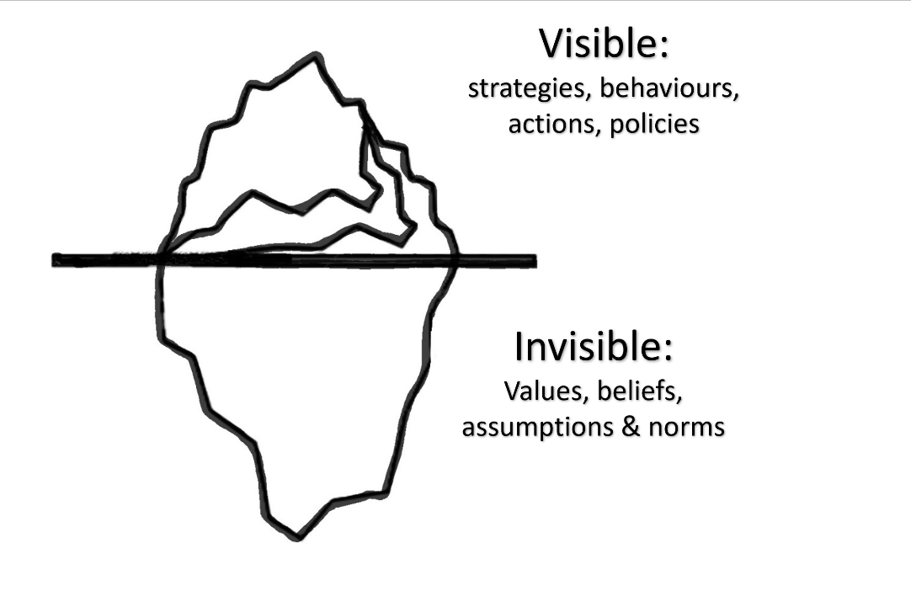

**Figure 1: Iceberg metaphor of culture**

1. During routine interactions with dutyholders (for example, inspections, assessments, permissions, incident notifications, engagements and contacts), inspectors will identify insights and intelligence which provide signs about the health of organisational culture. Each weak signal could show positive or negative aspects to the flag and could be indicative of a deteriorating culture or a precursor to deteriorating performance, or alternatively they could be indicators of strength and should be reinforced. Each signal may be small or inconsequential from each interaction, but collectively they could be insightful of trends, positive or negative.   
   Insights gained from dutyholder interactions can also provide information to be used in discussions with leadership and corporate functions on culture and its impact on performance.
2. Understanding any weak signals will provide insights into the organisational culture and enable ONR to act proportionately and focus on those dutyholders before performance declines. Using the flags does not provide a full assessment of organisational culture, but provides insights into values, beliefs and norms that are not usually apparent to an inspector. A handy two sided ‘print out’ of the warning flags is available in Appendix C and shows the positive and negative definitions.
3. The warning flags are presented in **Figure 2**.

|  |  |  |
| --- | --- | --- |
| Complacency and overconfidence | Compromised decision making | Regulator relationships |
| Deviation from standards and behaviours | Impaired sharing and isolationism | Poorly managed change |
| Missed learning | Inconsistent leadership | Lack of engagement and personal ownership |

Figure 2: Warning flags that can indicate deteriorating organisational culture

1. The nine warning flags are derived from sources which provide descriptions of poor organisational culture, in turn derived from the analysis of events and international research from across multiple sectors [19, 20, 21].   
   These indicators are not the inverse of a positive organisational culture, but the characteristics that have been noted during investigations into large accidents and disasters. The bibliography in Section ‎6, ‘Guidance on developing a positive organisational culture’, provides further detail on what would be required to develop a positive culture.
2. The warning flags are summarised in this section and further detail is available in Appendix B which presents practical examples of what good looks like, or how a negative flag would be manifested. Appendix A presents a summary of positive and negative flags.
3. **Complacency and overconfidence**

An absence of major accidents and incidents does not necessarily indicate that risks are being adequately controlled, so it should not breed complacency. Performance may appear to be good; there are many green performance indicators, but there does not appear to be an appetite to consider warning signs, question arrangements or challenge decisions. Leaders are not monitoring performance and fail to identify discrepancies between actual performance and metrics. Leaders do not welcome diverse indications of actual performance, such as audit and inspection findings, outstanding actions from audits, inspections or monitor subtle performance indicators. These actions are not implemented and a desire to continuously improve is absent.

Focusing on good news can cause disengagement with learning and can lead to cynicism and a failure to continuously improve. Examples could include blame and scapegoating decreasing the likelihood of reporting; failing to determine root causes; overly focusing on individual accountability; and failing to implement corrective actions in a timely manner.

1. **Compromised decision-making**

Decisions may have been made that place an emphasis on production, schedule, generation or other priorities at the expense of safety, security or safeguards. There is acceptance that maintenance and equipment problems can be deferred, and that decisions to deviate from standards can always be ‘justified’. Decision-making does not consider long term impacts and there may be insufficient challenge to decisions made elsewhere (for example, by parent body organisations or corporate functions), which may not have fully considered the impact on safety, security or safeguards. The reasons and rationale for decisions are not communicated appropriately and can lead to cynicism about motivations, which compromises perceptions of leadership and decreases trust.

1. **Ineffective regulator relations**

This warning flag considers how receptive the dutyholder is to challenge and attend to insights from the internal and external regulators. There is a reliance on the external regulator to provide assurance and help manage risk within the organisation. Relationships could be overly friendly or conversely defensive and uncooperative, which may be evident in how regulatory insights are accepted (and acted upon), ignored and disregarded, or argued over. ONR’s behaviours and how they are received can influence the dutyholder’s behaviours and can indicate cultural shortfalls. Performance data is routinely shared, and the rationale for decision-making discussed. This flag also includes how valued and involved internal regulators are and how their insights are acted upon.

1. **Deviation from standards and behaviours**

This flag considers the drift away from accepted good practice or a dutyholder’s management system arrangements. For example, arrangements, procedures and work instructions are not used, safe standards of work are eroded, poor housekeeping is present, or key skills and expertise are being lost. This deviation may be manifested in plant touchers or knowledge workers. Conduct does not appear to prioritise safe and secure behaviours. There is a lack of formality and discipline, which compromises performance and, if tolerated, could lead to significant degradation of performance. There may be evidence of non-compliance being tolerated and normalised throughout the dutyholder.

1. **Impaired sharing and isolationism**

In the nuclear industry it is important to share and build upon knowledge, arrangements and events from high-performing organisations as part of continuous learning to identify and understand performance gaps. This is typically via benchmarking, networks and national and international groups, such as the Safety Directors Forum (SDF), including their working groups on security, safeguards and conventional health and safety, and the World Association of Nuclear Operators (WANO), and could include other high hazard industry bodies. However, some organisations state that they are too different to gain value from sharing, cite other concerns that ostensibly preclude sharing, or focus on ‘keeping up appearances’. This can lead to organisations lagging behind the industry standard and not being aware that their performance has drifted, as well as failing to capture learning from others.

1. **Poorly managed change**

It is widely recognised that modifications to process, plant and people, if poorly executed, can lead to poor outcomes. If changes are poorly managed and communicated, staff not consulted and engaged, or the risks not understood and mitigated, the negative impact will be greater. Change should be carried out by experienced individuals, and implementation agreed following appropriate scrutiny. Leadership needs to be fully engaged in change management and ensure that arrangements are followed and risks appropriately managed.   
These principles are equally important to organisational change, including deviating from a capable organisation and failing to manage changes in leadership, capability and competence.

1. **Missed learning**

A learning organisation should challenge the differences between established understanding and practice, and reflect on these to identify and understand any shortfalls between actual and intended outcomes. Lessons should be learned from internal and external sources to continually improve leadership, organisational capability, safety decision making and safety performance. This could be following up on audit findings, incident investigations, assurance insights, and encompasses the desire to continuously improve. If current practice and thinking are not challenged, opportunities to improve – including reporting, investigating and acting – may be missed. Near misses should be seen as opportunities to learn and a culture of open reporting should be fostered.

1. **Inconsistent leadership**

There are many indicators of leadership shortfalls that undermine organisational culture, including lack of visibility, lack of communication of behavioural expectations, shortfalls in skills, knowledge and competencies. There may also be implicit or explicit promotion of production, schedule or efficiencies at the expense of safety or security, and these behaviours are not recognised or challenged by leaders. Additionally, leaders may not reinforce expected behaviours –   
for example, delivery of actions from inspections, audits and investigations, use of personal protective equipment (PPE) and relevant procedures, and reporting of unsafe conditions - by providing oversight and appropriate focus. Leaders may fail to ensure that they have access to a variety of opinions within the organisation so don’t they have a good understanding of performance including behaviours and effective implementation of the management system.

Leaders embed good management practices, including establishing clear norms and expectations so that there is a sense of fairness and predictability, encouraging open communications and actively listening; and supporting and appreciating people speaking up.

1. **Lack of personal ownership and engagement**

This warning flag reflects the behaviours by the staff at all levels throughout the organisation, including contractors and the supply chain, and concerns their engagement, ownership, participation and involvement in management arrangements. This can be noted in engagement at meetings and contributions to organisational learning, improving work instructions or providing challenge. All believe that their contribution is valued, that they have a role and recognise that their voice matters. Leaders have a key role in rewarding and encouraging these behaviours and breaking down silos and pockets of disengagement.

# How to use the warning flags

1. Figure 3 and this section sets out how to use the warning flags in three main steps.

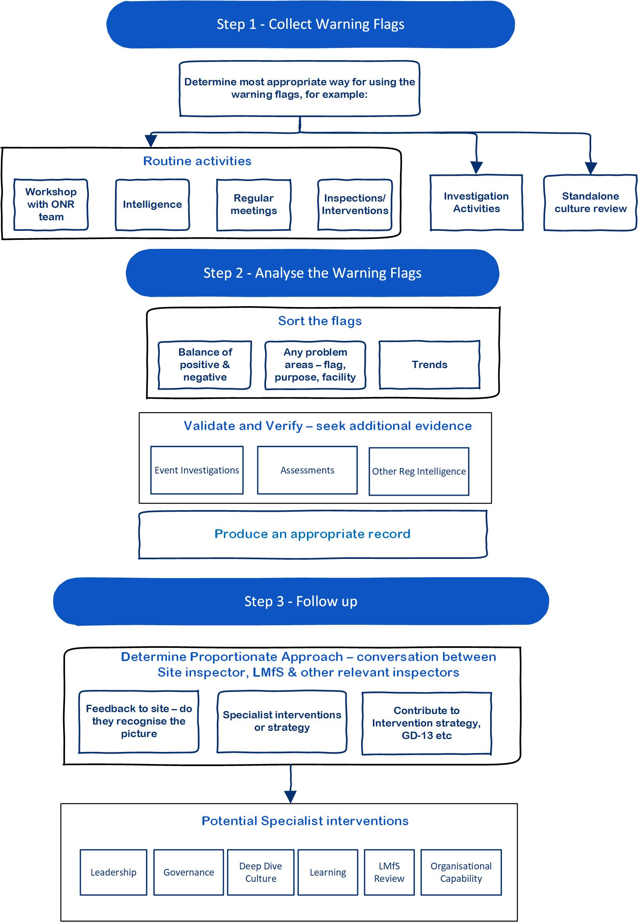

Figure 3: How to use the warning flags

1. Inspectors should ensure that any concerns identified through the use of the warning flags are captured in a way that helps ONR to monitor and identify trending. Equally it is important to dutyholders that positive and negative signs are fed back such that these can be reinforced, remedied or shared with the dutyholder.

## Step 1: Collect warning flags

1. Inspectors periodically sample and evaluate dutyholders’ performance.   
   The warning flags provide a mechanism and structure around which signs of organisational culture, positive or negative, can be organised. They can be used in three main ways, to:

* Collect flags during routine activities;
* Consider flags during preliminary inquiries or investigations to guide information collection; and,
* Enhance a compliance inspection or support a dedicated culture intervention (refer to Appendix A).

1. Inspectors should be alert for the nine warning flags during:

* Interventions;
* Dutyholder meetings;
* Plant walkdowns;
* Assessment of safety cases; and,
* Other regulatory activities.

1. Each of these interactions provides opportunities for cultural insights to be detected – for example, compliance with PPE requirements, housekeeping, acceptance of low standards, or leadership behaviours and decision-making. These insights can be considered as weak signals, which can be recorded to collectively inform any regulatory judgement on culture. The flags can be collected by a number of inspectors interacting with a dutyholder and collated against the warning flags. It is important for both negative and positive flags (the inverse of the warning flags) to be recorded such that a balanced picture is obtained, and the collation of insights is not biased. It is worth reflecting on how complex sites could be broken down, as they may have subcultures guided by different priorities and leadership. There might be pockets or departments which exhibit poor or good behaviours, so best practice should be shared within an organisation.
2. Following an intervention with a dutyholder, a summary of the warning flags witnessed could be recorded in a Contact Record for example.   
   Similarly, they could be recorded in an Intervention Record or running file notes. After some period of time these insights can be collated and analysed to consider the weak signals and their significance (described in Step 2).
3. The warning flags can also be used to support culture interventions, or prompt questions in compliance inspections. Whilst inspections can be used to judge compliance with relevant legislation and provisions, they are also used to identify best practice, influence improvement and inform regulatory strategies. Investigating culture warning flags supports a targeted enabling approach. For targeted culture interventions, specialist LMfS support should be sought.
4. Additionally, the warning flags can be used to guide preliminary inquiries and investigations following events. The flags can prompt areas to explore during investigations and act as a common framework [22].
5. Appendix B presents examples of good and bad practices according to each flag, which will help guide data collection based on the types of issues seen.

## Step 2: Analyse the warning flags

1. On a periodic basis, analysis of the warning flags collected and recorded for a dutyholder can be assimilated by either the nominated site inspector or the LMfS specialist inspector. The flags will be collated and considered to determine if they identify:

* Problem areas isolated to a specific flag, or specific to a purpose or facility;
* Trends, whether adverse or improving;
* Upcoming changes at the site/dutyholder which could amplify any cultural weaknesses; and,
* Threats to organisational culture and potential deterioration.

1. The flags can be categorised, and sorted into the themes, considering the balance between negative and positive and considering if the flags fall into sub themes. For example, missed learning, could include failing to follow up on actions, shortfalls in the quality of investigations or apportioning blame. The insights can be considered to determine if there is a conclusion or summary statement that reflects the sub theme, or the flag. It is worth using the collective insight across ONR’s purposes to understand whether there are consistencies or differences according to purpose. Step 3 identifies how these summary statements can be used to guide regulatory activities, including strategies and interventions.
2. If the flags have not been collected routinely as part of normal business, a standalone review could be carried out. This would involve collecting insights and comments from the regulatory team by, for example, collating examples quarterly from routine interventions and summarising the flags identified. This could also support an LMfS review [23].
3. These insights should be recorded as an assessment note or other appropriate record. It is important to record the findings, both positive and negative and feedback to the dutyholder as appropriate. The advantage of recording positive and negative flags is that performance changes over time can be monitored. If the flags indicate a concern around organisational culture, a discussion about a proportionate risk-informed regulatory approach should be carried out to plan the next steps. If the review of the cultural flags determines that organisational culture is drifting or threatened, there are a range of options that could be explored to target the areas of greatest concern via enabling dutyholders or investigating further regulatory strategies (refer to Step 3). It is also worth considering seeking validation and verification ahead of any interactions with the dutyholder, including history of accidents and incidents, outcome of assessments and other regulatory intelligence.

## Step 3: Follow up

1. Following the analysis of the warning flags and the development of summary statements, the inspector in conjunction with the LMfS specialist inspector and other relevant specialists and inspectors should consider the best way of proceeding to successfully influence the dutyholder. Options to consider include:

* Regulatory intelligence, intervention planning and strategy development [24];
* Input into the assignment of dutyholder attention levels [25];
* Feedback to dutyholder; and
* Specialist interventions.

1. ONR’s preferred approach is to encourage the dutyholder to understand the health of their organisational culture, as well as having a process (refer to Appendix A for a potential plan, do, check, act model) for managing organisational culture. It is important to remember that having a process does not mean that it will achieve the necessary outcomes; however, it will provide a framework for improvement. Options for assessing organisational culture include self-assessment, commissioning an independent assessment or both, which should feed into action plans. A Nuclear Industry Safety Culture Inventory (NISCI) has recently been developed on behalf of ONR which could be used if the gaps are linked to nuclear or conventional safety and provides a method for assessing safety culture [5].
2. If judged appropriate, inspectors may choose to discuss their conclusions with the senior leadership at the dutyholder. The intent is to talk through the findings and describe the threats as identified by ONR. Examples should be provided to enhance the credibility of the conversation further, as conversations around culture can be difficult.
3. Approaching the conversation with sensitivity will assist with communicating the observations and enable the dutyholder to understand why these observations are being made. This conversation should be supported by the LMfS specialist inspector and should be considered as an enabling conversation. ONR should not suggest that the organisational culture is failing, weak or inadequate (or the converse), but highlight that our inspectors have identified potential threats via the organisational culture warning flags. This could then be explored with questions such as:

Does your culture support safe and secure operations? How do you know?

Do staff and contractors share a common purpose on safety and security?

Talk me through a part of your culture you are trying to improve? Why this, and how are you achieving it?

How are you monitoring the impact of your change initiatives on organisational culture?

How do you plan to develop, improve, and sustain your organisational culture?

1. Examples of phrases to **avoid** include:

“Based on our interactions over the last few months we have identified examples that suggest that your (safety) culture is poor…”

“These are the types of matters seen that ONR has experienced over the last [period] and we think these are weaknesses in your culture…”

“We think that your organisational culture is good…”

1. The LMfS specialist inspector in collaboration with the site inspector may determine that a targeted intervention is warranted and appropriate based on the flags. The regulatory intelligence gleaned from the flags could guide the next steps for ONR, including:

* Examining culture in organisations [26];
* Leadership and management for safety reviews [23]; or
* Specific organisational interventions including:
  + Safety leadership [27];
  + Governance [28]; and,
  + Nuclear safety advice and independent challenge [29].

# Further guidance on developing a positive organisational culture

* HSE, ‘Leadership for Major Hazard Industries’ [30]
* IAEA, ‘Developing Safety Culture in Nuclear Activities - Practical Suggestions to Assist Progress’ [31]
* IAEA, ‘A Harmonized Safety Culture Model’ [32]
* IAEA, ‘Nuclear Security Culture’ [33]
* Nuclear Industry Safety Directors’ Forum, ‘Key Attributes of an Excellent Nuclear Security Culture’ [34]
* ONR, ‘Technical Assessment Guide - Maintenance of a Robust Security Culture’, [35]

# 

# Appendix A – Organisational culture management cycle

1. ONR expects dutyholders to have an approach to develop and improve their organisational culture. However, having a process does not mean that the culture will be healthy or positive.
2. **Figure 4** presents a basic ‘Plan, Do, Check, Act’ framework for managing organisational culture. ONR expects dutyholders to have an approach to develop and improve their organisational culture. This will include an organisational culture strategy (‘Plan’) and include for example, behavioural expectations, Mission and Vision statement, governance arrangements. There should be a step for implementing the culture (‘Do’), including communications, training, and leadership reinforcement. The ‘Check’ step is where the dutyholder assess the culture to ensure that it meets the organisational expectations and consider other performance indicators.   
   ‘Act’ is identification of further actions to learn and improve. The cyclical model is based on the idea of continuous improvement, and course correction.

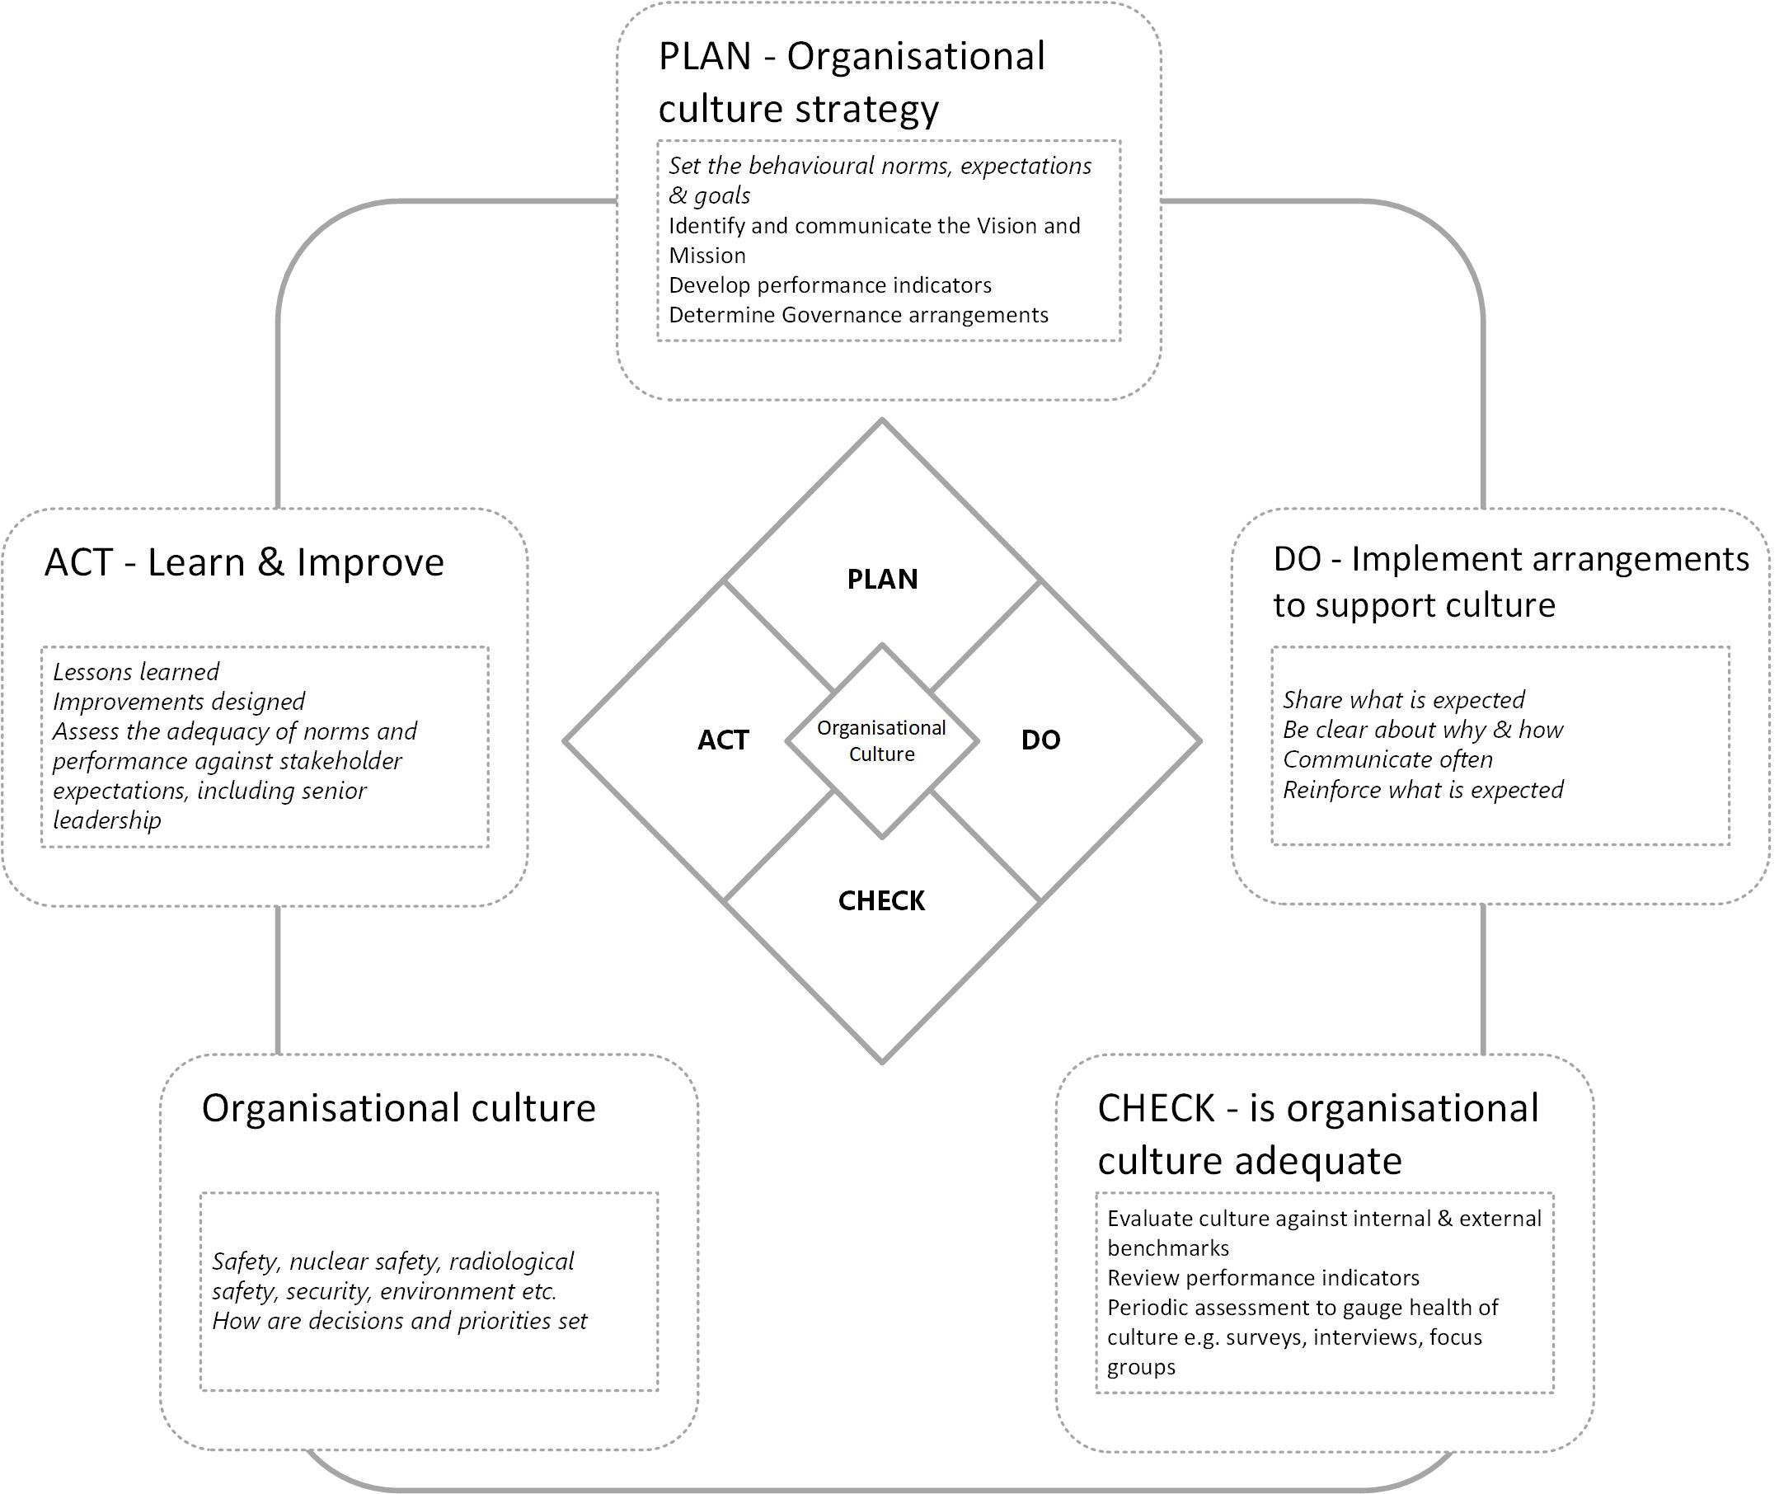

Figure 4: Organisational Culture Management Cycle

# Appendix B – Warning flag examples

|  |  |
| --- | --- |
| **Flag 1 - Complacency and overconfidence** | |
| An absence of major accidents and incidents does not necessarily indicate that risks are being adequately controlled, so it should not breed complacency. Performance may appear to be good; there are many green performance indicators, but there does not appear to be an appetite to consider warning signs, question arrangements or challenge decisions. Leaders are not monitoring performance and fail to identify discrepancies between actual performance and metrics. Leaders do not welcome diverse indications of actual performance, such as audit and inspection findings, outstanding actions from audits, inspections or monitor subtle performance indicators. These actions are not implemented and a desire to continuously improve is absent.  Focusing on good news can cause disengagement with learning and can lead to cynicism and a failure to continuously improve. Examples could include blame and scapegoating decreasing the likelihood of reporting; failing to determine root causes; overly focusing on individual accountability; and failing to implement corrective actions in a timely manner. | |
| **Good looks like** | **Warning flag** |
| * Dutyholder’s senior management drive continual improvement in safety and security performance and have a clear understanding of the standards and expectations. * Plateaued performance indicators are updated to provide useful insights of performance. * Dutyholder’s management are continually questioning and looking for opportunities to learn. * Staff at all levels generally make the effort to understand the potential risks presented by their work or within their span of control. * All aspects of plant, people safety and security are owned by someone, are reviewed from time to time and there are long-term plans for replacement or upgrade as appropriate. Degraded conditions are known and not passively accepted. * Challenge both in decision making and during routine work is normal and accepted constructively as a learning opportunity. | * There is complacency within management, including a failure to appreciate where they may be falling behind or tolerance of poor behaviour. * More effort is put into justifying that conditions are well managed as opposed to exploring the need for change. * Degraded, ageing and/or obsolete equipment is known about; everything is considered to be good enough. No case is produced to support the decision. * Over reliant on quantitative indications rather than seeking adverse signals and opportunities to enhance. * It is built to ‘modern’ standards so there is nothing to improve. * Numbers - Key Performance Indicators (KPIs), probabilistic safety assessment etc., prove we are fine. We do not need to do anything different. * We are special/different/expert so external standards do not apply. * Staff take shortcuts on the assumption that the worst is unlikely, the safety case is conservative, or because they are unaware of risk. * The moment is not right to make improvements, it would be more convenient later. It is not ALARP just now. Procrastinating and making excuses for the status quo. |

|  |  |
| --- | --- |
| **Flag 2 - Compromised decision making** | |
| Decisions may have been made that place an emphasis on production, schedule, generation or other priorities at the expense of safety, security or safeguards. There is acceptance that maintenance and equipment problems can be deferred, and that decisions to deviate from standards can always be ‘justified’. Decision-making does not consider long term impacts and there may be insufficient challenge to decisions made elsewhere (for example, by parent body organisations or corporate functions), which may not have fully considered the impact on safety, security or safeguards. The reasons and rationale for decisions are not communicated appropriately and can lead to cynicism about motivations, which compromises perceptions of leadership and decreases trust. | |
| **Good looks like** | **Warning flag** |
| * Key decisions are clearly communicated, including factors and options considered, and there is evidence of challenge and questions. * Technical conscience is considered fairly against operational convenience. Seniority of rank does not dominate decision-making and is recognised in formal mechanisms. * Decision-making on improvements required is timely considering time at risk, and unnecessary prevarication and over-caution are avoided. Risks include all areas, safety (nuclear, radiological & conventional) and security etc. * Decision makers know when to bring in experts to support decision-making. * Design and planning considers a wide range of risk controls; engineered, process, cultural, supervisory. * Decision making clearly considers the lessons of operational experience, both own and others. * Long term investment decisions are realistic and reflect risks and balance priorities. | * Operational decisions appear to prioritise commercial pressures including schedule, cost and convenience above standards. * There is evidence of ‘group think’ in decision making, where the views of the strongest/loudest character are accepted as correct. * Dutyholders consider, or asks regulator to consider, that ‘big picture’ interests, such as national interest or arbitrary timelines over-ride safety or security. * Apparently reasonable technical conscience, e.g., concerns raised by technical specialists are dismissed in favour of commercial/convenience drivers (“not now, we’re busy”). * Decisions are not made in a timely manner due to over-complex process, diffuse decision-making or workload, or failing to consider cumulative risk. * Decision-making is postponed so there is drift towards a more risky position. * Formal decision-making processes are not adopted; hence groupthink and other error traps are not avoided. |

|  |  |
| --- | --- |
| **Flag 3 - Ineffective regulator relationships** | |
| This warning flag considers how receptive the dutyholder is to challenge and attend to insights from the internal and external regulators. There is a reliance on the external regulator to provide assurance and help manage risk within the organisation. Relationships could be overly friendly or conversely defensive and uncooperative, which may be evident in how regulatory insights are accepted (and acted upon), ignored and disregarded, or argued over. ONR’s behaviours and how they are received can influence the dutyholder’s behaviours and can indicate cultural shortfalls. Performance data is routinely shared, and the rationale for decision-making discussed. This flag also includes how valued and involved internal regulators are and how their insights are acted upon. | |
| **Good looks like** | **Warning flag** |
| * Dutyholders have open discussions with the regulator about problems, risks, concerns, do not need to be prompted and there is trust on both sides. * Dutyholders prepare well for interventions and take feedback in constructive spirit. * ONR findings are taken away to explore the issue, look at evidence and come back with a considered response. * Regulatory issues are managed by the dutyholders through to completion and updates are timely. * The internal regulator is valued and included; their challenge is appreciated. * Regulators contribution is valued and sought. Advice is not seen as direction but contributing to risk management. * Dutyholders welcome working with regulators and use insights to develop a coherent risk-based approach. * Dutyholders are not seeking to transfer risk to the regulator. | * Dutyholders do not prepare for ONR interventions, and simply react ad hoc to what is asked on the day. * The dutyholder is not responsive to requests for information and fails to provide the right people to support discussions. * Repeat objections to planned interventions, and arguments over findings. * Evasiveness, obstruction or lack of cooperation often encountered. * Defensive response to regulator findings rather than dispassionate, considered and evidence-based reaction. * Tendency to accept ONR recommendations as actions without questioning and fail to manage risk priorities. * Regulatory issues drift for extended periods and are not actively managed by dutyholders. * Fear and caution compromises questioning and disclosure of information. * The different regulators are pitted against each other such that no progress is made, or risks resolved. |

|  |  |
| --- | --- |
| **Flag 4 - Deviation from standards and behaviours** | |
| This flag considers the drift away from accepted good practice or a dutyholder’s management system arrangements. For example, arrangements, procedures and work instructions are not used, safe standards of work are eroded, poor housekeeping is present, or key skills and expertise are being lost. This deviation may be manifested in plant touchers or knowledge workers. Conduct does not appear to prioritise safe and secure behaviours. There is a lack of formality and discipline, which compromises performance and, if tolerated, could lead to significant degradation of performance.  There may be evidence of non-compliance being tolerated and normalised throughout the dutyholder. | |
| **Good looks like** | **Warning flag** |
| * Dutyholders behave with rigour and rarely deviate from arrangements. * Human failings are generally errors rather than violations. * The expectations for workplace behaviours are clear and explicit, and reinforced visibly. * Organisation appears well cared-for, plant evidently in a good material condition, working conditions generally tidy and well-lit (as proportionate). * Understanding of hazards and risk is clear, so rationale behind compliance with arrangements is understood. * Standards for safety and security are set, communicated and reinforced. * It is commonly understood what the behavioural expectations for safety and security are, and deviations are challenged. * Challenges to behaviour are welcomed by all. Examples are seen of the workforce challenging leaders. * Staff apply good practice behaviours and techniques such as pre- and post-job debriefs and consider job risk factors and error precursors. | * Turning a blind eye to routine rule breaking (e.g., walkways, clear desk policy, smoking, PPE, litter) and walking by. * Poor working conditions (lighting, housekeeping, signage etc), especially away from well-trodden areas. * Evident poor material condition of plant. * Security standards are drifting (e.g., CCTV failure, key management, information management). * The organisation tolerates failure to follow own arrangements when under pressure from schedule or cost. * Procedural violations are evident and the reasons underlying the violations are neither investigated nor rectified. * Leaders are blind to actual behaviours and ways of working as they ‘walk by’ or fail to recognise behaviours that deviate from the standard. |

|  |  |
| --- | --- |
| **Flag 5 - Impaired sharing and isolationism** | |
| In the nuclear industry it is important to share and build upon knowledge, arrangements and events from high-performing organisations as part of continuous learning to identify and understand performance gaps. This is typically via benchmarking, networks and national and international groups, such as the Safety Directors Forum (SDF), including their working groups on security, safeguards and conventional health and safety, and the World Association of Nuclear Operators (WANO), and could include other high hazard industry bodies. However, some organisations state that they are too different to gain value from sharing, cite other concerns that ostensibly preclude sharing, or focus on ‘keeping up appearances’. This can lead to organisations lagging behind the industry standard and not being aware that their performance has drifted, as well as failing to capture learning from others. | |
| **Good looks like** | **Warning flag** |
| * Dutyholders are outward-looking and up to date with standards and best practice in the industry. * Benchmarking is encouraged and external feedback (e.g., WANO) welcomed and taken seriously. * The dutyholder has the technical capability to appreciate industry norms and standards in all necessary technical disciplines. Networks are used and maintained. * The organisation strives to apply relevant good practice across its facilities and functions. * Open and candid exchanges of information when benchmarking to ensure effective learning. * Weaknesses are discussed, so that benchmarking is not simply about self-congratulation but uncovers useful insights to improve. * Horizon scanning and considering “what if” is carried out, and examples found to learn from. | * Dutyholders are unaware of modern standards in some technical domains. * Standards applied by other facilities do not apply because this location is ‘special and different’. * Lack of routine contact with other organisations to share experiences. * Fail to benchmark and use security reasons as an excuse for not sharing. * Senior managers are not aware of, or do not accept, the perspectives of frontline staff. * Organisation sees benchmarking as a way of demonstrating strengths, rather than exposing challenges. * Friction and misunderstanding between functions or departments instead of alignment. * Organisation is self-referencing and does not see opportunities to learn elsewhere. * Learning opportunities are limited to the easy and obvious as opposed to addressing root causes. * Outward looking activities are not supported by leadership. |

|  |  |
| --- | --- |
| **Flag 6 - Poorly managed change** | |
| It is widely recognised that modifications to process, plant and people, if poorly executed, can lead to poor outcomes. If changes are poorly managed and communicated, staff not consulted and engaged, or the risks not understood and mitigated, the negative impact will be greater. Change should be carried out by experienced individuals, and implementation agreed following appropriate scrutiny. Leadership needs to be fully engaged in change management and ensure that arrangements are followed and risks appropriately managed. These principles are equally important to organisational change, including deviating from a capable organisation and failing to manage changes in leadership, capability and competence. | |
| **Good looks like** | **Warning flag** |
| * Change management arrangements cover all types of change, including people, plant and process. * All change happens in a planned, controlled way and with a clear sense of the desired end state, and risk gap. * Change management recognises the need to cover transition and does not simply focus on the endpoint. * Relevant technical specialists are included in change management. * Change proposals are subject to scrutiny and challenge to ensure that risks and mitigations are appropriate. * Oversight and governance of change is proportionate and appropriately qualified to judge and recognise shortfalls. * Following changes, learning opportunities are sought. * There is proactive review and discussion with staff to ensure that the organisation remains fit and is functioning well. * Staff are clear about where they fit in the company’s work and how they contribute. * Specialist capability is maintained, and vulnerabilities managed. There is clarity over demographic changes and future work demand. * Succession plans are clear and have depth. * Management of organisational change is applied to all areas of the business and not just those required for compliance. | * Many changes are underway, and leadership are failing to adequately communicate or plan for the extent of change. * More effort is put into justifying that conditions are well managed as opposed to exploring the need for change. * Lip service is paid to change arrangements, e.g., under categorising, avoiding governance and assumptions about risk. * Risk gap is underestimated so that change is deferred. * Uncertainty about the future causing delays, distraction or affecting morale. * Capability in specialist areas lost and not replaced. * High attrition rates are tolerated. * Improvement work delayed because of lack of competent resource. * Lack of clarity about who is responsible and accountable during change, and at end points. * Lip service is paid to change management processes, e.g., ‘subject to management of change’ following announcement of change. * Focus is on process compliance, rather than management of risk. * No checks to verify that the change has achieved the desired outcome, and to correct if required, or investigate and learn for future changes. |

|  |  |
| --- | --- |
| **Flag 7 - Missed learning** | |
| A learning organisation should challenge the differences between established understanding and practice, and reflect on these to identify and understand any shortfalls between actual and intended outcomes. Lessons should be learned from internal and external sources to continually improve leadership, organisational capability, safety decision making and safety performance. This could be following up on audit findings, incident investigations, assurance insights, and encompasses the desire to continuously improve. If current practice and thinking are not challenged, opportunities to improve – including reporting, investigating and acting – may be missed. Near misses should be seen as opportunities to learn and a culture of open reporting should be fostered. | |
| **Good looks like** | **Warning flag** |
| * Dutyholder’s management display an appetite for learning and encourage the same from all staff. * Many diverse sources of learning are used to promote a culture of continuous improvement. * Improvements are not limited to the ‘must do’s’, but also include enhancements and opportunities to improve. * Investigations are timely and include proportionate investigation of causes and ‘extent of condition’. * Causal factors of incidents arising from apparent human and organisation failings are sought rather than just blaming individuals or issuing instructions to take care. * Disciplinary action is reserved for specific extreme behaviours, but the importance of being accountable is recognised by all. * There is evidence of learning from a broad range of sources. * Deviations from expected outcomes are investigated to extract learning and areas for improvement. * A healthy attitude to learn and improve without interpreting this as criticism. * Contractors and supply chain are treated the same way as the dutyholder. | * Opportunities to identify trends from a broad range of sources are missed and learning not considered. * Human failure is identified as the cause of events, rather than being a symptom of underlying causes, which leads to behavioural solutions rather than seeking to eliminate the risk or provide engineered solutions. * Defect backlogs are unmanaged, and prioritisation is poor. * External learning is missed or dismissed as not relevant. * Delayed delivery of remedial actions leading to tolerance of inaction. * Leadership fails to check that investigations are prompt and of good quality. * There are repeat events. * Investigations do not identify root causes or ‘extent of condition’ for more significant events. * Corrective actions are not progressed or are ineffective. |

|  |  |
| --- | --- |
| **Flag 8 - Inconsistent leadership** | |
| There are many indicators of leadership shortfalls that undermine organisational culture, including lack of visibility, lack of communication of behavioural expectations, shortfalls in skills, knowledge and competencies. There may also be implicit or explicit promotion of production, schedule or efficiencies at the expense of safety or security, and these behaviours are not recognised or challenged by leaders. Additionally, leaders may not reinforce expected behaviours - for example, delivery of actions from inspections, audits and investigations, use of personal protective equipment (PPE) and relevant procedures, and reporting of unsafe conditions - by providing oversight and appropriate focus. Leaders may fail to ensure that they have access to a variety of opinions within the organisation so don’t they have a good understanding of performance including behaviours and effective implementation of the management system.  Leaders embed good management practices, including establishing clear norms and expectations so that there is a sense of fairness and predictability, encouraging open communications and actively listening; and supporting and appreciating people speaking up. | |
| **Good looks like** | **Warning flag** |
| * The attitudes, behaviours and decisions of leaders demonstrate commitment to safety and security above other priorities. There is no confusion as its been clearly communicated. * Leaders have sufficient knowledge and experience to understand the impact of their decisions on safety and security. * Senior management are open with frontline staff and trusted. * Leaders spend a sizeable proportion of their working day face-to-face with their subordinates, are familiar with their views and understand the barriers which ensure safety and security. * Managers are aware of performance of staff, and hold them to account, e.g., for safe and secure working practices or delivery of required improvements * Leaders visibly praise safe behaviour even if it has resulted in commercial inconvenience. * There is alignment between leaders across all organisational functions and levels of hierarchy in pursuit of a common purpose (e.g., the relative priority of safety and security), strategies and goals, and all are held to account for their performance. * Dutyholder’s senior managers are seen to be driving continually improving standards in safety and security. | * Leaders are unaware of practices on the frontline and fail to ensure standards are upheld by their subordinates. * Leaders are seen as remote and there is little direct contact or communication; or only following events. * Direct communication with subordinates focuses chiefly on delivery and cost, safety and security is raised less frequently or only at set-piece occasions (e.g., standdowns following events). * Staff believe that managers prioritise delivery and cost when they conflict with safety and security. * Managers are unaware of safety or security commitments made, or are aware but fail to hold staff accountable. * ‘Leaders in the field’ programmes are either ineffective or chiefly seen as a nuisance by all concerned. Meetings are prioritised over visibility. * Management improvement initiatives are frequently ineffective at achieving compliance or the desired outcome and appear to just come and go. This cycle means that workforce engagement is not achieved. * Leaders are not held to account over their ‘invisibility’. * Leaders fail to lead by example and turn a blind eye to bullying and elitist behaviours. |

|  |  |
| --- | --- |
| **Flag 9 - Lack of personal ownership and engagement** | |
| This warning flag reflects the behaviours by the staff at all levels throughout the organisation, including contractors and the supply chain, and concerns their engagement, ownership, participation and involvement in management arrangements. This can be noted in engagement at meetings and contributions to organisational learning, improving work instructions or providing challenge. All believe that their contribution is valued, that they have a role and recognise that their voice matters. Leaders have a key role in rewarding and encouraging these behaviours and breaking down silos and pockets of disengagement. | |
| **Good looks like** | **Warning flag** |
| * People at all levels can show they are actively engaged in safety and security and are enabled to contribute and make improvements. * Workforce understand their role and how their job and tasks fit into the overall organisational purpose. * Managers at all levels show ownership for safety and security, have plans to continually improve and actively look for learning opportunities they can take. * All staff consistently receive feedback on safety and security performance and are held to account. * Arrangements are in place that allow people to change procedures and collaborate in setting fit-for-purpose arrangements. * People consistently meet improvement commitments in a timely manner. * Processes for safety and security are respected and adhered to both in spirit and letter. * People are recognised and thanked for constructive challenges to the arrangements and practices. * Leaders recognise the importance of acknowledging and acting upon feedback. | * Engineers and managers show little evidence of being proactive, are passive about degraded conditions or threats and do not identify opportunities to improve. * Commitments to improve safety and security are continually missed or delayed due to other priorities. * There is ‘learned helplessness’ in the face of problems, too many barriers to making changes leading to inaction. * Workforce are passive and accept degraded conditions and arrangements. * Issues are not raised or escalated, as workforce are cynical believing that nothing will happen (based on past experience) or that nothing will be done with the report (e.g., set to trend, with no resultant actions). * People passing the blame or pointing at others rather than accepting responsibility to fix problems or make improvements. * Body language is bored, passive or disengaged. * Individual accountability is absent. |

# Appendix C – Warning flags: Handy cards

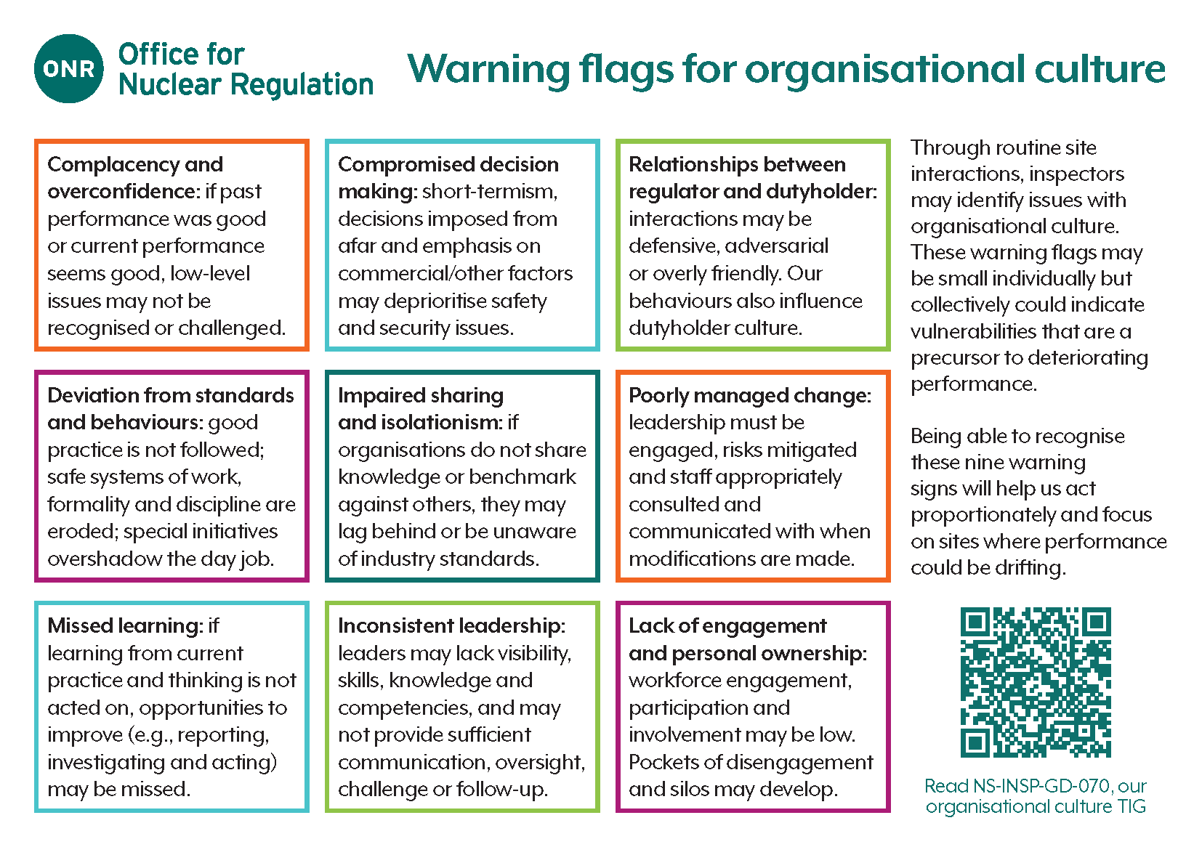

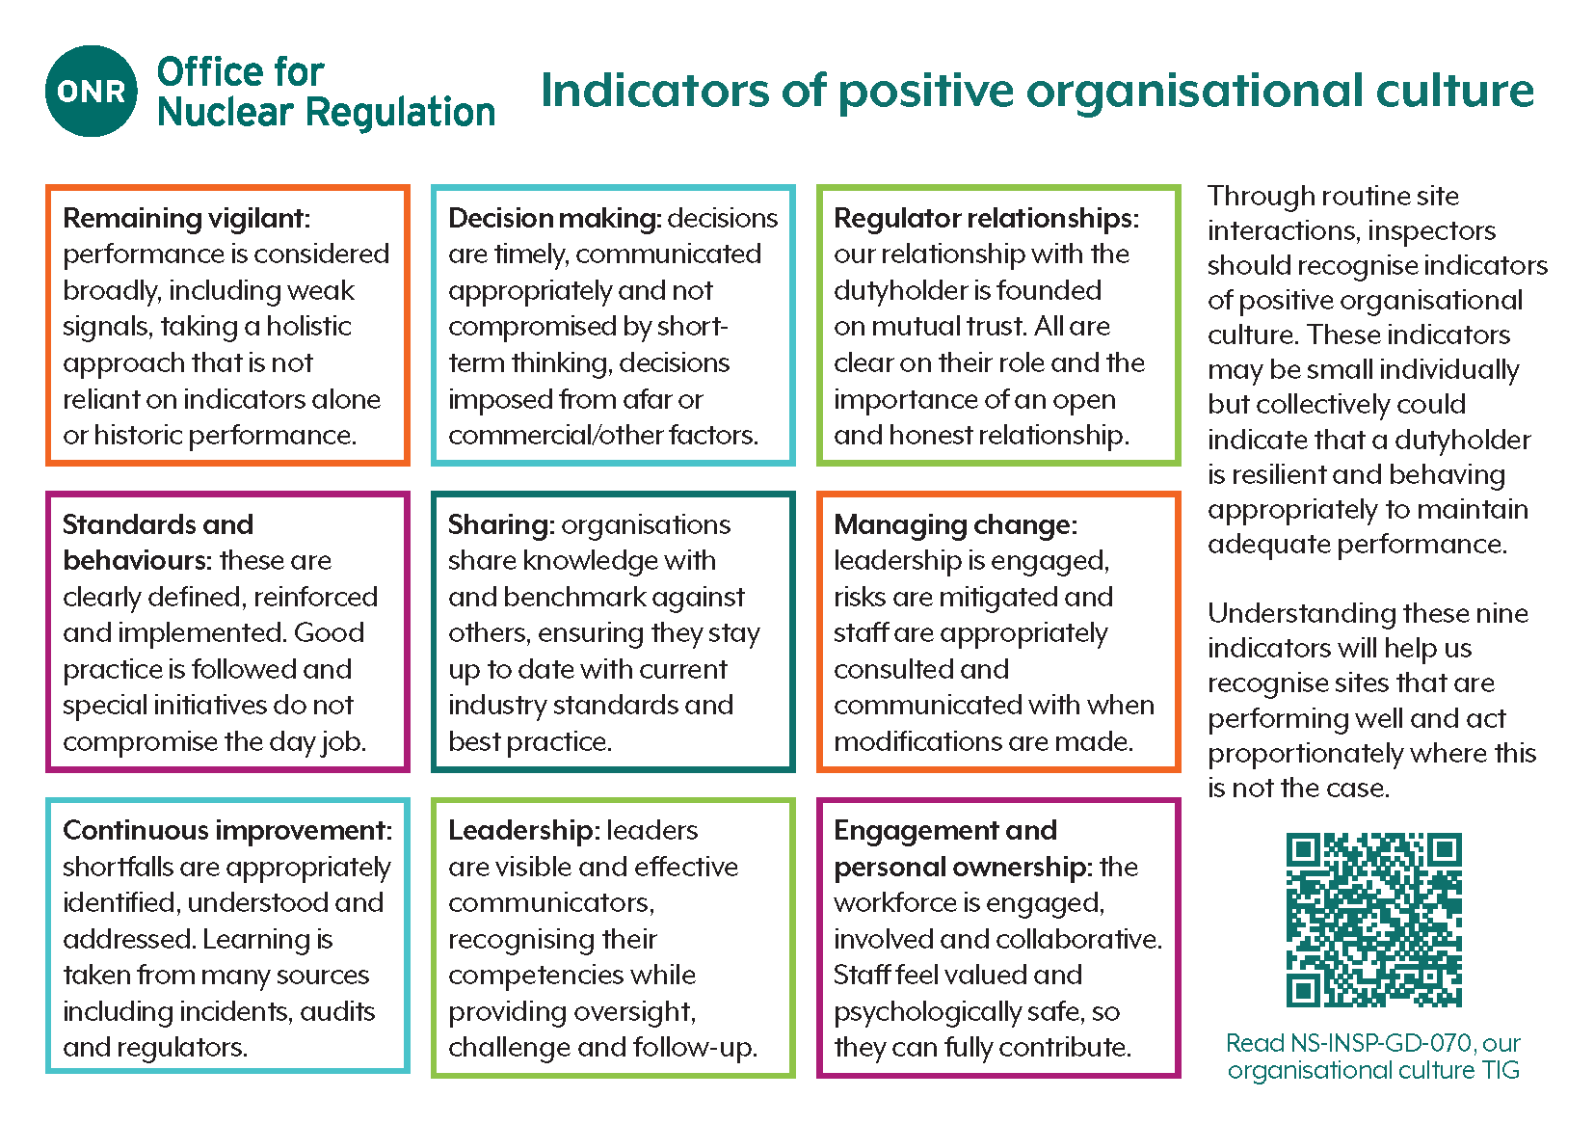

# 

# References

|  |  |
| --- | --- |
| [1] | BS ISO, “BS ISO 30400:2022 - Human Resource Management Vocabulary,” 2022. |
| [2] | ONR, “TD-HOC-GD-003 - Safety culture: Definition and model”. |
| [3] | IAEA, “IAEA Nuclear Safety and Security Glossary,” [Online]. Available: https://vocabulary.iaea.org/iaea-safety-glossary.html. |
| [4] | ISO, “ISO 10010:2022 - Quality management — Guidance to understand, evaluate and improve organizational quality culture (Edition 1),” 2022. [Online]. Available: https://www.iso.org/standard/38457.html. |
| [5] | AMBS and ONR, “Development of a Nuclear Industry Safety Culture Inventory (NISCI),” 2023. [Online]. Available: https://www.onr.org.uk/documents/2023/ambs-onr-nisci-report.pdf. |
| [6] | ORR, “ORR's strategy for regulation of health and safety risks - Chapter 13: Leadership and culture,” 2017. [Online]. Available: https://www.orr.gov.uk/media/15780. [Accessed July 2023]. |
| [7] | HSE, “Safety culture – extract from inspectors human factors toolkit,” [Online]. Available: https://www.hse.gov.uk/humanfactors/topics/common4.pdf. [Accessed 13 July 2023]. |
| [8] | Process Safety Leadership Group (HSE), “Seven Principles of leadership – leading from the top: avoiding major incidents,” 29 April 2008. [Online]. Available: https://www.hse.gov.uk/leadership/principlesleadership.htm. [Accessed 13 July 2023]. |
| [9] | NHS, “Patient Safety and Safety Culture,” [Online]. Available: https://www.england.nhs.uk/patient-safety/safety-culture/. [Accessed 13 July 2023]. |
| [10] | CAA, “Safety culture,” [Online]. Available: https://www.caa.co.uk/safety-initiatives-and-resources/how-we-regulate/state-safety-programme/safety-promotion/safety-culture/. [Accessed 13 July 2023]. |
| [11] | IAEA, “Nuclear Security Series No. 20 - Objective and Essential Elements of a State’s Nuclear Security Regime, Nuclear Security Fundamentals,” 2013. [Online]. Available: https://www.iaea.org/publications/10353/objective-and-essential-elements-of-a-states-nuclear-security-regime. |
| [12] | IAEA, “Safety Standards Series No. GSR Part 1 (Rev. 1) - Governmental, Legal and Regulatory Framework for Safety,” 2016. [Online]. Available: https://www.iaea.org/publications/10883/governmental-legal-and-regulatory-framework-for-safety. |
| [13] | IAEA, “Safety Standards Series No. GSR Part 2 - Leadership and Management for Safety,” 2016. [Online]. Available: https://www.iaea.org/publications/11070/leadership-and-management-for-safety. |
| [14] | ONR, “NS-INSP-GD-017 - LC 17 Management Systems,” [Online]. Available: https://www.onr.org.uk/operational/tech_insp_guides/ns-insp-gd-017.docx. |
| [15] | ONR, “Safety Assessment Principles (SAPs) for Nuclear Facilities - 2014 Edition (Revision 1),” January 2020. [Online]. Available: https://www.onr.org.uk/media/pobf24xm/saps2014.pdf. |
| [16] | ONR, “Security Assessment Principles for the Civil Nuclear Industry,” 2022. [Online]. Available: https://www.onr.org.uk/media/g05fszjn/security-assessment-principles.pdf. |
| [17] | ONR, “ONR-CNSS-MAN-001 - ONR Nuclear Material Accountancy Control and Safeguards Assessment Principles”. |
| [18] | WENRA, “WENRA Safety Reference Levels for Existing Reactors,” 2020. [Online]. Available: https://www.wenra.eu/node/86. |
| [19] | IAEA, “IAEA-TECDOC-1477 - Trending of low level events and near misses to enhance safety performance in nuclear power plants,” 2005. [Online]. Available: https://www-pub.iaea.org/MTCD/publications/PDF/te_1477_web.pdf. |
| [20] | Department of Energy, “Human Performance Handbook Volume 1 - Appendix A,” 2009. [Online]. Available: https://nerc.com/pa/rrm/ea/CA_Reference_Materials_DL/DOE%20-%20Vol%201%20Human%20Performance%20Handbook.pdf. |
| [21] | R. Taylor, L. van Wijk, J. H. May and N. J. Carhart, “A study of the precursors leading to 'organisational' accidents in complex industrial settings,” *Process Safety and Environmental Protection,* vol. 93, pp. 50-67, 2015. |
| [22] | ONR, “ONR-ENF-GD-005 - Conducting Investigations,” 2021. [Online]. Available: https://www.onr.org.uk/media/documents/guidance/onr-enf-gd-005.pdf. |
| [23] | ONR, “TD-HOC-GD-002 - Leadership and Management for Safety Reviews,” January 2022. [Online]. Available: https://www.onr.org.uk/operational/other/td-hoc-gd-002.pdf. [Accessed 13 July 2023]. |
| [24] | ONR, “ONR-INSP-GD-059 - Guidance for Inspection Strategy Planning and Reporting,” 2022. [Online]. Available: https://www.onr.org.uk/media/documents/guidance/onr-insp-gd-059.pdf. |
| [25] | ONR, “ONR-GEN-GD-013 - Guidance on the Assignment of Dutyholder Attention Levels,” 2021. [Online]. Available: https://www.onr.org.uk/operational/other/onr-gen-gd-013.pdf. [Accessed 13 July 2023]. |
| [26] | ONR, “TD-HOC-GD-001 - Examining culture in organisations,” 2023. [Online]. Available: https://www.onr.org.uk/operational/other/td-hoc-gd-001.docx. |
| [27] | ONR, “NS-TAST-GD-107 - Safety leadership,” [Online]. Available: https://www.onr.org.uk/operational/tech_asst_guides/ns-tast-gd-107.pdf. |
| [28] | ONR, “NS-TAST-GD-104 - Corporate governance for safety,” 2023. [Online]. Available: https://www.onr.org.uk/operational/tech_asst_guides/ns-tast-gd-104.docx. |
| [29] | ONR, “NS-TAST-GD-080 - Nuclear Safety Advice and Independent Challenge,” 2023. [Online]. Available: https://www.onr.org.uk/operational/tech_asst_guides/ns-tast-gd-080.docx. |
| [30] | HSE, “Leadership for the major hazard industries (Rev. 1),” [Online]. Available: https://www.hse.gov.uk/pubns/indg277.pdf. |
| [31] | IAEA, “Safety Reports Series No. 11 - Developing Safety Culture In Nuclear Activities - Practical Suggestions to Assist Progress,” 1998. [Online]. Available: https://www.iaea.org/publications/5144/developing-safety-culture-in-nuclear-activities-practical-suggestions-to-assist-progress. |
| [32] | IAEA, “Harmonized Safety Culture Model,” 2020. [Online]. Available: https://www.iaea.org/sites/default/files/20/05/harmonization_05_05_2020-final_002.pdf. |
| [33] | IAEA, “Nuclear Security Series No. 7 - Nuclear Security Culture,” 2008. [Online]. Available: https://www.iaea.org/publications/7977/nuclear-security-culture. |
| [34] | NI SDF, “Key Attributes of an Excellent Nuclear Security Culture,” 2013. [Online]. Available: https://www.nuclearinst.com/write/MediaUploads/SDF%20documents/Security/Key_attributes_of_an_excellent_Nuclear_Security_Culture.pdf. |
| [35] | ONR, “CNS-TAST-GD-2.1 - Maintenance of a Robust Security Culture”. |

# Glossary

|  |  |
| --- | --- |
| Acronym | Description |
| HSE | The Health and Safety Executive |
| IAEA | International Atomic Energy Agency |
| ISO | International Organization for Standardization |
| LC | Licence condition |
| LMfS | Leadership and Management for Safety |
| NISCI | Nuclear Industry Safety Culture Inventory |
| ONMACs | Nuclear Material Accountancy, Control and Safeguards Assessment Principles |
| ONR | The Office for Nuclear Regulation |
| PPE | Personal protective equipment |
| SAPs | Safety Assessment Principles |
| SDF | Safety Directors Forum |
| SyAPs | Security Assessment Principles |
| TAG | Technical Assessment Guide |
| TIG | Technical Inspection Guide |
| WANO | World Association of Nuclear Operators |
| WENRA | Western European Nuclear Regulators Association |