Safeguards Annual Report 2022



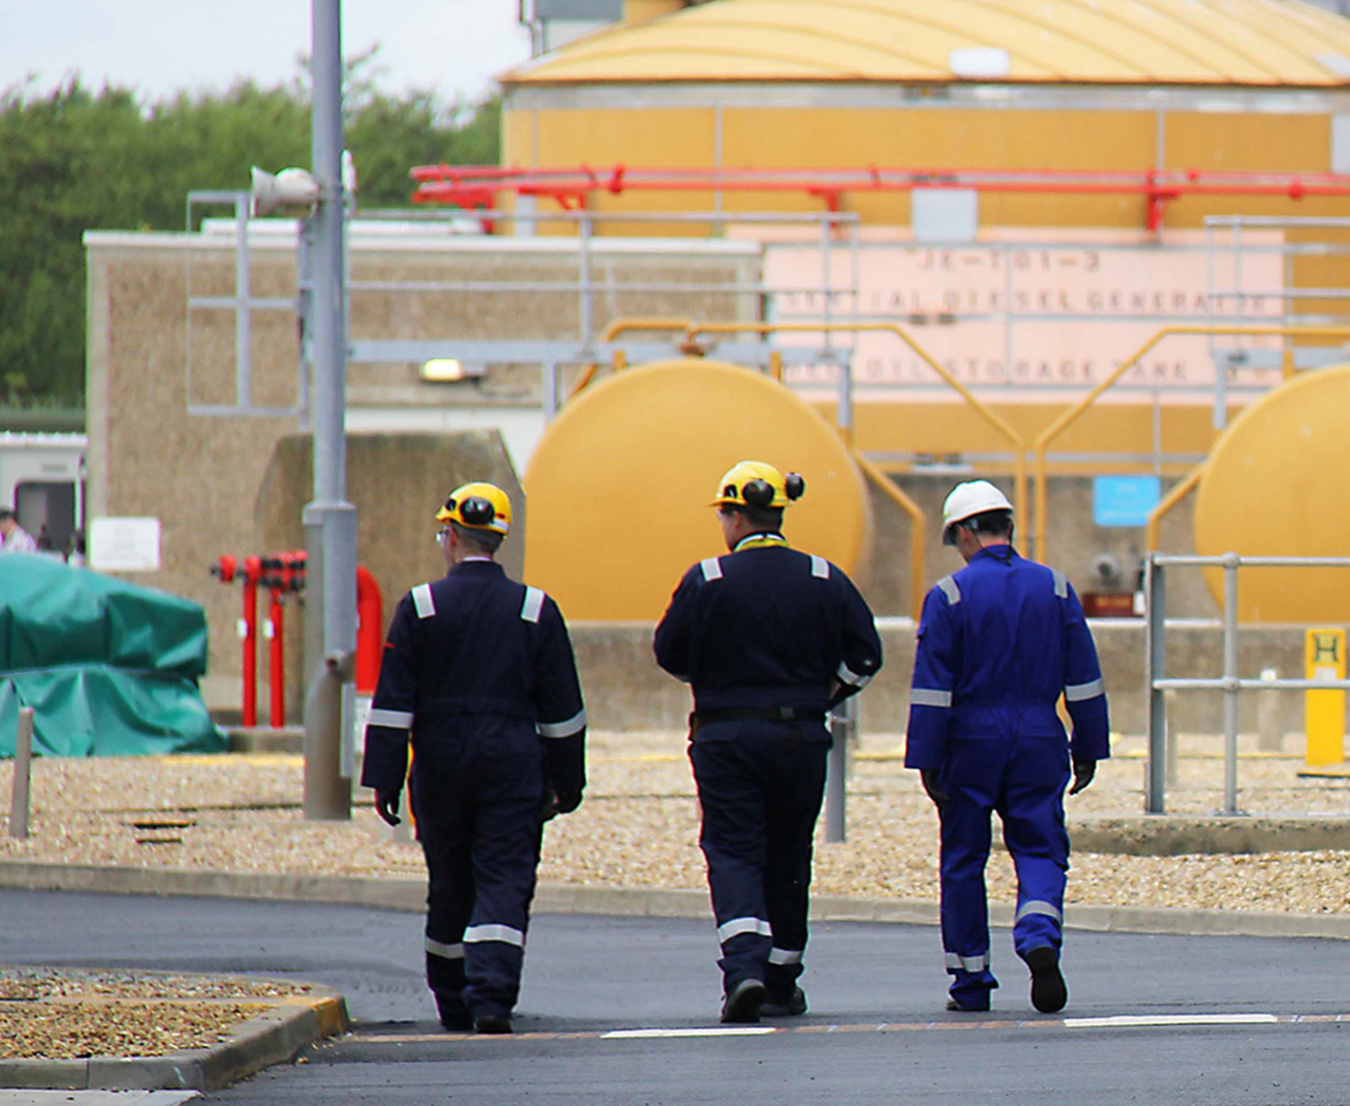
March 2023
Safeguards Annual Report 2022

Contents
Introduction 1
Regulatory activities 1
Inspection 2
Assessment 3
Facilitation 3
Reporting 4
Qualifying Nuclear Facilities with Limited Operation 5

Introduction
We have been the state regulatory authority for safeguards since 31 December 2020, following the UK’s departure from the European Atomic Energy Community (Euratom) and the end of the Brexit transition period. Our regulation of safeguards, and facilitation of the safeguards activities of the International Atomic Energy Agency (IAEA), are delivered by our Safeguards Subdivision, part of our Civil Nuclear Security and Safeguards (CNSS) division.
This report provides an overview of our implementation of the safeguards regime in 2022, as required under Regulation 41(2) of the Nuclear Safeguards (EU Exit) Regulations 2019 (NSR19).

Regulatory activities
NSR19 places duties on all holders of civil nuclear material in the UK to establish, implement and maintain a system of accounting for and control of qualifying nuclear material in each qualifying nuclear facility. Holders of qualifying nuclear material encompass a diverse range of organisations, from operators of major nuclear facilities (such as reactors, reprocessing plants, and fuel enrichment and fabrication plants) down to qualifying nuclear facilities with limited operation (QNFLOs), such as universities, research centres and small businesses.
We currently regulate compliance across ten reactor sites, two reprocessing and waste management sites, one fuel enrichment site, one fuel fabrication site, several sites undergoing decommissioning, and more than 100 QNFLOs.
Our enforcement policy statement and The Regulators’ Code require us to enforce these duties in a manner that is:
- proportionate to risks arising from any breach;
- targeted on activities that give rise to the most serious risks;
- consistent across similar circumstances to achieve similar outcomes;
- transparent to the dutyholders in question; and
- accountable to the public.
To achieve this, we have established an effective and robust regulatory framework to ensure compliance with NSR19 and to enable the UK to meet its international safeguards obligations. This framework provides safeguards inspectors with a regulatory toolkit from which they can make targeted and proportionate interventions to ensure operators are adequately complying with NSR19. This toolkit includes a combination of regulatory activities that can be broadly categorised into on-site inspection and the regulatory assessment of operator submissions.
We have maintained close engagement with operators throughout the implementation of our regulatory framework, regularly providing advice and feedback to operators.

Inspection
During the reporting period we conducted 39 on-site inspections. These inspections included:
Nuclear Material Accountancy Inspections, to confirm whether operators’ nuclear material accountancy and operating records, required by Regulations 10 and 11 of NSR19, align with the accounting reports submitted to us under Regulations 12-15 of NSR19;
Physical Inventory Take (PIT) Evaluation Inspections, to confirm that operators are undertaking regular PITs as required, and that this component of their accountancy and control system is proportionate to and appropriate for the facility in question, as required by Regulation 6 and Schedule 2 of NSR19;
Basic Technical Characteristics Inspections, to confirm whether design information declared by operators under Regulation 3 of NSR19 is accurate and matches physical reality. Design information is information concerning qualifying nuclear material subject to safeguards and the features of facilities relevant to safeguarding such material. It includes information on the form, quantity, location and flow of qualifying nuclear material and the facility layout and containment features.
Accountancy and Control Plan Inspections, to confirm whether operators are adequately implementing aspects of their nuclear material Accountancy and Control Plans (ACPs), as required by regulations 6, 7, and 9 of NSR19;
Safeguards System-Based Inspections, which take a cross-cutting approach by focusing on key nuclear material accountancy and control systems (such as measurement systems and data processing systems) and confirm whether these systems are being implemented in a manner which is proportionate to and appropriate for the facilities in question, as required by Regulation 6 and Schedule 2 of NSR19.
We have also undertaken several joint compliance inspections with our nuclear safety and security inspector colleagues. This has enabled us to identify areas of mutual regulatory interest and overlap between safeguards regulatory requirements and regulatory requirements set out in nuclear site Licence Conditions.
Undertaking joint inspections allows us to be more efficient and effective through sharing of regulatory intelligence and where possible, avoid the undue burden of separate interventions driven by each regulatory function. We will continue to develop and mature this area of innovation in our regulatory approach across ONR to include all relevant regulatory purposes.
Of these on-site inspections, 35 received a ‘green’ rating, indicating broad compliance with the requirements of NSR19 across the UK’s civil nuclear estate, with few (or no) minor shortfalls identified.
Four inspections received an amber rating, which requires action from the operator to address gaps in compliance. Generally, these compliance gaps were identified in the areas of adequacy of safeguards arrangements and procedures and their implementation, reliability and sustainability of safeguards systems, and capability and capacity of operator staff. We have worked constructively with operators to address these gaps in a timely manner.

Assessment
NSR19 requires operators to make submissions to us. These submissions include technical descriptions of facilities (Basic Technical Characteristics, as required by Regulation 3 of NSR19), descriptions of arrangements and procedures for nuclear material accountancy and control (Accountancy and Control Plans, or ACPs, as required by regulation 7 of NSR19), and accounting reports on nuclear material inventories and movements (as required by regulations 12-15 of NSR19).
We perform assessments of these submissions to judge their compliance with regulatory requirements and to inform our on-site inspection activities. Where we have considered it necessary, our assessments have been supported by on-site visits to confirm the accuracy of the information contained in the submissions.
We assessed all nuclear material accountancy reports submitted during the reporting period and carried out six other assessments. These included:
Basic Technical Characteristics assessments, to confirm whether these submissions were correct, complete, and adequate in line with the requirements of Regulation 3 of NSR19 and, where necessary, met international obligations. These assessments received green ratings, indicating broad compliance with regulatory requirements and relatively minor, if any, deficiencies in the submissions.
ACP assessments, to confirm whether the arrangements and procedures for nuclear material described in ACP submissions were proportionate to and appropriate for the facility in question, and are being implemented adequately, as required by Regulations 6, 7, and 9 of NSR19. One assessment received a ‘green’ rating, indicating broad compliance with the requirements of NSR19, with few minor shortfalls identified. In the reporting period, one ACP assessment received an ‘amber’ rating indicating gaps in the operator’s arrangements and procedures requiring improvements. We have raised regulatory issues to track and support the relevant operator in addressing these shortfalls.

Facilitation
As set out in Section 72 of The Energy Act (2013), one of our safeguards purposes is to enable and facilitate compliance by the UK with its international safeguards obligations. Under the UK’s Voluntary Offer Agreement (VOA) with the International Atomic Energy Agency (IAEA), the UK is obliged to facilitate IAEA safeguards inspections and site visits at facilities in the UK that have been designated for that purpose. The IAEA has designated three facilities across two sites for their inspection of the implementation of UK safeguards.
We facilitate IAEA safeguards inspection activities by liaising with them and the relevant facilities, overseeing facility preparations for inspection, and where necessary accompanying inspectors on-site. We have also successfully facilitated the installation of IAEA safeguards equipment at UK sites. The successful installation of equipment has allowed the IAEA to implement a more efficient and effective revised safeguards approach reducing the number of safeguards inspections and therefore reducing the burden on both the IAEA and the UK.
The IAEA carried out 25 safeguards inspections at designated facilities during the reporting period. We successfully facilitated all the IAEA inspections enabling the IAEA to fulfil their objectives. No issues have been raised by the IAEA regarding the facilitation of IAEA safeguards inspections in the UK.

Reporting
NSR19 requires operators of qualifying nuclear facilities to provide us with accounting reports for each material balance area. A material balance area is an area in or outside of a facility where the physical inventory of qualifying nuclear material can be determined when necessary and the quantity of qualifying nuclear material in each transfer into or out of the area can be determined.
There are currently 69 material balance areas across the UK (excluding qualifying nuclear facilities with limited operation – see below).
Regulations 13 to 18 of NSR19 prescribe the various types of reports and frequency of reporting required. These reports include initial nuclear material inventories (Regulation 13), monthly Inventory Change Reports (regulation 14), and Material Balance Reports and Physical Inventory Listings each calendar year (Regulation 15).
We have successfully assessed these reports to ensure that they are correct and complete and have submitted them to the IAEA in the required format under the UK/IAEA VOA, enabling the UK to meet its safeguards obligations. Within the reporting period, this amounts to more than 1,000 reports with hundreds of thousands of lines of data.
Regulation 19 of NSR19 requires operators to submit additional reports arising from international agreements and to fulfil obligations resulting from international trade. These include bilateral Nuclear Cooperation Agreements (NCAs) with the United States of America, Australia, Canada, Japan, and with Euratom. During the reporting period we have received, analysed and facilitated the submission of these reports to the relevant states through BEIS in accordance with the administrative arrangements underpinning each of these agreements.
There are several reports in addition to those mentioned above arising from several state level agreements with the IAEA (see table below). We have met all these reporting requirements. This includes substantial reporting commitments under the protocol additional to the voluntary offer safeguards agreement with the IAEA known as the ‘Additional Protocol’ (AP).
Report | Frequency
Qualifying Nuclear Facilities. ‘Facilities List ‘ | Annual
Application of Safeguards on material transferred to the UK pursuant of INFCIRC/175 | Quarterly
Minimisation and elimination of Highly Enriched uranium (HEU) pursuant to INFCIRC/912 | Annual
Neptunium (Np) and Americium (Am) Report | Annual
UK Export report pursuant of the UK/IAEA Additional Protocol (AP) agreement | Quarterly
IAEA Inspector designation | Periodic
Withdrawals of nuclear material from safeguards | Annual

Qualifying Nuclear Facilities with Limited Operation
We regulate more than 100 qualifying nuclear facilities with limited operation (QNFLOs), this number fluctuating over time due to the changing nature of these organisations’ activities. They primarily comprise universities, research centres, and small businesses. For these organisations, we employ the same regulatory framework to achieve compliance with NSR19 as with the larger facilities, adopting a targeted approach.
NSR19 provides for these operators to apply for a reduced safeguards reporting regime, which we have implemented following applications from eligible QNFLOs. The reduced reporting regime is working effectively and we continue to support QNFLOs in meeting their obligations under NSR19.
Conclusion
Through our implementation of the NSR19 in 2022, we have enabled the UK to meet all of its international safeguards’ obligations and delivered the required safeguards reporting. We have also effectively facilitated IAEA safeguards activities in the UK. We have engaged closely with operators throughout, providing regular advice and guidance to assist them in meeting their obligations under NSR19.

© Office for Nuclear Regulation, 2023
Any enquiries related to this document should be sent to contact@onr.gov.uk
Published March 2023

